^{91429 R}
3
Level 3 Geography Practice exam
91429 Demonstrate understanding of a given environment(s) through selection and application of geographic concepts and skills

Credits: Four
RESOURCE BOOKLET

Refer to this booklet to answer the questions for Geography 91429.

Check that this booklet has pages 2–12 in the correct order and that none of these pages is blank.

YOU MAY KEEP THIS BOOKLET AT THE END OF THE EXAMINATION.

RELEVANT GEOGRAPHIC CONCEPTS

Environments
May be natural and / or cultural. They have particular characteristics and features which can be the result of natural and / or cultural processes. The particular characteristics of an environment may be similar to and / or different from another. A cultural environment includes people and / or the built environment.

Perspectives
Ways of seeing the world that help explain differences in decisions about, responses to, and interactions with, environments. Perspectives are bodies of thought, theories, or world views that shape people’s values and have built up over time. They involve people’s perceptions (how they view and interpret environments) and viewpoints (what they think) about geographic issues. Perceptions and viewpoints are influenced by people’s values (deeply held beliefs about what is important or desirable).

Processes
A sequence of actions, natural and / or cultural, that shape and change environments, places, and societies. Some examples of geographic processes include erosion, migration, desertification, and globalisation.

Patterns
May be spatial (the arrangement of features on the Earth’s surface) or temporal (how characteristics differ over time in a recognisable way).

Interaction
Elements of an environment affecting each other and being linked together. Interaction incorporates movement, flows, connections, links, and interrelationships which work together and may be one- or two-way interactions. Landscapes are the visible outcome of interactions. Interaction can bring about environmental change.

Change
Any alteration to the natural or cultural environment. Change can be spatial and / or temporal. Change is a normal process in both natural and cultural environments. It occurs at varying rates, at different times and in different places. Some changes are predictable,
recurrent, or cyclic, while others are unpredictable or erratic. Change can bring about further change.

Sustainability
Adopting ways of thinking and behaving that allow individuals, groups, and societies to meet their needs and aspirations without preventing future generations from meeting theirs. Sustainable interaction with the environment may be achieved by preventing,
limiting, minimising, or correcting environmental damage to water, air, and soil, as well as considering ecosystems and problems related to waste, noise, and visual pollution.

THE NATURAL AND CULTURAL ENVIRONMENT OF UKRAINE

RESOURCE A: The location of Ukraine

Ukraine is a country located in eastern Europe, the second largest on the continent after Russia. The capital is Kyiv (Kiev), located on the Dnieper River in north-central Ukraine.

Ukraine is situated in the central part of Eastern Europe, on the crossroads of major transportation routes from Europe to Asia and from the Scandinavian states to the Mediterranean region.

Most of Ukraine is located south-west of the Eastern European plain. Mountains occupy only 5% of Ukrainian territory: the Ukrainian Carpathian mountains in the west and the Crimean mountains in the south. The highest peak in Ukraine, Goverla Mountain (2,061 m), is situated in the Carpathians. Roman-Kosh peak (1,545 m) is the highest mountain in Crimea.

The Ukraine’s Black Sea coastline exceeds 1,500 km. Sea coasts in Ukraine are mainly flat, except for the region near the Crimean mountains. Water temperature at the seaside ranges from 0-8°C in winter to 25°C in summer.

The Azov Sea’s shore is low-lying, straight, with specific sand spits. The Azov Sea is rather shallow. Sea water near shore freezes in the winter. The water temperature in summer reaches 25-30°C.

There are more than 73,000 rivers in Ukraine. Ukrainian rivers mostly belong to the basins of the Black and Azov seas. Only the Western Bug and other right influxes of the Vistula River flow to the Baltic Sea basin. The largest rivers in Ukraine (Dnepr and Danube rivers) are navigable.
More than 20,000 water reservoirs are situated in Ukraine, including more than 3,000 lakes. They are mostly situated in Polesye, Prichernomorskaya lowland, and the Crimean steppe.

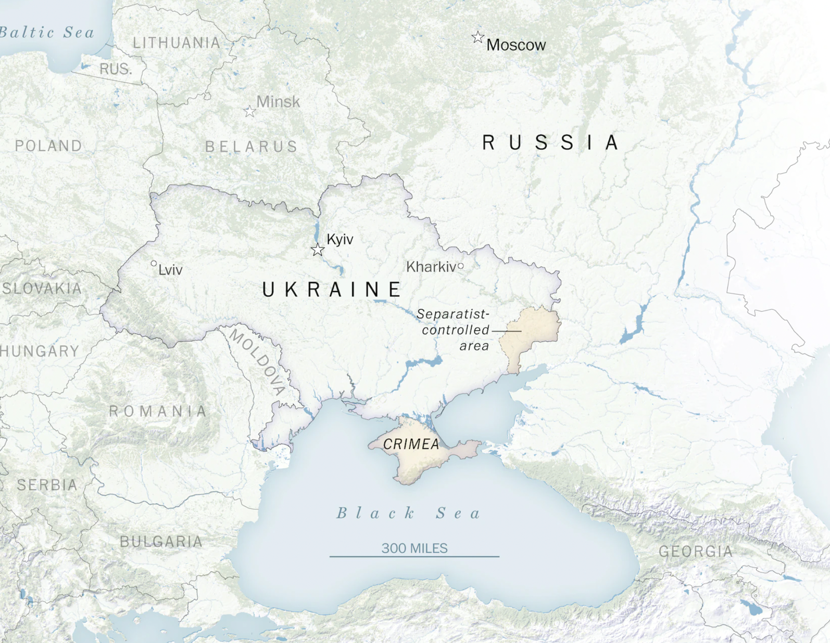

Figure 1: Political map of Ukraine and surrounding countries. Source: Washington Post.

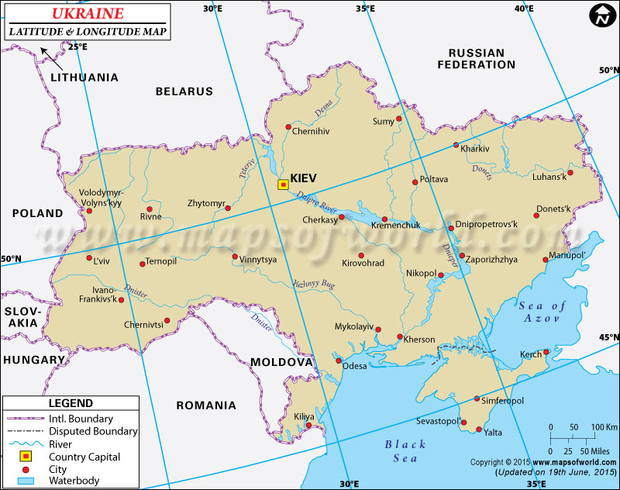

Figure 2: Political map of Ukraine showing latitude and longitude. Source: Mapsofworld.com.

RESOURCE B: Ukrainian culture

When Ukraine was a part of the Soviet Union, a policy of Russian in-migration and Ukrainian out-migration was in effect, and ethnic Ukrainians’ share of the population in Ukraine declined from 77 percent in 1959 to 73 percent in 1991. But that trend reversed after the country gained independence, and, by the turn of the 21st century, ethnic Ukrainians made up more than three-fourths of the population. Russians continue to be the largest minority, though they now constitute less than one-fifth of the population. The remainder of the population includes Belarusians, Moldovans, Bulgarians, Poles, Hungarians, Romanians, Roma (Gypsies), and other groups.
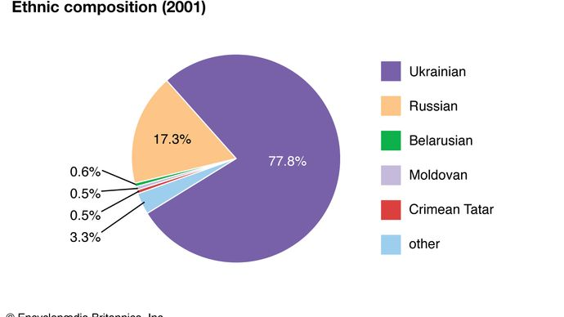
Historically, Ukraine had large Jewish and Polish populations, particularly in the Right Bank region (west of the Dnieper River). In fact, in the late 19th century slightly more than one-fourth of the world’s Jewish population (estimated at 10 million) lived in ethnic Ukrainian territory. This predominantly Yiddish-speaking population was greatly reduced by emigration in the late 19th and early 20th centuries and by the devastation of the Holocaust. In the late 1980s and early ’90s, large numbers of Ukraine’s remaining Jews emigrated, mainly to Israel.

The vast majority of people in Ukraine speak Ukrainian, which is written with a form of the Cyrillic alphabet. The language—belonging. Figure 3: Pie-chart of Ukrainian ethnic composition. Source: brittanica.com.
with Russian and Belarusian to the East Slavic
branch of the Slavic language family—is closely related to Russian but also has distinct similarities to the Polish language. Significant numbers of people in the country speak Polish, Yiddish, Rusyn, Belarusian, Romanian or Moldovan, Bulgarian, Crimean Turkish, or Hungarian. Russian is the most important minority language.

RESOURCE C: Ukrainian history

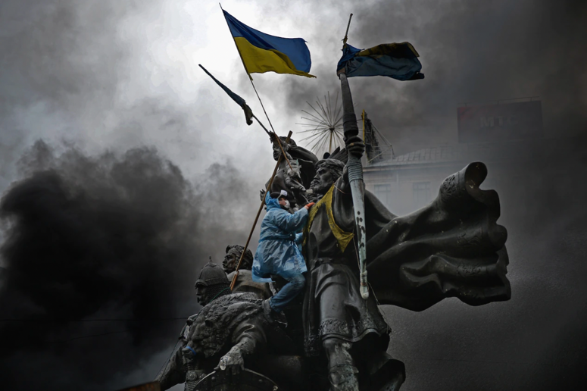
Image 1: Deadly violence engulfed Kyiv’s Maidan, or Independence Square, in 2014 after the Ukrainian government, under pressure from Moscow, abandoned an agreement to strengthen ties with the European Union. Russia remains opposed to Ukraine's move toward the West.
Source: National Geographic

As the threat of a Russian invasion of Ukraine continues to dominate the news, a look back at the long, intertwined history of the contentious neighbours reveals how the stage was set for today’s conflict.

The two countries’ shared heritage goes back more than a thousand years to a time when Kyiv, now Ukraine’s capital, was at the centre of the first Slavic state, Kyivan Rus, the birthplace of both Ukraine and Russia. In A.D. 988 Vladimir I, the pagan prince of Novgorod and grand prince of Kyiv, accepted the Orthodox Christian faith and was baptized in the Crimean city of Chersonesus. From that moment on, Russian leader Vladimir Putin recently declared, “Russians and Ukrainians are one people, a single whole.”

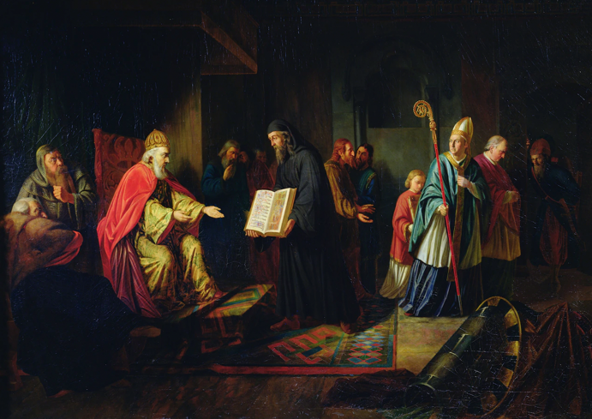
Image 2: A 19th-century painting depicts Vladimir I, ruler of Kyivan Rus—the birthplace of both Ukraine and Russia—choosing Orthodox Christianity as the new state religion in A.D. 988. Source: National Geographic

Yet over the past 10 centuries, Ukraine has repeatedly been carved up by competing powers. Mongol warriors from the east conquered Kyivan Rus in the 13th century. In the 16th century Polish and Lithuanian armies invaded from the west. In the 17th century, war between the Polish-Lithuanian Commonwealth and the Tsardom of Russia brought lands to the east of the Dnieper River under Russian imperial control. The east became known as "Left Bank" Ukraine; lands to the west of the Dnieper, or "Right Bank," were ruled by Poland.

More than a century later, in 1793, right bank (western) Ukraine was annexed by the Russian Empire. Over the years that followed, a policy known as Russification banned the use and study of the Ukrainian language, and people were pressured to convert to the Russian Orthodox faith.

Ukraine suffered some of its greatest traumas during the 20th century. After the communist revolution of 1917, Ukraine was one of the many countries to fight a brutal civil war before being fully absorbed into the Soviet Union in 1922. In the early 1930s, to force peasants to join collective farms, Soviet leader Joseph Stalin orchestrated a famine that resulted in the starvation and death of millions of Ukrainians. Afterward, Stalin imported large numbers of Russians and other Soviet citizens—many with no ability to speak Ukrainian and with few ties to the region—to help repopulate the east.

These legacies of history created lasting fault lines. Because eastern Ukraine came under Russian rule much earlier than western Ukraine, people in the east have stronger ties to Russia and have been more likely to support Russian-leaning leaders.

Western Ukraine, by contrast, spent centuries under the shifting control of European powers such as Poland and the Austro-Hungarian Empire—one reason Ukrainians in the west have tended to support more Western-leaning politicians. The eastern population tends to be more Russian-speaking and Orthodox, while parts of the west are more Ukrainian-speaking and Catholic.

With the collapse of the Soviet Union in 1991, Ukraine became an independent nation. But uniting the country proved a difficult task. For one, “the sense of Ukrainian nationalism is not as deep in the east as it is in west,” says former ambassador to Ukraine Steven Pifer. The transition to democracy and capitalism was painful and chaotic, and many Ukrainians, especially in the east, longed for the relative stability of earlier eras.

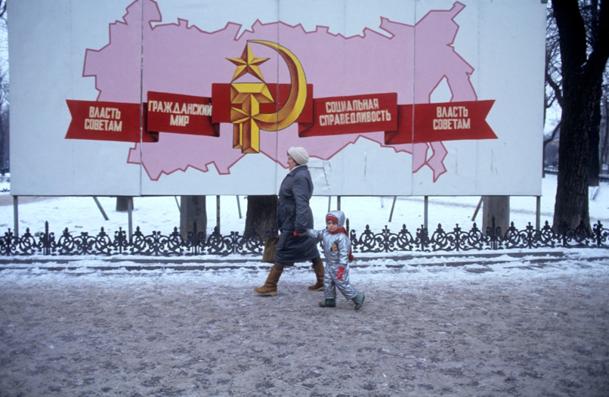
Image 3: Pedestrians in Odessa, a port city on the Black Sea in southern Ukraine, walk past a sign heralding Soviet themes of power and justice in 1991—the year Ukraine became an independent nation and the USSR was dissolved. Source: National Geographic

"The biggest divide after all these factors is between those who view the Russian imperial and Soviet rule more sympathetically versus those who see them as a tragedy," says Adrian Karatnycky, a Ukraine expert and former fellow at the Atlantic Council of the United States. These fissures were laid bare during the 2004 Orange Revolution, in which thousands of Ukrainians marched to support greater integration with Europe.

RESOURCE D: Putin Calls Ukrainian Statehood a Fiction. History Suggests Otherwise.

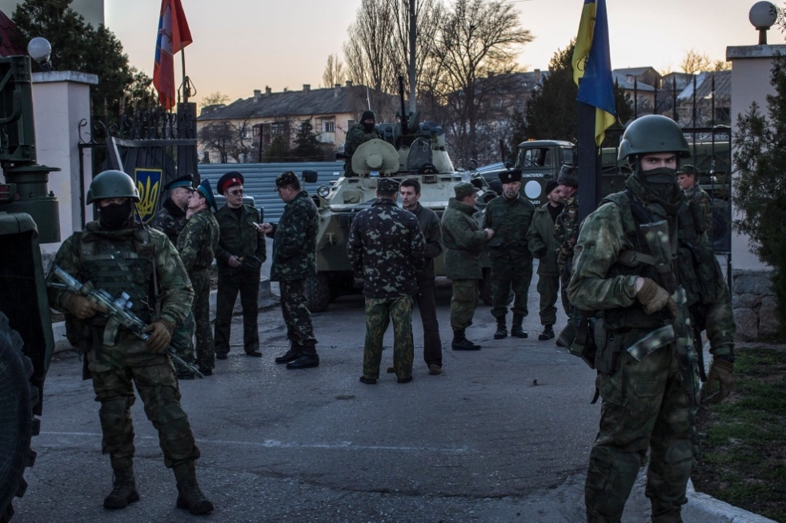
KYIV, Ukraine — In his speech to the Russian nation, President Vladimir V. Putin argued that the very idea of Ukrainian statehood was a fiction.

Mr. Putin declared Ukraine an invention of the Bolshevik revolutionary leader, Vladimir Lenin, who he said had mistakenly endowed Ukraine with a sense of statehood by allowing it autonomy within the newly created Soviet state.

“Modern Ukraine was entirely and fully created by Russia, more specifically the Bolshevik, communist Russia,” Mr. Putin said. “This process began practically immediately after the 1917 revolution, and moreover Lenin and his associates did it in the sloppiest way in relation to Russia — by dividing, tearing from her pieces of her own Image 4: Russian soldiers during the annexation of Crimea in 2014. Credit: Mauricio Lim historical territory.” for The New York Times

As a misreading of history, it was extreme even by the standards of Mr. Putin, a former K.G.B. officer who has declared the Soviet Union’s collapse the greatest geopolitical catastrophe of the 20th century.

Ukraine and Russia share roots stretching back to the first Slavic state, Kievan Rus, a medieval empire founded by Vikings in the 9th century.

But the historical reality of Ukraine is complicated, a thousand-year history of changing religions, borders and peoples. The capital, Kyiv, was established hundreds of years before Moscow, and both Russians and Ukrainians claim it as a birthplace of their modern cultures, religion and language.

“Putin’s argument today that Ukraine is historically subsumed by Russia is just not right,” said Cliff Kupchan, chairman of the Eurasia Group, a political risk consulting organization.

The newly created Soviet government under Lenin that drew so much of Mr. Putin’s scorn on Monday would eventually crush the nascent independent Ukrainian state. During the Soviet era, the Ukrainian language was banished from schools and its culture was permitted to exist only as a cartoonish caricature of dancing Cossacks in puffy pants.

Mr. Putin also argued on Monday that the myth of Ukraine was reinforced by the crumbling Soviet government of Mikhail Gorbachev, which allowed Ukraine to slip free of Moscow’s grasp. It was a weakened Moscow that “gave” Ukraine the right to become independent of the Soviet Union “without any terms and conditions.”
It was not Moscow that granted Ukraine’s independence in 1991, but the Ukrainian people, who voted resoundingly to leave the Soviet Union in a democratic referendum.

Now, with an estimated 190,000 Russian troops surrounding Ukraine like a sickle, Mr. Putin’s declaration that Ukraine’s very existence as a sovereign state was the result of historical error threatened to send a shudder through all the lands once under Moscow’s dominion. It also elicited expressions of contempt from Ukrainians.

It is not clear whether Mr. Putin believes his version of Ukrainian history or has simply concocted a cynical mythology to justify whatever action he plans next. But his contention that Ukraine exists solely within the context of Russian history and culture is one he has deployed at least as far back as 2008, when he attempted to convince George W. Bush, who had expressed support for Ukraine’s NATO membership, of the country’s nonexistence.

Last summer, Mr. Putin published a 5,300-word essay that expounded on many of the themes he highlighted in Monday’s speech, including the idea that nefarious Western nations had somehow corrupted Ukraine, leading it away from its rightful place within a greater Russian sphere through what he called a “forced change of identity.”

Joshua A. Tucker, a political science professor at New York University says the Russian leader was laying the groundwork for the argument “that Ukraine is not currently entitled to the sorts of rights that we associate with sovereign nations.”
“It was a signal that Putin intends to argue that a military intervention in Ukraine would not be violating another country’s sovereignty,” he added.

RESOURCE E: The 20th-Century History Behind Russia’s Invasion of Ukraine

Before Russian forces fired rockets at the Ukrainian capital of Kyiv; seized Chernobyl, site of the world’s worst nuclear accident; and attacked Ukraine’s second-largest city, Kharkiv, Russian President Vladimir Putin shared some choice words.
In an essay published on the Kremlin’s website in Russian, Ukrainian and English last July, Putin credited Soviet leaders with inventing a Ukrainian republic within the Soviet Union in 1922, forging a fictitious state unworthy of sovereignty out of historically Russian territory. After Ukraine declared its independence in 1991, the president argued, Ukrainian leaders “began to mythologize and rewrite history, edit out everything that united [Russia and Ukraine], and refer to the period when Ukraine was part of the Russian Empire and the Soviet Union as an occupation.”

The “historical reality” of modern-day Ukraine is more complex than Putin’s version of events, encompassing “a thousand-year history of changing religions, borders and peoples,” according to the New York Times. “[M]any conquests by warring factions and Ukraine’s diverse geography ... created a complex fabric of multiethnic states.”

Over the centuries, the Russian and Austro-Hungarian Empires, Poland, and Lithuania have all wielded jurisdiction over Ukraine, which first asserted its modern independence in 1917, with the formation of the Ukrainian People’s Republic. Russia soon wrested back control of Ukraine, making it part of the newly established Soviet Union and retaining power in the region until World War II, when Germany invaded. The debate over how to remember this wartime history, as well as its implications for Ukrainian nationalism and independence, is key to understanding the current conflict.

In Putin’s telling, the modern Ukrainian independence movement began not in 1917 but during World War II. Under the German occupation of Ukraine, between 1941 and 1944, some Ukrainian independence fighters aligned themselves with the Nazis, whom they viewed as saviours from Soviet oppression. Putin has drawn on this period in history to portray any Ukrainian push for sovereignty as a Nazi endeavour, says Markian Dobczansky, a historian at Harvard University’s Ukrainian Research Institute. “It’s really just a stunningly cynical attempt to fight an information war and influence people's opinions,” he adds.

Omitted from this version of events are the genocide and suppression that took place under Soviet rule—most famously the Great Famine. Holodomor, which fuses the Ukrainian words for starvation and inflicting death, claimed the lives of around 3.9 million people, or approximately 13 percent of the Ukrainian population, in the early 1930s. A human-made famine, it was the direct result of Soviet policies aimed at punishing Ukrainian farmers who fought Soviet mandates to collectivize. The Soviets also waged an intense “Russification” campaign, persecuting Ukraine’s cultural elite and elevating Russian language and culture above all others.
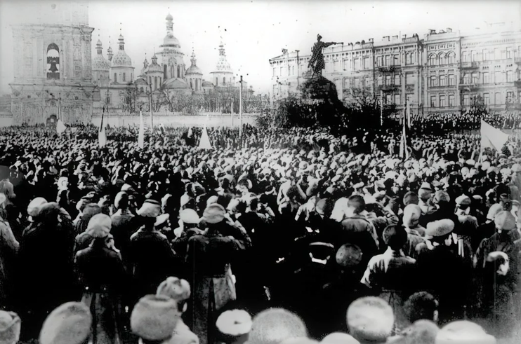
When Germany invaded in 1941, some Ukrainians, especially those in western Ukraine, saw them as liberators, says Oxana Shevel, a political scientist at Tufts University. The Ukrainians didn’t particularly want to live under the Germans so much as escape the Soviets, adds Shevel, who is the president of the nonprofit educational organization American Association for Ukrainian Studies.

“The broader objective was to establish an independent state, but in the process, [Ukrainians] also engaged in participation in the Holocaust,” she says.

From the Soviet point of view that Putin still embraces, it’s simple: The Holocaust aside, Ukrainian nationalists were “bad
Image 5: A nationalist rally in Kyiv in January 1917. guys” because “they fought the Soviet state.” Putin and other
Source: Wikimedia Commons critics often draw on Ukrainians’ wartime collaboration with the
Nazis to baselessly characterize the modern country as a Nazi nation; in a February 24 speech, the Russian president deemed the “demilitarization and de-Nazification of Ukraine” key goals of the invasion.

From the Ukrainian side of the debate, the country’s wartime history is more complex. Are the nationalists “bad guys” because they participated in the Holocaust, Shevel asks, or “good guys” because they fought for independence?

Putin has referenced Ukrainian nationalists in service of his own political agenda of portraying modern Ukrainians as Nazis. In today’s charged atmosphere, saying anything critical about Ukrainian nationalism or calling attention to Ukrainian nationalists’ involvement with the Nazis can be seen as supporting Russia’s depiction of Ukraine as a Nazi nation.
This Russian narrative is nothing new. Instead, it’s part of a long-term Russian information war on Ukraine.
“[Russian leaders] basically don’t recognize any Ukrainian historical agency except the agency that they imagined for them,” says Dobczansky.
Ukraine—and the world—seem to be imagining something different.

RESOURCE F: Wetlands and radioactive soil: How Ukraine’s geography could influence a
Russian invasion

As military analysts warn of a possible Russian invasion of Ukraine, they also are keeping an eye on the weather. Temperatures, cloud cover or even the radioactivity in the soil could determine when and where Russian troops make a possible move.
For centuries, armies and nations have waged wars on these same lands, from the steppes to the Eastern European heartland, and have faced similar obstacles — from mucky wetlands to rushing rivers and treacherous mountain ranges.
Russia, while mobilizing more than 100,000 troops along the Ukraine border, denies it plans to invade. But Washington and its allies are preparing for possible aggression by sending military personnel and equipment to NATO members near Ukraine.

Now, with airstrike capabilities and state-of-the-art materiel on both sides, geography and weather are less of a factor than they were in the past. But they still could influence the timing and the tide of a potential conflict. Cold weather provides hard, fast terrain countrywide for an invasion, experts said. Warmer weather starting in later February and into March brings with it thawing grounds, leading to muddy conditions that are less than ideal for heavy military vehicles.

“It is very inconvenient to carry out offensive operations in the spring,” said Kirill Mikhailov, an analyst at the Conflict Intelligence Team, an independent Russian open-source investigative organization that monitors Russia’s military. “Because the thaw turns ravines into creeks, and creeks into rivers. If you carry out an operation, it should be carried out either in January or February.”

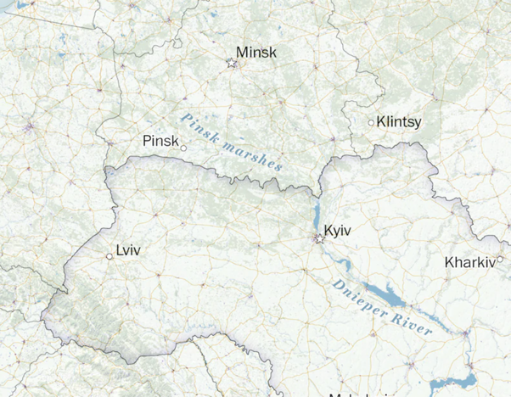
The Pinsk Marshes
To Ukraine’s north span roughly 100,000 square miles of wetlands known as the Pinsk Marshes. Here is one place the cold could really play a role. During the winter, these mucky flatlands freeze over, providing a more stable terrain for heavy military vehicles that would otherwise get stuck in the mud. Experts say the frozen ground, usually present in February, could provide Russian troops with the best window to cross into Ukraine. While more roads have recently been built throughout the marshes, traversing the open terrain would be strategically important.

“Those fields become critical because you can’t risk bottlenecks on a roadway,” said Seth G. Jones, senior vice president at the Center for Strategic and International Studies (CSIS). “You run into real problems on very muddy terrain in the March-April time frame.”
Historically the marshes have been an obstacle to forces. Image 6: The Pinsk Marshes. Source: Washington Post But muddy landscape might not be a deciding factor this time around,
according to a written analysis by the Center for Naval Analyses Russia Studies Program (CNA) in response to questions from The Washington Post. “While these marshes were flagged as a potential hazard for Western forces fighting a hypothetical war in the U.S.S.R. and considered ‘impassible except during winter,’ Russian troops have long proved quite adept at handling marsh and swamp terrain.”

The Dnieper River
While an invasion from Belarus’s south would be the most direct route to Ukraine’s capital, many expect potential Russian military aggression to also come from the northeast and east, where pro-Moscow separatists control Ukrainian territory in Donbas, and more than 100,000 Russian troops have amassed on the country’s border with Ukraine.
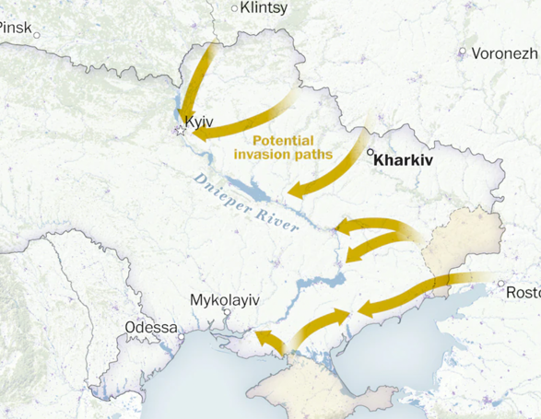
They could come through Kharkiv, Ukraine’s second-most-populous city. There are no geographic obstacles separating this eastern metropolis from Russia, making it a fast and prime target.
Moving west, any invading force would reach the banks of the Dnieper River, which symbolically divides Ukraine into east and west, beginning in Russia and flowing through Belarus and Ukraine into the Black Sea.
The waterway, home to critical infrastructure including dams, would be a key consideration in an invasion from Belarus or Russia.

Image 7: The Dnieper River. Source: Washington Post

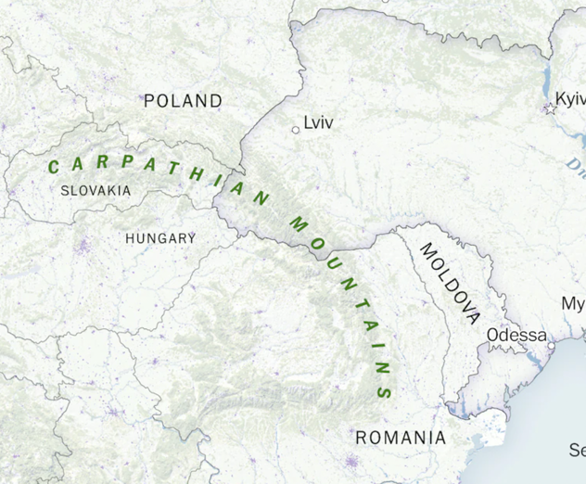
The Carpathian Mountains
A mountain range runs through Ukraine’s west, forming a natural barrier that stretches from Romania through Slovakia. The higher-ground vantage points of its peaks made them coveted territory in past conflicts. Russians battled Austro-Hungarian troops during the winter of 1915 in World War I, and soldiers froze in the snowy terrain.

But the mountains wouldn’t factor in a potential Russian invasion today, analysts said. There’s been no recent Russian military presence detected in that area.

The Black Sea
In Ukraine’s south is the Black Sea, an important body of water that serves as the country’s shipping route with its connection to the Mediterranean. The Black Sea has been the site of numerous conflicts throughout history, including the Russo-Turkish wars, the Crimean War in the 1850s and World War II. Image 8: The Carpathian Mountains Source: Washington
Post
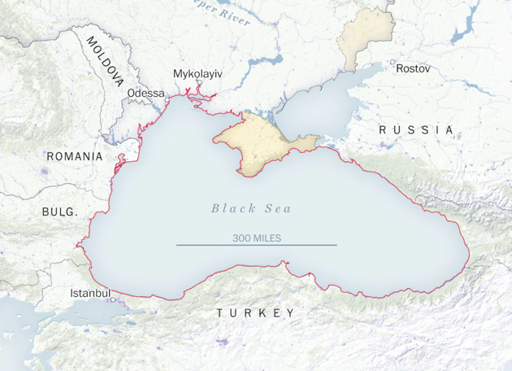
In 2014, Russia annexed Crimea, giving the country expanded access to the sea.

Now, CNA said: “The Russian Navy depends on transit through the Black Sea for supplying military presence in Syria and for rotating ships in and out of its Mediterranean squadron.”

Since 2014, the organization added, the Russian navy’s Black Sea Fleet has “expanded and modernized.” Twenty of its ships were recently “engaged in a major naval exercise in the Black Sea,” as part of a “large-scale naval exercise involving all Russian fleets.”

Other Western naval vessels enter the Black Sea periodically, but those that stray too close to Crimea often face brushes with Russian warships, Image 9: The Black Sea. Source: Washington
as Moscow sees these moves as a direct challenge to its annexation of
the peninsula.

‘The Zone’
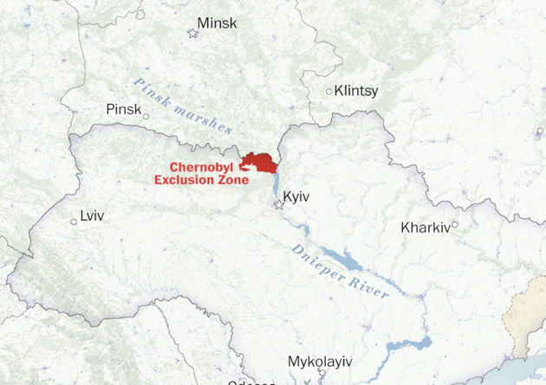
Russian forces seeking the most direct route to Kyiv could run into another obstacle: Chernobyl. The site of a nuclear disaster in 1986, the 1,000-square-mile zone is heavily restricted to keep people safe from radioactivity still embedded in the ground.

In November, Ukraine deployed border guards to patrol the area as tensions with Russia and Belarus heightened. While certain areas are safe to occupy for some time, the explosions and artillery fire of warfare in the area could be dangerous.

“The delivery of air-to-surface munitions, artillery, mortar and multiple rocket-launcher fire in the Belarus-Ukraine border area could also disperse radioactive debris in the soil,” said Russian military analyst Pavel Felgenhauer.

Image 10: The Zone. Source: Washington

RESOURCE G: How Russia’s invasion of Ukraine may play out

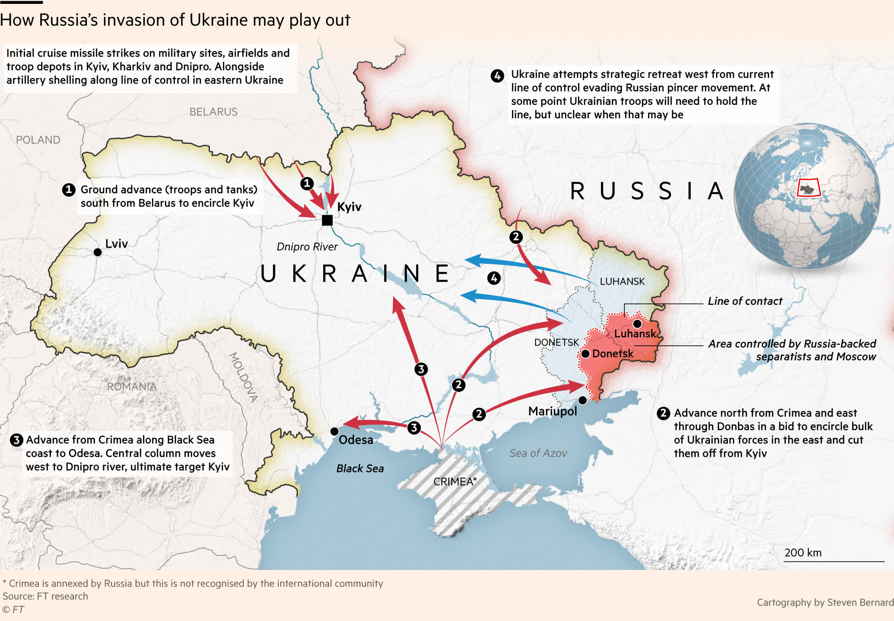
Figure 4: Map of potential Russian invasion routes. Source: ft.com.

Acknowledgements

Material from the following sources has been adapted for use in this examination.

RESOURCES A & F – Wetlands and radioactive soil: How Ukraine’s geography could influence a Russian invasion
https://www.washingtonpost.com/world/interactive/2022/ukraine-russia-invasion-geography-weather/

RESOURCE B: Ukrainian culture
https://www.britannica.com/place/Ukraine

RESOURCE C: Russia and Ukraine: the tangled history that connects—and divides—them
https://www.nationalgeographic.com/history/article/russia-and-ukraine-the-tangled-history-that-connects-and-divides-them?loggedin=true

RESOURCE D: Putin Calls Ukrainian Statehood a Fiction. History Suggests Otherwise. https://www.nytimes.com/2022/02/21/world/europe/putin-ukraine.html

RESOURCE E: The 20th-Century History Behind Russia’s Invasion of Ukraine
https://www.smithsonianmag.com/history/the-20th-century-history-behind-russias-invasion-of-ukraine-180979672/

RESOURCE G: Russia’s invasion of Ukraine in maps.
https://www.ft.com/content/4351d5b0-0888-4b47-9368-6bc4dfbccbf5

