Two-year rāhui for Waiheke Island waters to protect kaimoana
31 Jan, 2021 03:25 pm By Te Aorewa Rolleston of RNZ
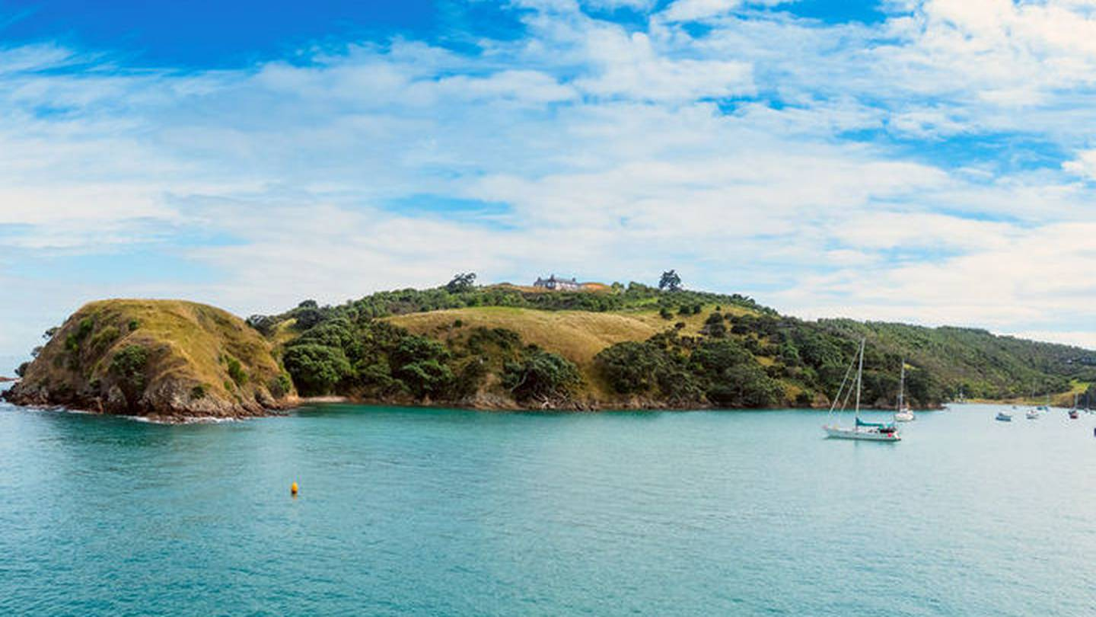
Mana whenua on Waiheke island are placing a two-year rāhui on the island in a bid to stop four species of kaimoana from collapsing.
The iwi, Ngāti Pāoa, has been worried for years about declining inshore biodiversity on the Hauraki Gulf's most populated island.
And with community support, a restriction is being imposed from this weekend.
Ngāti Pāoa kaumātua and tohunga were to lead a dawn ceremony on Sunday morning, to place a rāhui on the waters surrounding the island.
It follows a series of hui with the community and mana whenua about the need to restore declining numbers of scallops, mussels, crayfish and pāua.
The rāhui will apply from the foreshore to 1 nautical mile out to sea.
Ngāti Pāoa spokesperson Herearoha Skipper said some of the species can no longer be found around the island.
"There's nothing to actually take anymore, so that's the real concern for our iwi. So it was quite a simple, easy decision to make, to actually put on the table that we need to lay down a rāhui to restrict everyone from taking particularly species that are now extinct," Skipper said.
Kaumātua had been worried about the situation for years and now they wanted urgent action.
Ministry for Primary Industries (MPI) national manager for fisheries compliance Steve Ham said MPI was considering the iwi's application for a temporary closure and once it was granted it will enforce the restrictions.
"MPI will work with the local communities and obviously through publications, through pamphlets, on our website, on the NZ Fisheries app, to notify of any temporary closure that goes into place and once that closure is put in place then they can enforce the rules and areas to restrict" Ham said.
Waiheke local board chairwoman Cath Handley said the iwi had shown great leadership and the community supported the proactive stance.
The Waiheke community would support a rāhui that covered more species, she said.
"The response was overwhelmingly positive, to their (Ngāti Pāoa) proposal, in fact many people wanted it to go further than it does because it specifies four species. There is a great deal of will on Waiheke for significant marine protections for the Hauraki Gulf," Handley said.
The Government should have addressed the threat much earlier and Ngāti Pāoa had sped up the process for protecting the Hauraki Gulf, she said.
Ngāti Pāoa said it would introduce a management plan including signs, boundary markings and marine monitoring.
People who break the rāhui could be prosecuted under the Fisheries Act, Ngāti Pāoa said.

