POPULATION PYRAMID CHALLENGE:

1. The following population pyramid is of a town in North Dakota called Grand Forks. According to a census, the city's population was 52,838.

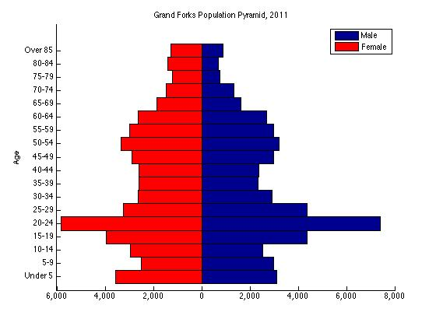

Describe two features of the population structure of this community of Grand Forks.

Suggest reasons for the population pyramid to be like this in Grand Forks.

2. What is this population showing? Suggest THREE reasons why there are many more females than males in this location.

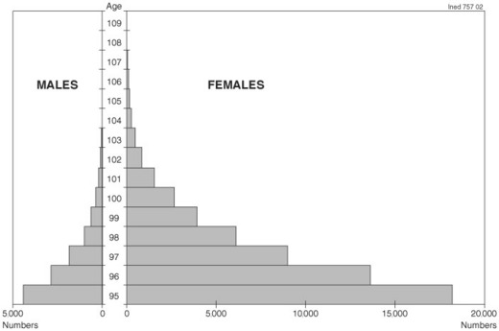

3. What is this population showing? Suggest THREE reasons why there are many more males than females in this location.

