Graph interpretation

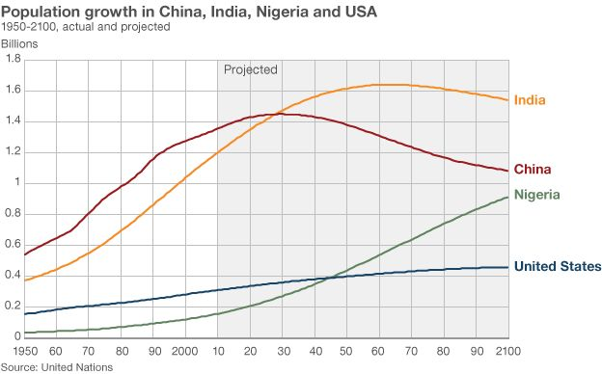

- Which countries have the higher natural increase in population? How can you tell this from the graph?

- In approximately 2027 (according to the graph), China’s population is going to be overtaken by India. What factors will cause this to happen?

- List the factors that you think would influence a country to have a high birth rate.

- List the factors that you think would influence a country to have a high death rate.

- If a country has a declining death rate, but still a high birth rate, what does this mean for population growth?

- What part of the World is shown to have an increase in growth rate over time – what impact might this have?

