This line of **latitude** is called the Tropic of Antarctic Circl .

It is 66.5 degrees sout of the equator. . .

This line of **latitude** is called the Antarctic Circle .

It is 66.5 degrees sout south hhhh of the equator. .equator ..

This line of **longitude** is called the .

Name:

Mapping lines of latitude and longitude

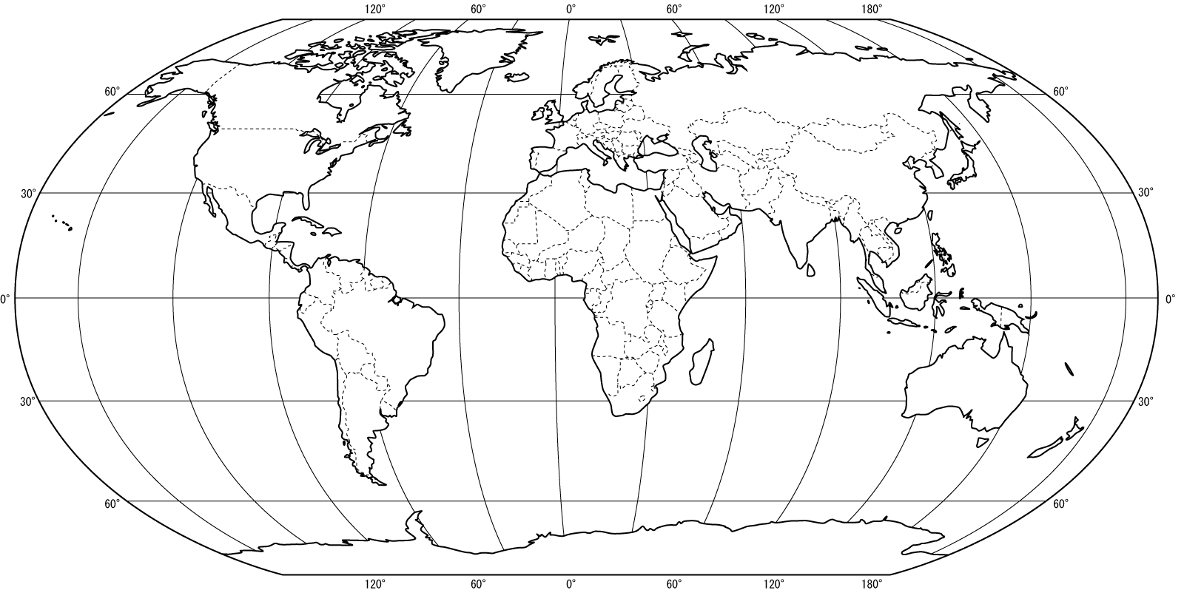

This line of **latitude** is called the equator

This line of **latitude** is called the Tropic of

quator . It is degrees of the .

This line of **latitude** is called the Antarctic Circle .

It is 66.5 degrees sout of the equator. ..

Extension Questions

1. On the map draw and label the International Date Line.
2. (In your book) Can you explain what the International Date Line is?
3. (In your book) In as much detail as you can explain why the Prime Meridian is in Greenwich, England.