Scholarship Geography Workshop One
Presented by AGTA and School of Environment, University of Auckland

Introduction to Scholarship Geography

Outcome Description
The student will use knowledge of geography to critically analyse a geographic context.

Scholarship Performance Descriptor
The student will demonstrate aspects of high level:
- analysis and critical thinking
- integration, synthesis, and application of highly developed knowledge, skills, and understanding to complex situations
- logical development, precision and clarity of ideas.

Outstanding Performance Descriptor
In addition to the requirements for Scholarship, the student will also demonstrate, in a sustained manner, aspects of:
- perception and insight
- sophisticated integration and abstraction
- independent reflection and extrapolation
- convincing communication.

In 2019, the examination questions and resource booklet will focus on the significance of geographic location in a global context.
Some resource materials (such as maps, text, photographs, models, graphs, tables, and cartoons) related to this theme will be provided to assist candidates.
Candidates will be required to complete questions that involve critically analysing, processing, selecting, extracting, justifying, predicting, integrating, and presenting information.
Candidates will be required to include relevant original visuals that will enhance their answers.
Candidates will be expected to demonstrate understanding of a range of geographic perspectives and to use their geographic knowledge, skills, and understanding to support their answers.

Notes:

Find further information about Geography scholarship here: http://bit.ly/1VW7Fi1

One of the key thing’s that students must be able to do in the Scholarshsip Geography examination is to be able to answer the question that is asked. This involves you having a clear understanding of the command (instructional) words.
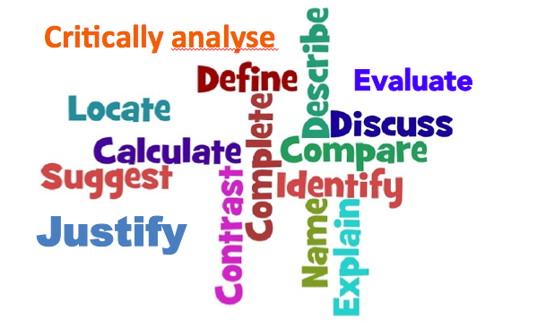
In Level 3 Geography, you have been using the command words such as: Analyse (externals and internals); Justification (internals such as the current geographical issue) and Evaluation (internals - global and research).

Scholarship Geography is generally a step up from these phrases to include phrases such as:

Critically evaluate - When you critically evaluate in an essay, you need to decide on your subject's significance, value, or quality after carefully studying its good and bad features. (similar to Assess)

Critically analyse - When you critically analyse something you consider it carefully and in detail in order to understand or explain it. To analyse, identify the main parts or ideas of a subject and examine or interpret the connections between them.

Discuss - To discuss in an essay, you need to consider your subject from different points of view. Examine, analyse and present considerations for and against the problem or statement.

Justify - When asked to justify a statement in an essay you should provide the reasons and grounds for the conclusions you draw from the statement. Present your evidence in a form that will convince your reader.

To what extent – this means you need to discuss the particular degree to which something is or is believed to be the case.

Consider these possible examination questions as they relate to our topic:

Critically evaluate the significance of location for the development of different nations. Justify your answer.

Discuss how geographic location restricts or enhances the development of a country?

To what extent does location affect the resource development of a country or region? Use examples/case studies from across the globe to support your answer.

One of the key ideas that students are required to do in the scholarship Geography examination is to include relevant original visuals that will enhance their answers.

Read the following excerpts from the article on the World’s Most strategically located countries

The World’s Most Strategically Located Countries
The most strategically located countries are due to geography, regional /border influence, and access to vital trade routes. As a result, some states are more fortunate than others.
We have
- Choke-Point countries (Panama, Iran, Turkey, Egypt, Indonesia-Singapore-Malaysia, Saudi Arabia, Spain & Portugal) for their ability to control sea lanes.
- Crossroads countries (Georgia, Kazakhstan, Pakistan, Afghanistan) for their importance to land trade.
- Not too isolated countries (the United States, the United Kingdom, Japan)
- Central countries (Germany, China, Denmark) are the largest nations in important neighbourhoods.
- Superpower-adjacent countries (India, Taiwan) since superpowers take particular interest in these countries.

Choke-Point countries Situated in the Anatolian plateau of West Asia is Turkey.
The country spans between Europe and Asia, forming a land-bridge that borders the Levant (Iraq and Syria), Iran, the Caucasus (Georgia, Azerbaijan, and Armenia), and South Eastern Europe (Greece and Bulgaria). As a result, it controls access to both the Black Sea, and the Mediterranean Sea via the Bosporus and Dardanelles strait.
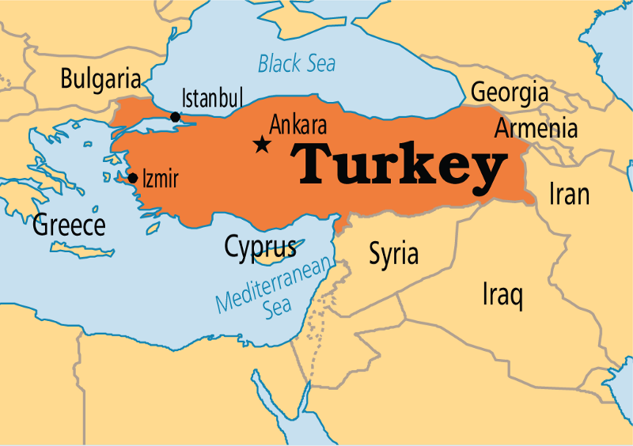
Key geographic challenge: to create economic development in the eastern region of the country. Also, manage the Kurdish insurgency in its south-eastern provinces along the Taurus Mountains, and the Eastern Anatolian plateau. Finally, balance the ever-changing geopolitical dynamics near its borders; growing Iranian influence in Syria and Iraq, and Russia’s expansionary move in the Caucasus.

Turkey as a Land bridge spanning between Europe and Asia

Crossroads countries At the crossroads between Central Asia and South Asia lies Afghanistan.
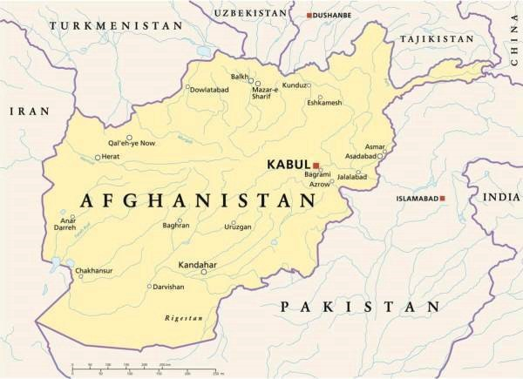
Any power who controls Afghanistan control the land routes between the Indian subcontinent, Iran, and Central Asia. Afghanistan’s position at the crossroads of Central Asia, the Middle East, and the Indian subcontinent led to invasions by external actors with diverse languages, cultures, and tribes (Pashtun, Tajiks, Turkmens, and Uzbeks). Bordered by Iran on the West, Pakistan — East; and Turkmenistan, Uzbekistan, and Tajikistan — North, its importance is immense. Also, it shares a tiny stretch of border with China in the North-East, the Wakhan Corridor. Afghanistan is a crucial crossroad for trade with Central Asia, Russia, and Europe.
Key geographic challenge: maintain strong authority over the immense territory across the rugged landscape, diverse language, and ethnic tribes.

Not too isolated countries In North-western Europe is the United Kingdom.
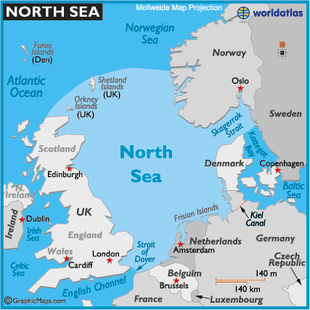
The United Kingdom consists of the island of Great Britain, the North-eastern part of the island of Ireland and many smaller islands. The country is surrounded by the Atlantic Ocean, the North Sea, the Irish Sea, and the English Channel. The UK detachment from Continental Europe offers its protection against potential invasion from mainland Europe. Britain control of Gibraltar and subsequently the Strait of Gibraltar. The Strait controls access to the Mediterranean from the Atlantic and separates Europe from Africa.
Crude oil, LPG and consumer goods exporters from the Middle East and Asia can easily export their cargoes through the Mediterranean Sea via the Strait to Britain. Situated in sight of unstable North Africa, Sahel belt, where Islamist extremism is increasing, the strait is vital for Britain’s national security. The UK is determined to keep the Strait for communications and intelligence reasons and to monitor traffic in the Strait of Gibraltar which separates Europe from Africa.
Key geographic challenge: manage the four constituent countries of England, Wales, Northern Ireland and Scotland. Also, preserve control over the surrounding seas (the North Sea to the east, the English Channel to the south and the Celtic Sea to the south-west, the strait of Gibraltar, and the Irish Sea) for dominance of the Mediterranean and the Atlantic Ocean to defend its trade and economic interest and national security.

Central countries Between Russia, mainland Southeast Asia, the Indian subcontinent and Central Asia lies China.
It more than 14500 km-long coastline borders the Yellow Sea, East and South China Seas. Also, It has the most significant number of neighbours (14) sharing its 22,000 km of land borders. China is vital for trade with South East Asia (Malaysia, Singapore, Myanmar, Vietnam, and Laos), India subcontinent (Bhutan, India, Nepal, Pakistan), Central Asia (Kazakhstan, Kyrgyzstan, Tajikistan), East Asia (South Korea, Japan, Mongolia, Taiwan), and Russia’s far east.
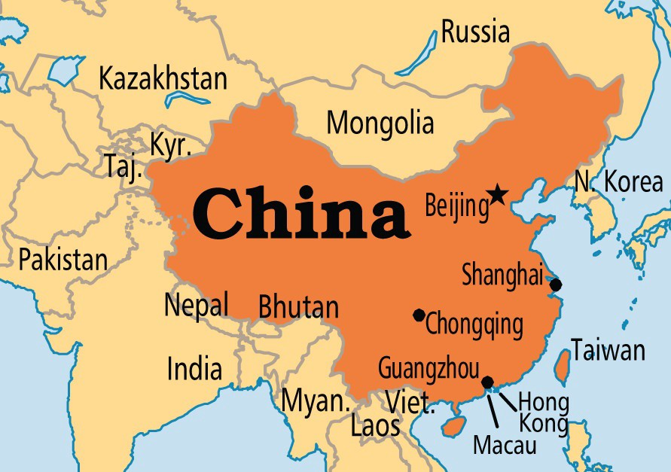
Key geographic challenge: protect its heartland along the Yellow River, the Yangtze and the Pearl River by developing a blue water Navy to defend the South China Sea, and the Yellow Sea. These trade routes are crucial for China to export its products to Europe, Asia, and Africa without hindrance.

Superpower-adjacent countries Strategically located between the Middle East and South-East/East Asia is India.
To the South West is the Bay of Bengal, the Arabian Sea, and the Indian Ocean. It bordered by Pakistan (North West), China (North), Nepal (Centre), Bhutan (North East), Bangladesh & Myanmar (East), and Sri Lanka at the South. India controls the Indian Ocean.
Despite its vastness, the Indian Ocean has immense economic and strategic importance for India. A majority of India’s sea-trade transits through the Ocean. The Indian Ocean is India’s main gateway to European and African Markets. The Indian Ocean is home to choke points of the Straits of Malacca and Hormuz and Malacca — narrow corridor through which most of the world’s trade, and around 33 million barrels of crude oil flow towards Europe and Asia daily. 70% of India’s crude oil and LNG supplies flow through the Indian Ocean.
Key geographic challenge: develop massive naval capabilities to secure its critical supply routes along the Indian Ocean against China.

Creating diagrams

You have part of an article on The World’s Most Strategically Located Countries

Alongside the person sitting next to you create a diagram to show why your area (to be allocated on the day) has advantages and disadvantages in terms of its geographic location – consider aspects such as trade, inequalities, position on the globe itself, climate and weather, exposure to natural disasters and geopolitics.

Critically evaluate the significance of location for the development of different nations. Justify your answer.

How significant is location…..

Justification - this means you must show/prove to be reasonable why this is the most significant factor.

The reasons why I think this is because …….

And

And

