Topic for the year

Share resources on the topic on some form of social media platform or via your school intranet system.

I use FB.

Get students to comment and discuss articles alongside the theme for the year.

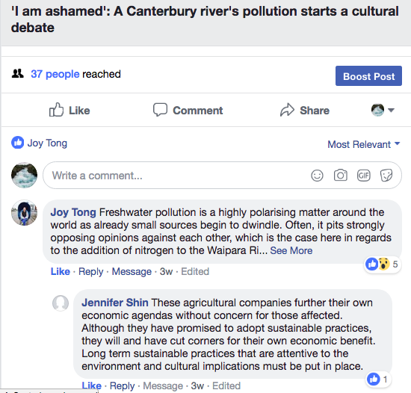

Students encouraged to read around the topic which they can find or you.

Maybe plan an essay on the topic e.g. Discuss how differing access to freshwater can affect the development of a country

Write an introduction to this essay

Course Outline 2018

- Explanation of the scholarship standard, the
assessment specifications and the terminology

Specific learning activities:
What is scholarship? Why do it?
What is the standard?
What are the assessment specifications?
Understand the terminology used in the examination?
What the year will bring…

- Command words

Specific learning activities:
The activity here is to get students to really understand the words they will be faced with in the examination
- Eg
- Justify why you should be allowed out on Saturday night
- Discuss the pros and cons of single sex schools
- Compare two/three different girls schools in Auckland
- Evaluate the impacts that the….. has had on……

- Looking at old exam papers – 2014 – 2017

Specific learning activities:
Students divide into groups and look for common themes
on the types of questions asked in the past
– report back to the group

- Writing skills – Planning

Specific learning activities:
What makes good writing?
Planning is critical – see ppt on this
Students critique previous students plans

- Writing skills – Introductions

Specific learning activities:
Go over the point of an introduction in Scholarship
Look at examples
Write some introductions to essays (not related to the topic)
Critiquing introductions
Along the way get students to complete tasks around the topic e.g. writing a body paragraph

Read resources and share them with each other

Watch various youtube clips

Critiquing previous students work e.g. from the NZQA website

- Using the resource booklet

Specific learning activities:
To give students ways of using the resource booklet

- Writing skills – Body paragraphs

Specific learning activities:
(see powerpoint)

- Writing skills – Including visuals in essays (two lessons)

Specific learning activities:
Why should we include visuals?
Different types of visuals
Have fun creating visuals
Discuss the pros and cons of the visuals
Critique visuals.

- Writing skills – including Perspectives

Specific learning activities:
Discuss perspectives with students - what exactly are they?
Read articles from different perspectives – discuss and role play with the students.

- Practice writing – critiquing

