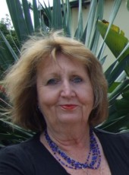
McCann Publications

Jean McCann
Educational Writer and Contractor

Email: jean.mccann@xtra.net.nz

AS 91431
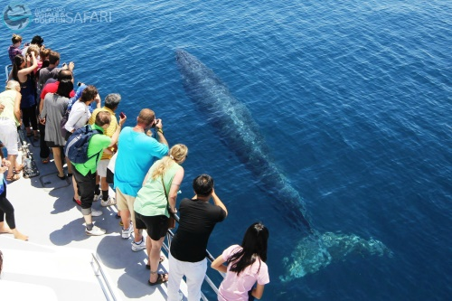
The Issue: The Hauraki Gulf – an ecosystem under pressure”
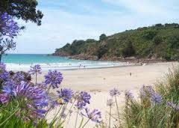
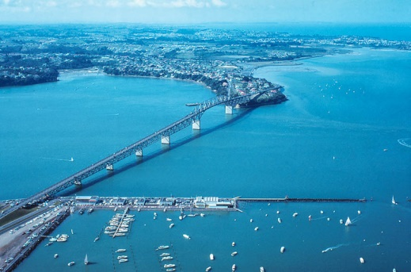
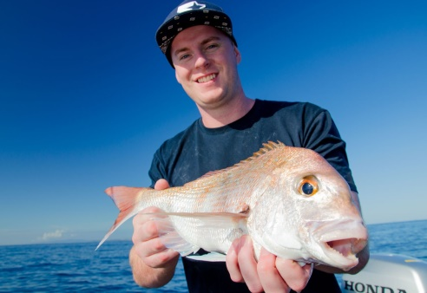

All the work is done for you. This is a new resource comprising:
- A guide for Teachers covering the “how to” including suggested approaches and the marking criteria.
- A marking schedule with full explanation of how to interpret the standard and differentiate between the grades.
- A colourful assessment resource for students with internet sites for further individual student research.
- An assessment task with full explanations for students.

This assessment package has everything and has been carefully compiled to meet NZQA standards.
A total of $60 for the resources.
Order today.
jean.mccann@xtra.co.nz

