McCann Publications

Jean McCann
Educational Writer and Contractor

Email: jean.mccann@xtra.net.nz

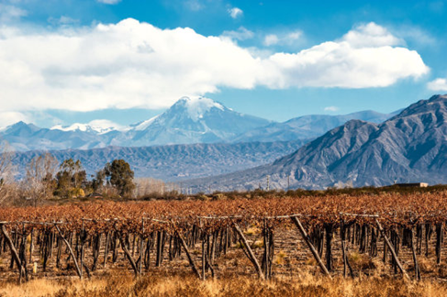
The global topic of Fold Mountains AS91246
An easily understood global topic and assessment task for Level 2 students.
The Andes Mtn Range, S America stretching 7000km from N to S.
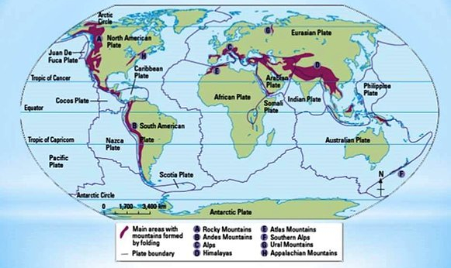
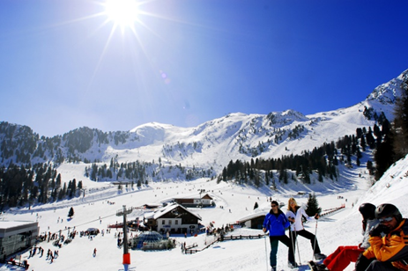
Tourism in the Alps
All the work is done for you. This is a new resource comprising:
- A guide for Teachers covering the “how to” with a cover page with the marking criteria, a marking schedule with full explanation of how to interpret the standard and differentiate between the grades.
- A PowerPoint on the requirements of the standard 91246 with explanations and handy hints to show the students.
- A colourful assessment resource for students with internet sites for further individual student research.
- An assessment task with full explanations for students.
This assessment package has everything and has been carefully compiled to meet NZQA standards. A total of $80 for all the resources.
Order today.
jean.mccann@xtra.co.nz

