McCann Publications

Jean McCann
Educational Writer and Contractor

Email: jean.mccann@xtra.net.nz

Level 3 Issue: AS 91431
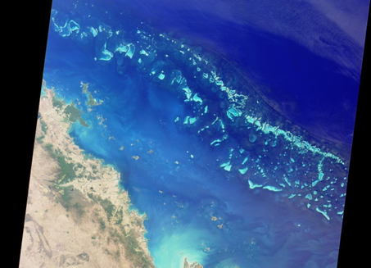
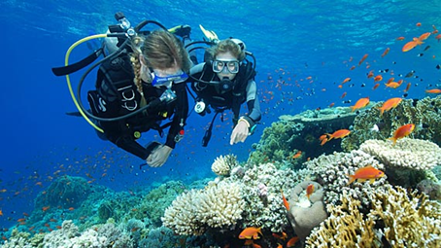
The on-going deterioration and future sustainability of the Great Barrier Reef.

A fascinating issue which will fully engage your students’ attention!
Show your students David Attenborough’s series on the Great Barrier Reef as an Introduction to the Issue https://www.youtube.com/watch?v=zW1uLmsUsh0
This can be used as a stand-alone Assessment Task or as a companion to L3 Global Topic of Tropical Coral Reefs. Why?
Internal Standards take up too much teaching time in Level 3 which teachers and students can ill afford. Why not use the same topic for two standards.
All the work is done for you. This is a new resource comprising:
- A guide for Teachers covering the “how to” with a cover page with the marking criteria.
- A marking schedule with full explanation of how to interpret the standard and differentiate between the grades.
- A colourful assessment resource for students with internet sites for further individual student research.
- An assessment task with full explanations for students.
This assessment package has everything and has been carefully compiled to meet NZQA standards. A total of $60 for all the resources.
Order today.
jean.mccann@xtra.co.nz

