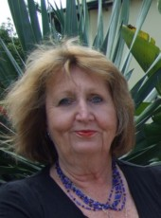
McCann Publications

Jean McCann
Educational Writer and Contractor

Email: jean.mccann@xtra.net.nz

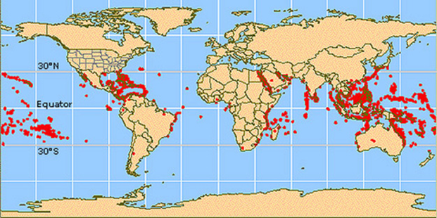
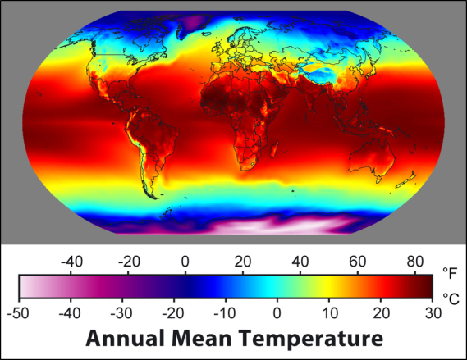
The global topic of Tropical Coral Reefs
AS 91432
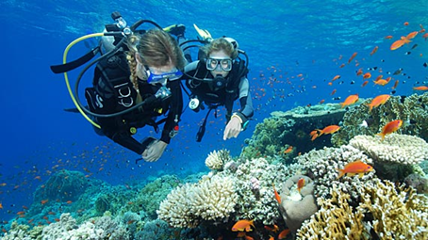
Tropical Coral Reefs are a fascinating and colourful topic for Level 3 students.

All the work is done for you. This is a new resource comprising:
- A guide for Teachers covering the “how to” with a cover page with the marking criteria.
- A marking schedule with full explanation of how to interpret the standard and differentiate between the grades.
- A PowerPoint on the requirements of the standard 91432 with explanations and handy hints to show the students.
- A PowerPoint on Tropical Coral Reefs to intrigue and enthral them as an introduction to the global topic.
- A colourful assessment resource for students with internet sites for further individual student research.
- An assessment task with full explanations for students.
This assessment package has everything and has been carefully compiled to meet NZQA standards. A total of $80 for all the resources.
Order today.
jean.mccann@xtra.co.nz

