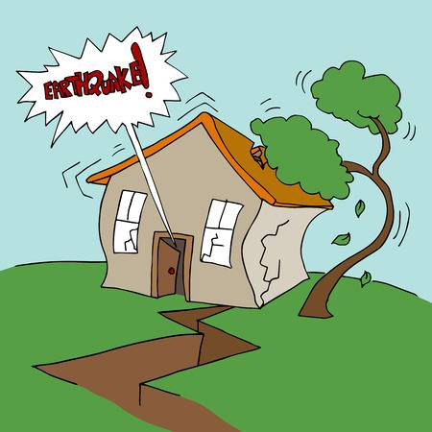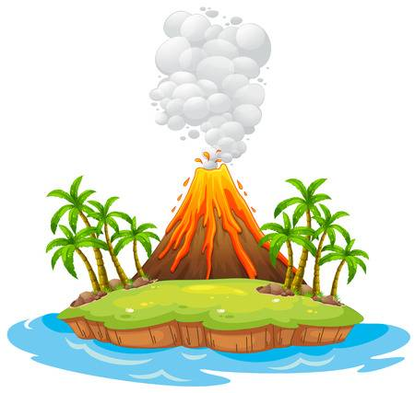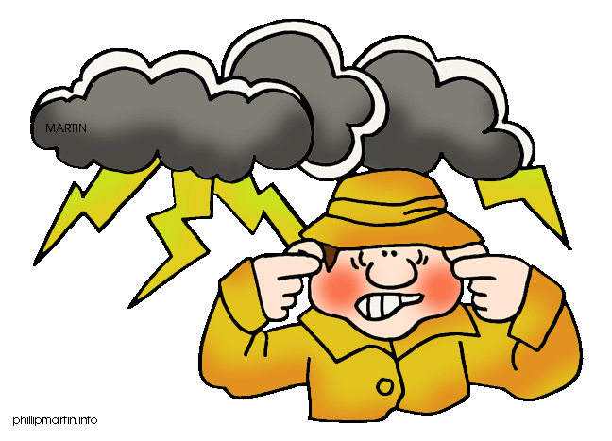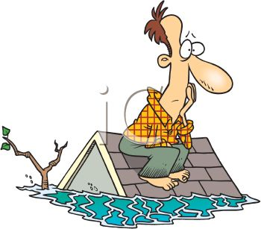
Disaster and Conflict
Are you interested in …
- Why volcanoes blow their tops? OR What causes the earth to “shake, rattle and roll” during an earthquake?
- How people cope and survive in extreme situations?
- Why people can’t always agree on what should/shouldn’t be done to resolve an issue or problem?
Do you like to learn …
- By studying real life situations and contexts – such as the volcanic eruptions in Kīlauea, Hawaii or how to solve the problem of our polluted beaches.
- Through collaborating, communicating, doing research, using your critical thinking skills and fieldwork - “getting out and doing stuff”- such as the optional fieldtrip to Rangitoto – a volcanic island in the Hauraki Gulf.
Year 11 GEOGRAPHY has 2 x 6 month courses.
Choose to do 1, or even better, DO BOTH!

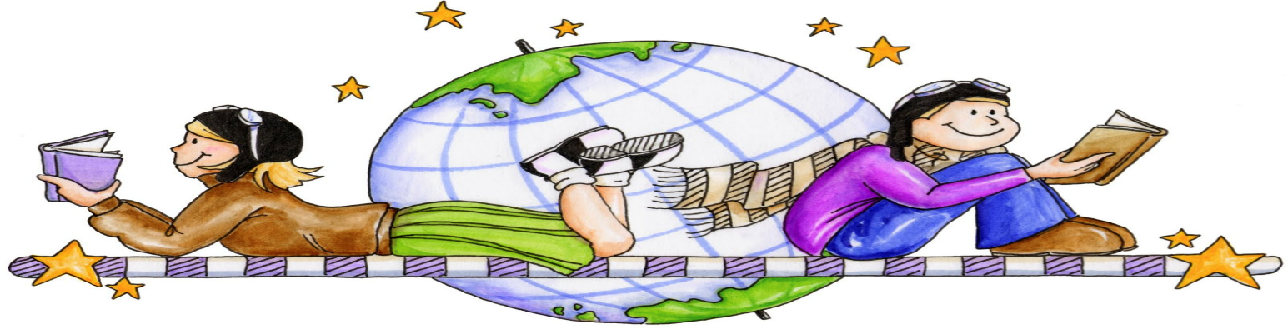
Explore and Experience
Are you interested in …
- Exploring the world around you by using Google Earth, Virtual Reality Google Glasses, other online digital tools, basic geographic skills and basic orienteering.
- Finding out about your ancestry – where am I from?
- Sustainable environments – are we doing enough or could we be doing more?
Do you like to learn …
- Through practical indoor/outdoor activities, studying real life situations and contexts, and fieldwork, “getting out and doing stuff”, such as the optional fieldtrip to The Poor Knights Island – a marine reserve located on the east coast of Northland.
- Through collaborating, communicating, doing research and using your critical thinking skills and effective presentation skills.

