Mapping questions – Waitakere Ranges

Instructions:
- Use the laminated topomap of Waitrakere Ranges to find the answers.
- Use this sheet as a question sheet and write your answers in your own exercise book.
- You will need a ruler & a protractor.

Key

- Draw and label the key symbols for the following: railway bridge, railway tunnel, height elevation in meters, cliff, terrace, slip, dam, waterfall, rapids, watercourse.

Location

- What is located in grid square 3903? 3103? 3398?
- What is located at 6 figure grid reference 448999? 430021? 415032?

Direction

If you were standing at 430021 name the compass direction of the following places:
- Big Bay (4599),
- Little Huia (3802),
- Spragg Monument (4103).

If you were standing at Spragg Monument (4103), state the bearing to the following places: (Use a protractor and measure the number of degrees starting from north, going clockwise. EG East is 090, South is 180.)
- The beacon at Manukau Heads (3398)
- Lion Rock (3009),
- Jakie Hill, Te Ka a Maki (3801)

Distance

A linear scale is shown in the bottom South West corner of the map. Use it to calculate
- The width of the narrowest section of the Manukau Entrance.
- The straight line distance between Ninepin Rock (3398) and Karekare Point (3104).
- What is the distance if you travelled along the beach between Ninepin Rock and Karekare Point?

Land use

- What is the main landuse in grid square 4507? 3505? 3905?
- Describe the relief (height and shape of the land) of the squares 3505 -> 3805?
- What are three cultural impacts shown on the map? Give evidence for each.
- Two streams start within 100m of each other – 359056 & 362056. Where do they meet the ocean? Suggest why they go in different directions.

Altitude

- What is the name of the water body at 3905? What height is the water at? (Use contour lines to figure this out.)
- Why is the water not at zero?
- What is the name and location of the highest point on the map?

From where was this picture taken?

- Find the Lower Nihotupu Reservoir (found in grid square 4308). State an approximate location (six figure) location of the photographer. Which direction is the camera pointing?
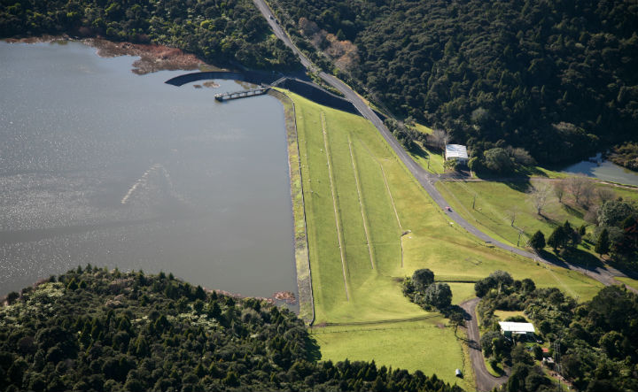

Describe the journey

- Describe in words the journey if you walked from the intersection at 419041 along the Karangahape Peninula to MacLachlan Memorial. Describe the journey you would travel.
For example: As you set off you will walk for 3km along a dusty road, then across some farmers fields before climbing a steep hill. The top of the hill will be 550m tall and you will be able to see the Lake Turner, and the exotic forest. You finish your journey as you meet the state highway.

