Geogrefresh – is it time to refresh your knowledge of the world?

- Largest islands of the world

Correctly identify these islands of the world from largest to smallest:
New Guinea
Baffin Island
Victoria Island
Sulawesi
North Island (NZ)
Luzon
Australia
Borneo
Sumatra
Great Britain
South Island (NZ)
Newfoundland
Iceland
Greenland
Madagascar
Honshu
Ellesmere Island
Java
Vuba
Mindanoa
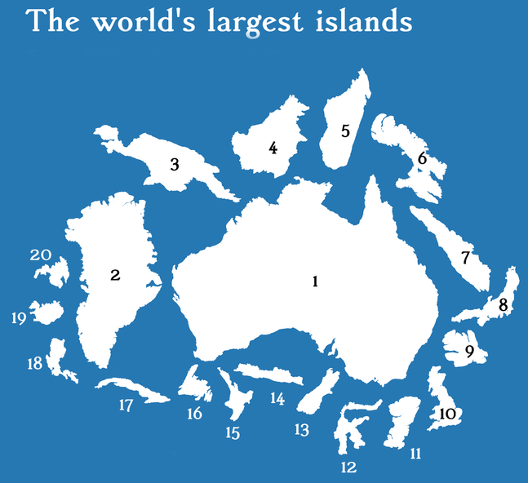

Image sourced from https://bradjballard.com/2017/11/25/the-worlds-largest-islands/

- Oceans - smallest to largest

Correctly rank the five main oceans of the world from largest to smallest:

Indian - Atlantic - Pacific - Arctic - Southern

- Longest rivers of the world

Correctly identify the continent of origin of the longest 10 rivers on Planet Earth:

River
- The Nile
- The Amazon
- The Yangtze
- The Mississippi
- The Yenisei
- The Yellow / Huang He
- The Ob
- The Paraná
- The Congo
- The Amur

Continent

- Which is not a desert?

Mojave - Namib - Great Sandy - Sahara - Kalahari - Chihuahuan - Arctic - Gobi - Thart - Thompson - Simpson - Kyzyl Kum

Answer:

- Seven summits

The “Seven Summits” are mountaineers ultimate goal: to summit the highest mountain on each of the seven continents of the world.
Can you correctly pair each of the seven summits below with the correct continent?

Mountain

- Everest
- Aconcagua
- Denali
- Kilimanjaro
- Elbrus
- Puncak Jaya
- Vinson
Continent

- North America
- South America
- Africa
- Europe
- Asia
- Australasia
- Antarctica

- Name changers

Countries change their names all the time, which makes life a little confusing for Geographers. Below are a list of countries who have since changed their names. Can you correctly guess what these countries are known as today? The year they changed their name is in brackets next to the country.

Former name...  - Czech Republic (2016)  - Kingdom of Serbs, Croats and Slovenes (1929)  - Persia (1935)  - Transjordan (1949)  - Upper Volta (1984)  - Dahomey (1975)  - Zaire (1997)  - Rhodesia (1980)  - Abyssinia (1941)  - Swaziland (2018)  - Ceylon (1972)  - Siam (1948)  - Burma (1989)  - Kampuchea (1990)  - Western Samoa (1997) | Known today as…

- Baby countries

Some countries, having separated from others or declared independence, are much younger than others. Below is the list of the 10 youngest countries. Can you match them with their year of independence and get them in order of oldest to eldest?

Country

- Montenegro & Serbia
- Palau
- Bosnia & Herzegovina
- Kosovo
- Timor Leste
- Eritrea
- Slovakia & Czech Republic
- South Sudan
- Kazakhstan
- Iraq
Year of independence

- 1991
- 1992
- 1993
- 1993
- 1994
- 2002
- 2003
- 2006
- 2008
- 2011

Youngest

Eldest

