AO’s:
7.1: Understand how the processes that shape natural and cultural environments change over time, vary in scale and from place to place, and create spatial patterns.
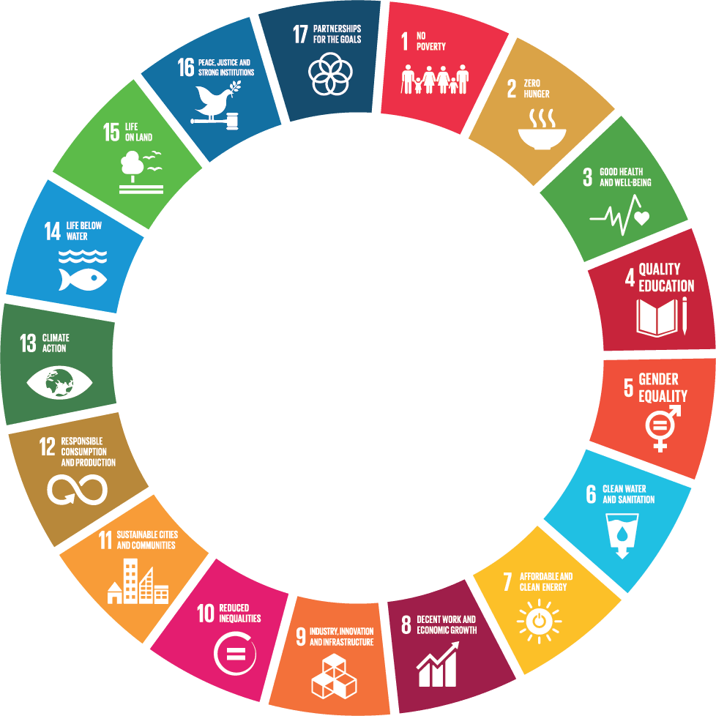
7.2: Understand how people’s perceptions of and interactions with natural and cultural environments
differ and have changed over time.

Context for study
- Sustainable development goals and Marine reserves

Learning outcomes:
- Sustainable development goals
- Why are the SDGs so important globally, regionally (Pacific) and for NZ
- The Global, Pacific and New Zealand’s fishing industry
- The significance of marine reserves

Conceptual understandings:
- Natural environments are the result of processes interacting and they change over time
- People and the environment interact making some cultural and natural environments vulnerable,

Key Concepts:
- Environments: Natural
- Interaction: between groups of people in the decision making process
- Perspectives: of different groups of people on the issue of a new marine reserve
- Taonga – the fishing resource as a treasure for local iwi

Principles:
- High expectations: aiming to meet E criteria in assessment
- Community engagement: considering their actions and wider involvement in NZ when it comes ot fishing and personal fish consumption
- Future focus: how they will conduct themselves morally in business environments, as tourists etc
- Inclusion and diversity: understanding the needs of a range of groups of people and their perspectives, both context related and inside the classroom
Values:
- Social, economic and environmental sustainability
- Empathy with other experiences
- Community involvement for the common good

These will be developed by
- Exploration of a range of perspectives and stories the importance of the fishing resource globally, in the Pacific and in NZ
- Reflections on actions taken by agencies/groups with regard fishing and the consequences of these
- Encouraging an understanding of how we need to be aware of the needs of communities with regard to regulations regarding fishing
Key Competencies:
- Thinking: evaluating opinions, considering consequences of actions
- Using language, symbols and text: maps, graphs, newspaper articles, completing diagrams, glossary of new words
- Managing self: to listen and gain information from learning activities
- Relating to others: understanding other perspectives, and empathy for others experiences
- Participating and contributing: to group work in particular.
Geographic Skills:
Mapping, analysis of data from resources, synthesis of information from a variety of sources, understanding perspectives and viewpoints, essay writing,

Assessment:
- Diagnostic: class discussion regarding previously considered geographic issues, discussions about the language of the standard (intro slides), group work contributions and questions
- Formative: worksheets, discussions and class work
- Summative: internal assessment

Suggested Learning Sequence
- Introduction to the Sustainable development goals – what are they?
- Why are the SDGs so important globally, regionally (Pacific) and for NZ
- Global, Pacific and NZ fishing industry
- New Zealand’s fishing resources
- What is the nature of the issue – location, who is affected, where he issue is taking place…
- Explaining the different viewpoints individuals (or groups) hold in relation to the issue
- Explaining how one viewpoint has or could change over time
What are the possible solutions, proposing a solution and justifying the decision.

 | Lesson title | Activities | Resources
LESSON 1 | What are the main problems of the world? | ‘What are the biggest problems faced by people in our community/ country /worldwide?”  Students list as many ideas as possible  Then after 10 minutes or so students should start to categorise the ideas (in pairs)  Which of these problems are the most significant and why.  OR  Give students 10 * post-it notes  Ask them to walk around the room and note down the most important problem for each of the following things:  Health, Education, Land, Oceans, Women, Children, Business, Government, Cities, Health  - These can be posted onto Large A4 sheets – then categorised by a small group  - Report back to the class  Writing task  Students are to write the following on a google doc for marking.  Choose the most significant problem facing the world.  Give reasons (at least three) why this is the most significant problem –include examples to help you explain what the main problem is)  (Hand in – students should be writing around 200-250 words for this) | see PPT1  Padlet activity  https://padlet.com/maryr1/grs2kiygg4sw  Google doc writing task
LESSON 2 | What are the SDGs? | Watch the World’s Greatest Lesson – 6 mins introduced by Ken Robinson  www.globalgoals.org/worldslargestlesson.  Introduce the SDG’s  - Go through the ppt on the SDGs and discuss with the students the SDGs in general – two videos to watch also – they are embedded into the powerpoint | See PPT2
LESSON 2 and 3 | More on the SDGs | With students working in pairs get students to go around to different stations within the classroom to find out more about each of the SDGs 1-16.  At each station there are:  The goal  Sub goals  An infographic about the particular goal  Photographs  Students are to complete a summary of the key ideas of 8 goals, one question they have about the goal, and why they think this is an important goal to have the world work towards in 2030.  The worksheet also has a section for students to consider one question they have regarding that goal.  - Students need to write all of their questions on post-it notes and put them on the wall  Or  Use the website  https://sustainabledevelopment.un.org/sdgs  Students would click on the image then complete the activities.  Have students decide which Goal they think is most important, why, and how this goal is linked to the other goals, and write a paragraph explaining their choice. Students should refer to the information they gathered earlier from the eight problem stations.  To end the lesson, ask each student to write a sentence reflecting their views on the Global Goals and what they mean to them. @theglobalgoals #globalgoals  - Put these “tweets” on coloured card – for display. | Resource packets for goals 1-16  Worksheet  See page 4 handout  Post-it notes
LESSON 4 | The global goals in the Pacific and in NZ | Students are to identify which of the global goals are most significant for the Pacific and NZ  Using the website http://www.un.org/sustainabledevelopment/sustainable-development-goals/ and their knowledge about the following Pacific island nations  (Fiji, Tonga, Samoa, Cook Islands and NZ)  Get students (in small groups 3-4 students) to identify the main SDGs that are the most important ones to focus on and why.  Share with the class in group report back. | See page 5 handout
LESSON 5 | Exploring SDG 14 – Life below the Ocean | Finding Nemo  - Show the short clip embedded into the ppt on Nemo and friends experiencing fishing net woes  Discuss briefly the issue and get students to identify the relevant SDG  It is 14 – Life below water  But what others might be important too? | PPT3
LESSON 5 | Explore underwater | Google cardboard – explore underwater – have a fun lesson today.  https://youtu.be/7bBOw1HlqF8  https://youtu.be/K6xyPOttq7o  https://youtu.be/QitDU5QqHXs  https://youtu.be/hroZXF6ddhg | Google cardboard glasses – in the resource room  (I need to learn how to use these properly)
LESSON 6 | Problems of fishing across the globe | Read through Page 6 on the workbook with the class  Discuss how many people are earning their living from fishing – note to the students that most of these people are subsistence fishermen and women. (slide 1 and 2)  Then, note however that the damage is done by large industry  Show and discuss slide 4 and 5 – get students to see where the main patterns are  - They can annotate the map on page 7 and 8  Get students to read page 9 in the workbook and to summarise the main ideas of how overfishing is a problem  Show the clips embedded into PPT (if not enough time just show one)  - What is overfishing  - The consequences of overfishing  - How to stop overfishing  Then  Show clip on Slavery ate Sea  Link back these ideas to the SDGs | PPT4
LESSON 7 | Sustainable development of the fishing industry | Show slide 13 – talk a little about the Goal 14  Discuss the idea that fishing can be sustainable  Show two videos  - This is a sustainable fish  - Sustainable fisheries  Read page 10 and 11  Students to highlight the key ideas.  Look at the case study – World Fish – on the slides and on pages 12- 14 workbook  Discuss with the students  What other examples could they think of. | PPT 4
LESSON 8 | Preventing overfishing  Marine Reserves | Show slides on PPT 5 – this includes 3 * video clips – this lesson is optional  Show slides on PPT 6 on marine reserves | PPT 5  PPT 6
LESSON 9 | NZ Marine Reserves | Read pages 15-19 quietly – get students to think about the following:  Where are the marine reserves in NZ?  Why are they there?  What are benefits of the marine reserve?  Generally? And specifically to NZ?  Consider what might be the negatives of marine reserves?  What questions come to mind when you are considering this material?  Which SDGs are relevant to marine reserves?
LESSON 9/10 |  | Complete a Sentence Hunt on this material (pages 15-19) | See PPT 7
LESSON 11 | Introduction to the assessment | (note it is probably 26 March at this point)  Go over the standard – see page 40  Then, go over the actual assessment – see page 20 in the work book  Flick through the resources on pages 21-31 with the students (they are to read these later) | PPT 7
Lesson 12 | Plagiarism how to avoid it / Note taking | Show three videos on plagiarism (in resources) – discuss copying  Talk about note taking – practice with the resources  Show slide on APA referencing
Lesson 13/14 | Working on assessment | Students should be doing task 1 – planning pages on page 32  (Plan in class and write up at home)
Lesson 15 | Working on assessment | Students should be doing task 2 – viewpoint 1 -– planning pages on page 33 (Plan in class and write up at home)
Lesson 16 | Working on assessment | Students should be doing task 2 – viewpoint 1 -– planning pages on page 34 (Plan in class and write up at home)
Lesson 17 | Working on assessment | Students should be selecting a group or person and explaining in detail how their viewpoint may change over time -– planning pages on page 35 (Plan in class and write up at home)
Lesson  18 -19 | Working on assessment | Students to complete task 3 – on different courses of action (see pages 36 and 37) (Plan in class and write up at home)
Lesson 20 | Working on assessment | Justification of the course of action – write this up today in class  Print off your internal  Layout on the large cardboard sheets at home
April 12 |  | Hand in  Today play a game such as GeoGuesser  Or play with the google cardboard again

