

GEOGRAPHY TIPS FOR STUDENTS

DOING DIAGRAMS IN L1 EXTERNALS

Geography is a spatial subject and so the ability to show information in different ways is important. It is often said that a picture shows a thousand words so if you can replace all those words with a diagram go for it! As a result geography assessments try to incorporate information in both writing and visual formats so you need to be competent at both! If you are not an artist do not worry. You are not being marked on your ability to draw well but on how you show the information.

WHAT IS A DIAGRAM?

The word diagram is often used in assessment, as this is a big umbrella term that includes any kind or visual or non-written information. There are 4 main types of visuals you can do:
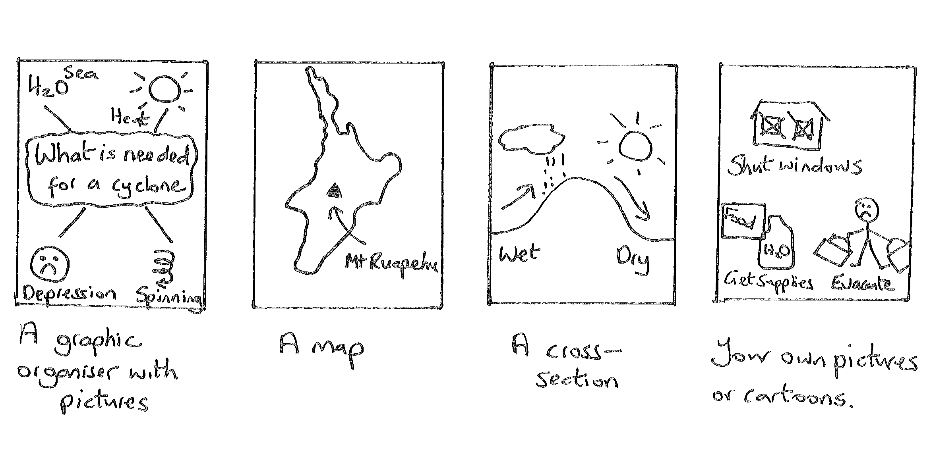Some questions may ask specifically for a map or cross section while other use the more general term of ‘a diagram’ that leaves it up to you. It is important that you read the question to determine where the visuals are to be included. These occur as either:

- A separate map or diagram question – in this case it is important you follow the rules.
- A series of diagrams can be used as an alternative to a written answer – important also that you follow the rules here. Be warned that while this sounds ‘easy’ it is often harder to provide real depth in your answer so if you want high marks try to avoid this option.
- To support an essay or written answer – spaces are not provided for these diagrams so simply draw a box on the lines provided. Such diagrams can be very small or rough and do not need to be as accurate such as including conventions.

So what are the rules with a diagram? This sheet has been set out in easy to follow stages to show you how to answer a separate diagram question.
STAGE 1: READ THE QUESTION

Your diagram is there to answer a question. It is therefore important to read this carefully and translate what you need to do in your own words. As an example take the question:

(a) Draw an annotated (labelled) diagram(s) to show the effects of your extreme natural event on the cultural environment of a named case study.

This question is clearly about how your extreme natural event affects people and buildings in your case study area.

It also pays to see if this is an (a) question as if it is read the (b) before you start. Often the diagram will need you to identify something that you can write about in more detail in the (b) part. If there is no (b) part then this will have to include a lot more detail.

STAGE 2: PLAN YOUR ANSWER

Before you start drawing PLAN how you are going to do this. If we break this question down we need to:
- show at least 3 different effects on people or buildings (two is the minimum as it asks for effects plural – 3 means you have more chance to get 2 correct)
- show how it is linked to a specific environment.

As an example let us imagine you are answering this using the extreme natural event of volcanic eruptions in the Pinatubo environment. While you may have lots of ways that people are affected choose the ones that you can write a lot about and in detail in the (b) part. Also try to make them different such as having a combination of social and economic factors. Based on this I might pick as my 3 effects:

- that people died when houses collapsed (social)
- that people had to be evacuated (social)
- that crops were destroyed leading to famine (social and economic)

STAGE 3: DRAW A BASE DIAGRAM
The next step is to produce a base diagram. You need to decide on the best way to show this information. Maps often allow more geography to be shown but other visuals are also acceptable. Once you have decided draw the base outline of what you want to use
Learn a base map for each environment you have studied
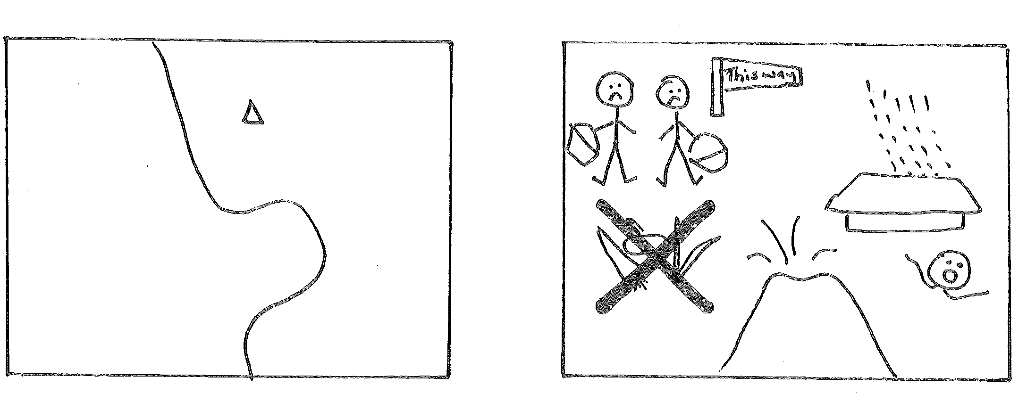

When drawing your base outline use a pencil first. It is difficult to get it correct the first time so this allows you to easily change it until you are satisfied. Once you are satisfied you can go over it in pen.

STAGE 4: ADD LABELS

Next it is important to link this diagram to an environment. You can do this by adding some names of places – easier to do in the case of a map. Alternatively include this in the title or better still do both! Labels mean single words. If you are doing a picture it may make sense to you what it is but it is important that this is conveyed to the person marking your work. Therefore, if you are doing your own drawings it is a good idea to say what they show. Your diagrams will now look like:

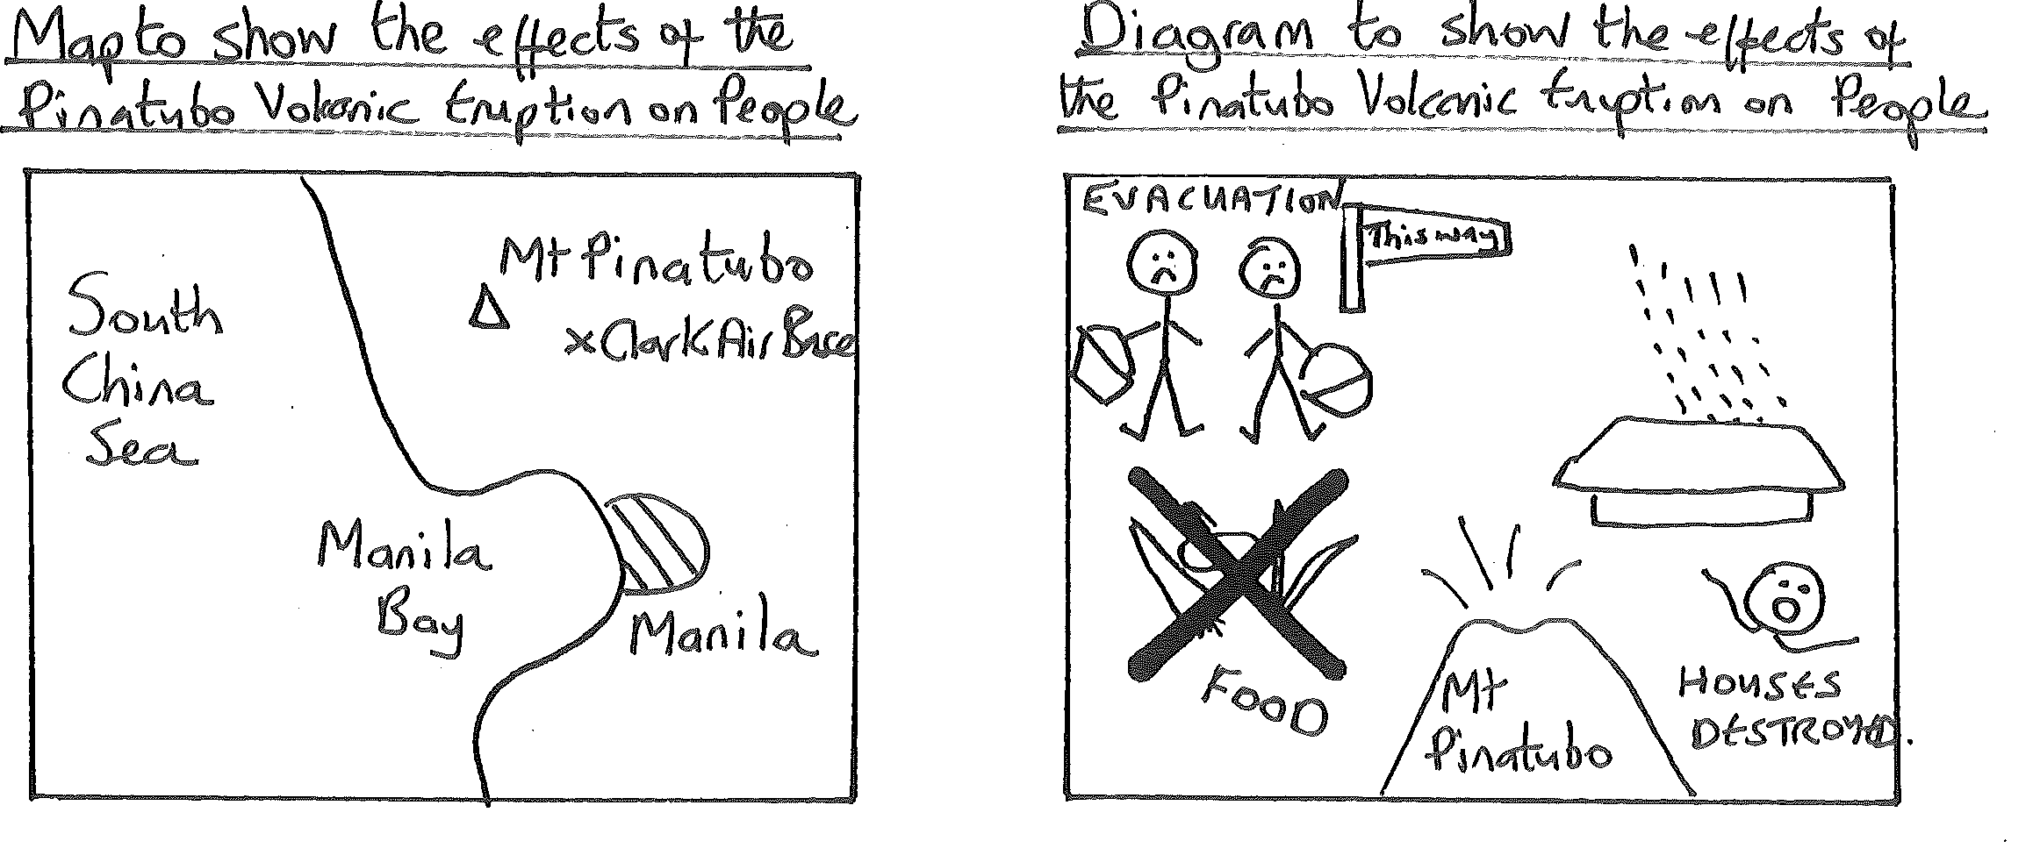
STAGE 5: ADD THE ANNOTATIONS

While you may understand what your diagram is showing to answer the question it may not be so obvious to a marker. The best way to do this is to annotate them. This means to put notes or simple sentences around your diagram that explain them. For example:

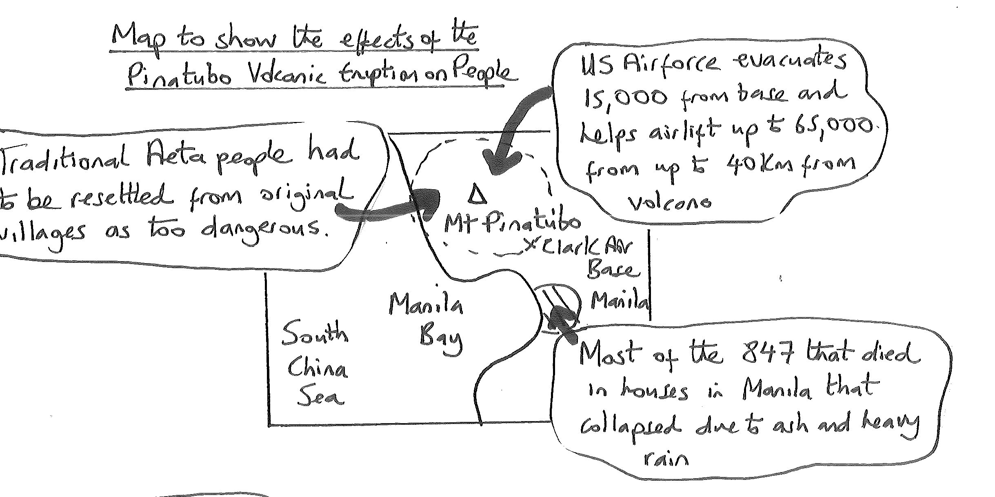
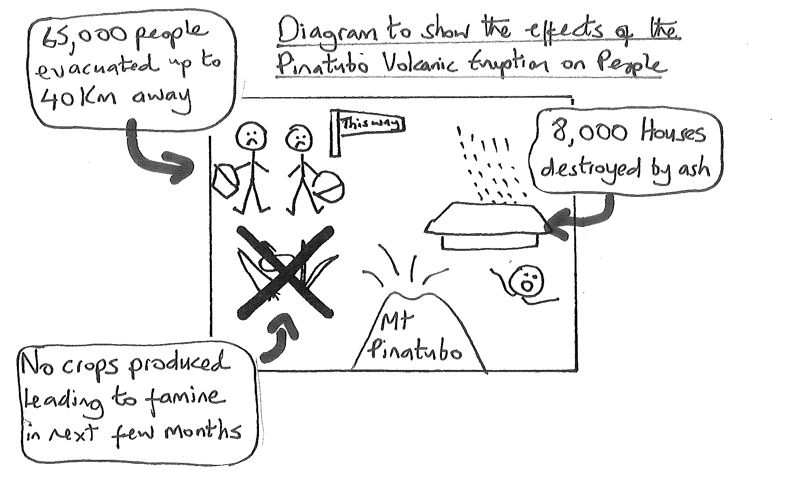
The notes can be either written on the map or linked around it using arrows as shown. If you can add some statistics onto your annotations as shown in this case do so. Not only does this link it to that environment but it also provides the detail that can gain you higher marks.

STAGE 6: ADD CONVENTIONS
The only convention that is essential at this level is a title. However, it is good practice to include these especially if you are using a map. Mapping conventions include (think FACKTS):

F rame – put a frame to show the boundary to your map/diagram
A rrow North – to show a maps orientation
C olour – try to use colour to differentiate different characteristics like blue for water, brown for mountains, green for forests, yellow for sand and red for settlements.
K ey – If you have used any symbols then add a simple key.
T itle – say where the map/diagram is of and what it is showing. It is good practice to take this from the question.
S cale - If you know this for a map then put it down.

Avoid block colouring features. If I were to colour the whole of my ‘Mount Pinatubo’ in it would waste time. It is just as effective to do the outline in brown and leave it there. If you do need to colour in a large area then draw simple lines. Manila on the map was done this way. It takes a lot less time and is just as effective. Your annotated diagram is now complete!

Jane Evans
Previous Northland/Auckland/Central North Geography facilitator

Margaret Leamy
Previous Lower North Island/South Island Geography facilitator

