The Curriculum | AS91014 (1.8) Apply spatial analysis, with direction, to solve a  geographic problem (Version 2) 3 credits (as at Nov 2016) | Conditions of Assessment
Level Six Achievement Objective  - Understand that natural and cultural environments have particular characteristics and how environments are shaped by processes that create spatial patterns  - Understand how people interact with the natural and cultural environments and that this interaction has consequences  _____________________________________________________________________________  Clarifications  Updated June 2014. This document has been updated in its entirety to address issues that have arisen from moderation in 2013.  Geographic Problem  The geographic problem selected must be able to be supported with a range of geographic information and spatial data. Teachers should refer to the Conditions of Assessment for guidance relating to the problem/topic selection, and the provision of resource material.  Manipulate spatial data to produce a layout  The intent is to transform the original spatial data to create new data/images as a layout that aids problem solving. Simple manipulations are provided in Explanatory Note 3 of the standard. Teacher direction can be given with data manipulation techniques and layout presentation. The task should guide the student through the spatial analysis process.  The manipulations must be displayed as a layout which will ideally be an A3 page (see the example below). The layout should show a combination of data, maps, graphs, visuals etc. related to the problem. Geographic conventions must be used when presenting data.  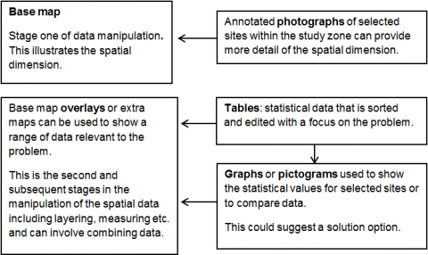  Solution  A valid answer/solution to the problem must be based on the data manipulations, and make direct reference to them. The quality and relevance of the presented spatial data in the layout can influence the depth of the valid answer/solution. | Achievement Achievement with Merit Achievement with Excellence  - Apply spatial analysis, with direction, to solve a geographic problem. - Effectively apply spatial analysis, with direction, to solve a geographic problem. - Comprehensively apply spatial analysis, with direction, to solve a geographic problem  Explanatory Notes  - This achievement standard is derived from the second Level 6 Geography achievement objective, of The New Zealand Curriculum, Learning Media, Ministry of Education, 2007, and is related to material in the Teaching and Learning Guide for Geography, Ministry of Education, 2010 at http://seniorsecondary.tki.org.nz.  - Apply spatial analysis typically involves:  - collecting spatial data relevant to the geographic question or problem  - completing simple manipulations of the spatial data to produce a layout related to the question or problem  - describing a valid answer or solution based on the manipulations.  Effectively apply spatial analysis typically involves:  - collecting sufficient spatial data to address the geographic question or problem  - completing simple manipulations of the spatial data to produce an accurate layout related to the question or problem  - explaining a valid answer or solution, based on the manipulations, that is supported by evidence.  Comprehensively apply spatial analysis typically involves:  - fully explaining a valid answer or solution, based on the manipulations, that is supported by detailed evidence.  - Spatial analysis involves collecting, manipulating and presenting spatial data for which direction will be given.  With direction refers to being given direction about spatial analysis including the collection, manipulation and presentation of spatial data.  Geographic problem refers to a question or problem (real or simulated) relating to aspects of the natural and/or cultural environment(s), and which includes a spatial dimension.  Collecting spatial data refers to either collecting data with a spatial component in the field or accessing spatial data from other sources.  Layout refers to some kind of map but may also include other visuals such as tables, graphs and images.  Simple manipulations refer to data transformations such as:  - measuring  - layering  - changing the symbols used  - sorting and editing a table  - querying the map  - using coordinate systems  - displaying a graph based on the map.  - Geospatial techniques and/or technology should be used to manipulate and present the spatial data in ways that support problem solving. | Students should demonstrate understanding and application of spatial analysis, with direction, to solve a geographic problem. The teacher should provide direction in the selection of topic and the use of the geospatial techniques and/or technologies.  Geospatial techniques (e.g. mapping) and/or technology (e.g. Google Earth, GIS software) should be used to manipulate and present the spatial data in ways that support problem solving.  Some assessment resources should be provided by the teacher, with students being encouraged to provide additional resource material.  Approaches to Assessment  Suggested approaches to presenting assessment evidence include:  - a layout with written, visual and/or oral evidence  Where a group approach is used the teacher needs to ensure that there is evidence that each student has met all aspects of the standard.  ________________________________________________  From Moderator Newsletters:  Similar contexts for more than one Geography standard  Use of similar contexts can reinforce learning and result in greater depth of student understanding.  Opportunities for using similar contexts in more than one Geography internally assessed standard could occur with:  - geographic issue and the geographic research standards  - sustainable use of an environment (91009) and geographic research and/or geographic issue standards  - urban pattern (91241) and the geographic research standard  - geographic issue and spatial analysis standards etc.

