GEOGRAPHY TIPS 3.6

Analyse aspects of a contemporary geographic issue (AS 91431)

WHAT IS THIS STANDARD ABOUT?

In this standard students have to investigate a geographic issue that is currently affecting people or places and is unresolved. They need to explain the nature of the issue, explain how people’s values and perceptions of the issue have led to their responses, propose a suitable course of action to address the issue and justify why this is a possible solution.

This standard provides students with the opportunity to apply geographic thinking to a real world situation. It scaffolds from a similar assessment at Level 1 and 2. However, unlike at the other levels the issue does not have to be based in New Zealand.

UNPACKING THE TERMS

- Geographic Issue: refers to a context that involves a concern, problem, debate or controversy related to a natural or cultural environment. It must have a spatial dimension or be able to be put on a map.
- Contemporary: means a current issue
- Explain: This means to provide reasons for, to account for, to provide a clear answer, to clarify. Logical reasons are provided
- Justification: An assessment that weighs up the pros and cons and shows an action to be reasonable and includes consideration of alternatives.
- Perceptions: Peoples/ group understanding / awareness of the issue. Do they see it as serious, a global issue or one that is relatively localized in its impacts.
- Values: Factors in a person’s life that influences how they look at or perceive an issue. This could be related to factors such as religion, age, sex, career, experience, education, political leanings, ethnicity, culture or family history etc.
- People’s Response: How they react to the issue. This could be in terms of their feelings such as anger, frustration, upset, being indifferent etc. Alternatively this can be in terms of the actions that results such as protests, petitions, writing to the newspaper, blogs, attending public meetings, lobbying MP’s, doing nothing
- Insight: This means linking causes with effects - reading into and beyond the subject matter/evidence.

DIFFERENTIATION BETWEEN LEVELS

There are several ways that the Level 3 standard is differentiated from Level 1 and 2. These include:

- The key instruction word here is ‘analyse’ whereas at Level 1 it is ‘describe’ and Level 2 it is ‘explain’. As a result quality explanations are needed that reflect level 8 of NZC and categorization of the factors involved.
- The topic chosen. While the same topics can be used at all levels some topics do not easily allow the depth of analysis required at Level 3.
- Unlike at other levels the topic at level 3 can be one from outside New Zealand. However, it needs to one for which detailed evidence can be gained.
- The depth of evidence provided must reflect Level 8 of the curriculum. As a result, what you expect for Level 3 for ‘explaining the nature of the contemporary issue” is not the same as what you would expect at level 2 despite the fact the question is similar.
- The assistance that is given by the teacher. It is vital to read the Conditions of Assessment http://ncea.tki.org.nz/Resources-for-Internally-Assessed-Achievement-Standards/Social-sciences/Geography/Level-3-Geography that clearly set out what the teacher can help with. At Level 3 this states that students are encouraged to choose their own issue in consultation with the teacher about its suitability.
- The resources provided. Only some resources should be provided by the teacher. These should be of the appropriate reading level for this year group and be of sufficient quantity to enable the students to achieve at Excellence. It is important to check the resources relate to the aspects required by the standard and that they are up to date. Students should provide additional resources themselves.

CHOICE OF ISSUE
When deciding on a suitable issue you should consider the following:

- Ensure the issue is ‘geographic’. Many interesting issues are more social and while these may appeal to students they may struggle to extract the geography from them. A geography issue is one that has a spatial dimension and an interactive relationship between people and the environment.
- Ideally the issue should have a relatively tight spatial dimension rather than one at a global scale.
- Ensure that the issue is ‘current’. This means it has not been resolved and valid alternative solutions can still be proposed.
- Ideally the issue needs to refer to a problem or controversy that involves different groups.
- Ensure you do not confuse the issue with the solution or outcome. The issue is not ‘should a particular ring road be built’ but the transport issues this is an option to solve. There should be a possibility of different possible courses of action for the issue.
- Ensure it is an issue where data is readily available. This especially applies to the values, perceptions and responses that may be hard to find. While issues can be chosen anywhere in the world the ability to access the different perspectives of the issues means that local issues are often easier to use.
- Can you combine this with another geography standard to cut down on background information? It is often useful to combine this with the 3.3 on a significant event, the 3.1 on issues around the natural environment use by people or an issue that expands on the cultural process for 3.2.
- Choose a topic in the news or of interest to students. This can be done by basing this on something local for which the student will have some prior knowledge.

EXAMPLES OF TOPICS
- Controversy around the location of a facility such as a marina, hotel complex, museum, arts centre or sports ground.
- Issues to do with conservation – mining in national parks, tourists visiting a national park, deforestation of a tract of local forest, pollution of a lake or river, possum or pest control, public access to beaches.
- Issues to do with promoting sustainability - traffic control, bicycle lanes, siting of a wind farm or tide turbine, rubbish reduction
- Issues to do with land use – converting farm land to housing development, urban sprawl, siting of a dam, new industrial complex.

WRITING ASSESSMENT TASKS
Writing your own assessment tasks is not difficult but can be daunting if you are new to geography teaching. Many resources are available via subject associations or cluster groups as teachers are willing to share ideas that have been proved to work well. Most cluster groups now use drop boxes for this purpose so check to see what is available in your region. There are several organisations that you can buy assessment tasks from such as Geostuff http://www.geostuff.co.nz/home.html and Classroom Solutions http://www.classroomsolutions.co.nz/geography.html that are often ideal to use in the first instance until you gain confidence.

If you are writing your own assessment tasks then use the exemplars provided on the TKI site as a guide. 2 exemplars are provided for each standard at http://ncea.tki.org.nz/Resources-for-Internally-Assessed-Achievement-Standards/Social-sciences/Geography/Level-3-Geography. You can download these and use them as a base to add your own context to. When doing this it is important that you use the language of the standard so have this available.

If you have constructed your own assessment task it is important that you get a fresh pair of eyes to moderate this before it is used. The TKI resources are provided as exemplars of what is possible and should not be downloaded and used in their original format as they are readily accessible to students. However, you can adapt them.

PRE-TEACHING
This standard is likely to take several weeks to be completed. Before assessing this it is important students are familiar with the following:

- Background to the standard - what is required for each criterion?
- What is meant by a perception.
- What is meant by “values” and how values are obtained.
- The ways people can respond to an issue.. What can they do if they feel strongly about the issue to get it resolved?
- How to select and apply evidence rather than ‘tell all you know’.
- How to make judgements based on the evidence presented
- What the term specific information’ means and how to incorporate these into answers.
- How to write geographic answers
- If relevant - background to the geographic issue – what it is about. The significance of the geographic location and the spatial dimension.
- Understanding any resources provided. What do they mean?
- A chance to add to the resources provided

EXPLAINING THE GEOGRAPHIC NATURE OF THE ISSUE
This acts as an introduction to the assessment to ‘set the scene’ or what is the issue and why is it geographic? It will include questions such as ‘ where does it happen (best to include a map) and what is the spatial extent of the issue? Is it growing or restricted to the origin? Who’s involved? What type of issue is it e.g. environmental, human rights etc.? Is there existing legislation related to the issue or is it clearly linked to other issues? This aspect only goes to Achievement.
EXPLAINING HOW PEOPLE’S VALUES AND PERCEPTIONS OF THE ISSUE HAVE LED TO THEIR RESPONSES

This aspect is different to the similar one at Level 1 and 2. Several additional requirements are needed:

- Different groups or individuals with different perceptions need to be identified. It is best if these are at different stages of a continuum.
- What the perceptions of these individuals or groups are.
- The reasons why these groups hold such different perceptions need to be explored. This is due to their values or ways they have been brought up and influenced. This could be related to factors such as religion, age, sex, career, experience, education, political leanings, ethnicity, culture or family history. It could also relate to how directly they are affected by the issue such as the NIMBY affect.
- How did the individuals/ groups respond to the issue. In other words what did they do about it? This could be in terms of the actions that result such as protests, petitions, writing to the newspaper, writing blogs, attending public meetings, lobbying MP’s, doing nothing etc. Alternatively this can be in terms of their feelings such as anger, frustration, upset, being indifferent etc.

It often pays to work backwards since the response is often the hardest to access. By discovering 3 different responses by groups or individuals you can then explore why they did what they did and what they felt about the issue.

This aspect is differentiated from Achievement to Merit to Excellence. For Achievement responses, perceptions and values must be explained using some case study evidence. For Merit responses, perceptions and values must be explained in detail. The difference here relates to the quality and depth of the answer by incorporating specific information such as names or statistics relating to the issue. For Excellence the step up relates to the reasoning provided for the perceptions and responses.

PROPOSING A SUITABLE COURSE OF ACTION AND JUSTIFYING THE SOLUTION

One suggested solution to the issue needs to be explored in this part of the assessment with valid reasons as to why this would help resolve it. As a result this differs from Level 1 and 2 where 2 or 3 solutions are provided and the students needs to decide which is best. This provides a ‘step up’ in that it allows more of a compromise between established solutions so that the best of each can be determined and reasons given for them.
The evaluation will become part of the justification, where the strengths of the selected option and the weaknesses of the alternatives will be emphasized. The students could be reminded to examine short/long term impacts or economic, environmental, social, political impacts etc. Students could give a compromise, but when justifying their proposed course of action alternatives must be considered.
For Achievement a student needs to explain why one course of action is best – this will include an assessment of the good features of it and compare it to at least one alternative using some evidence. For Merit the assessment of the pros and cons needs to show some depth and be substantiated with lots of evidence. It is also important that the reasons the alternatives were not considered as viable are explored. For Excellence the weighing up of pros and cons of each with an analysis of why the chosen solution comes out best and the others not as good is clear. The answer also needs of show clarity of argument and insight by using good geographic terminology.

MANAGEMENT OF THE ASSESSMENT
The standard can be lengthy and take several weeks to complete. A useful approach to this standard is to collect assessment evidence during the course of the learning. You teach the first aspect, set a task and collect that evidence and then move onto the next. Such an approach means that the assessment does not interfere with the learning. If this is done it is important it is not marked between each stage since a holistic judgment must be applied at the end.

The majority of schools assess this standard using a written booklet since the analysis requires a detailed report. It is also possible to do as an oral presentation if feasible with class numbers. You can also assess the different aspects in different ways, such as a poster/power point or movie for the nature of the issue and responses and a report for the different options.

MARKING OF THE ASSESSMENT
It is important to note the aspects of the issue that step up through the grades and how the quality is determined. The chart on the next page unpacks the Achievement Criteria. The final judgment is based on a holistic examination of the evidence.
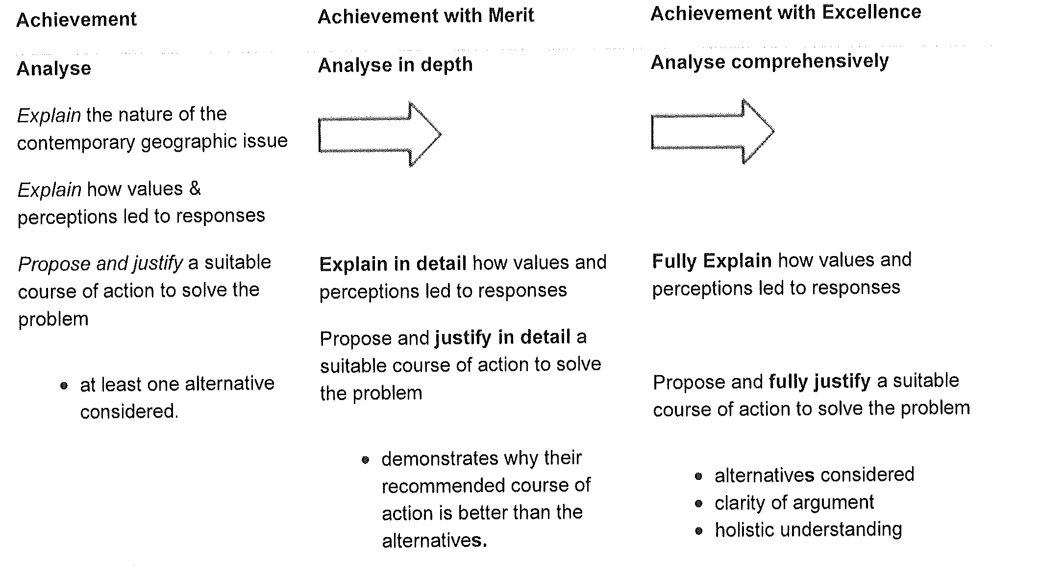
Jane Evans
Northland/Auckland/Central North Geography facilitator

Margaret Leamy
Lower North Island/South Island Geography facilitator

