GEOGRAPHY TIPS 3.5

Conduct geographic research, with consultation (AS91430)

WHAT IS THIS STANDARD ABOUT?
The aim of this standard is to assess students understanding of the geographic research process. Primary data is the focus in this standard so that links can be made by students between the real world and geography. As such it involves students getting out ‘into the field’ to collect data.

WHAT IS GEOGRAPHIC RESEARCH?
The main stages of any scientific research are the same irrelevant of what subject it is conducted in. These include:

STAGE 1: Setting up an aim, research question or hypothesis
STAGE 2: Planning what data you need and how to collect and present it.
STAGE 3: Collecting and recording the necessary data
STAGE 4: Presenting the data
STAGE 5: Analyse the findings
STAGE 6: Coming up with a conclusion that relates to the aim.
STAGE 7: Evaluating the research process

A good link to this is https://www.globe.gov/explore-science/student-zone/be-a-scientist/steps-in-the-scientific-process

DIFFERENTIATION BETWEEN LEVELS
The Research standard occurs at all 3 levels. The differentiation between levels occurs as a result of:

- The use of the word ‘consultation’ in the title. This means that students should initiate discussion with the teacher about their research aim and research methodology. The student, therefore, must take a lead in such aspects as deciding on the aim, their planning, how they will present data and how to analyse and evaluate it. It is vital to read the Conditions of Assessment http://ncea.tki.org.nz/Resources-for-Internally-Assessed-Achievement-Standards/Social-sciences/Geography/Level-1-Geography which clearly sets out what the teacher can help with. At Level 3 teacher input is confined to providing the framework for the selection of the research topic (location or theme) and instruction on fieldwork techniques and advanced methods of data presentation. Once this basic information has been provided any subsequent clarification must come from the student themselves. For example during collection of data the teacher will wait ‘in the field’ until the student approaches them with a question rather than the teacher commenting on what the students are doing.
- The instruction words involved – at level 3 the key word is ‘analyse’. This will mean that a lot more depth and explanation is required at this level compared to Levels 1 and 2.
- The amount of data collected. It is expected at Level 3 that enough data is collected to allow for a depth of analysis.

CHOICE OF TOPIC
At Level 3 the research topic (location or theme) can be selected by the teacher. In general there are 3 requirements that must be fulfilled to make the topic possible for use in this standard. These are:

- It must have a spatial component. In other words it can be mapped.
- It must involve the collection of primary data in the field using a combination of methods. The collected data needs to provide spatial, statistical and visual evidence, and be sufficient to address the research aim.
- It must consider aspects of the natural or cultural environment or interaction between them.

When deciding on a suitable topic you should also consider the following:

- Are there opportunities to leave the school site, and for how long?

While this standard offers the ideal excuse to get students outside the classroom it can be difficult to put this into practice. In this case you may need to look for solutions close by that can be conducted within normal class time. Examples here are to conduct a traffic investigation or compare 2 local centres in terms of the facilities and/or services provided. If this is not feasible collect data within the school grounds such as the spatial distribution of students in the playground.

- What will stimulate student interest?

Students tend to do a much better job when interested in what they are doing. Comparing different tourist attractions in terms of visitor surveys or investigating spatial graffiti patterns are more likely to stimulate their interest. Get students involved in the decision of what topic to choose.

- Can you combine this with another assessment so that students get a more in-depth understanding of it?

For example this fits in well with AS91426 on interacting natural processes or AS91427 on a cultural process. Fieldwork allows the student to gain useful specific information for this external. At the same time the background information gained for the externals can aid in the analysis of the research data. In the same way the research allows a more in depth study of AS91428 on a significant event or provide more background alongside the AS91431 on a contemporary issue.

- What equipment do you have to collect the data? How easy is this to use?

The collection of some data will require specialist equipment, such as abney levels, survey poles, accurate thermometers and a way of collecting data on altitude and wind speed may be required. Some of this equipment may be available to borrow from subject associations or neighbouring schools. Local $2 shops often are a source of simple timers, nets and tapes. Alternatively you may be able to make some of the equipment yourself such as using a protractor and piece of wood as a clinometer.

- Is the topic complex enough to allow an in-depth analysis required at Level 3?

A topic that is too simple may not lend itself to complex analysis. It often helps to introduce more complexities such as a comparison of different places or adding a time dimension. A traffic survey of a single road may be acceptable at Level 1 but for Level 3 it would need to be expanded by comparing traffic patterns of several sites or how a site changes over the course of a week or month(s) by extending the period over which data is collected.

WRITING ASSESSMENT TASKS
Writing your own assessment tasks is not difficult but can be daunting if you are new to geography teaching. Many resources are available via subject associations or cluster groups as teachers are willing to share ideas that have been proved to work well. There are several organisations that you can buy assessment tasks from such as Geostuff http://www.geostuff.co.nz/home.html and Classroom Solutions http://www.classroomsolutions.co.nz/geography.html that are often ideal to use in the first instance until you gain confidence.

If you are writing your own assessment tasks then use the exemplars provided on the TKI site as a guide. 2 exemplars are provided for each standard at http://ncea.tki.org.nz/Resources-for-Internally-Assessed-Achievement-Standards/Social-sciences/Geography/Level-3-Geography
use them as a base to add your own context to. When doing this it is important that you use the language of the standard so have this available.

If you have constructed your own assessment task it is important that you get a fresh pair of eyes to moderate this before it is used.

PRE-TEACHING
This standard is likely to take several weeks to be completed. Before assessing this it is important students are familiar with several geographic skills such as:

- What the research process means
- What consultation means – the role of the teacher.
- Methods of collecting data in the field eg sketch maps, using specialist equipment
- How to interpret statistical data (turning into %, averages and means, statistical maps)
- The geographic conventions required for all forms of presented data
- Graphing techniques
- Integration of data to effectively present
- Meaning of command words such as ‘analyse’, ‘critically analyse’, ‘evaluate’ and ‘critically evaluate’.
- How to write geographic answers using correct geographic terminology and concepts

STAGE 1: THE RESEARCH AIM
The student must develop their own aim, preferably after consultation with the teacher. Research aims need to be clear, simple and measurable. It is important that the students understand the value of consultation and are encouraged to take this opportunity at the planning stage. Do not just sign that an aim has been done but that the aim is a good one that will allow the student to achieve at this level. This may require several ‘attempts’ but is vital as the success of the research depends on the choice of a good research question.

STAGE 2: PLANNING
This may occur in a group if it is intended to collect data this way. Planning should make it clear what data the student(s) intend to collect (primary and secondary), how this is to be done and how they intend to present it. Ideally the planning should be approved prior to the student(s) going out to collect it.

Planning sheets must be included in the final research report.

STAGE 3: COLLECTING AND RECORDING DATA
Primary data must be the focus of this research and collected from the field using a combination of methods. Primary data in geography is taken as data that is unique, collected by a students first hand experience in the field, has not been collected before and is not published. Therefore a student taking readings of temperature in different parts of a school by using a thermometer is collecting primary data. A student getting those readings from the internet is collecting secondary data. A student taking photographs or drawing maps that they annotate is collecting primary data, accessing photographs or maps from the internet or photocopied from books is not. A student gaining information from someone by interviewing them is collecting primary data while quoting them from a published article in a magazine or from a video is not. The focus must be primary but secondary data can be used to back up the findings eg weather maps, models etc.

It is vital that more than one type of data is collected as the standard asks for a combination of methods so that different geographic skills are used. Students aiming for Merit and Excellence grades will need to collect some form of numerical data since the standard asks for a statistical form of presentation. Common methods include surveying, measuring or using questionnaires. Other types of data include interviewing, taking photographs, constructing maps, field sketches or making observations. In the case of physical geographic data this tends to be easier since several different methods of measuring can be employed. It is when the basis of research is a questionnaire that issues arise as this alone will not fulfill requirements of the standard. Instead this can be supplemented by including annotated photographs or observations on why particular sites were chosen.

While data can be collected individually it is often easier for students to collect data in groups. This allows students the chance to organize themselves such as allocating different jobs in terms of conducting a beach profile or sending each member to collect data in different locations that can then be shared. However, it is expected that each member of the group includes all the collected data in their report. The planning and collecting of data is the only stage in the process that can be completed collaboratively.

It is important that every class member has been seen collecting data at some stage. Getting students to hand in their raw data sheets can provide evidence of this. This can produce problems if a student is absent. If collection of data occurs over several days then as long as they are seen collecting it once they fulfill the criteria. If it is a whole day fieldtrip that they miss an alternative assessment will have to be given.

Ensure enough data is collected to address the research aim. Collection of data from one tourist attraction is not going to answer a research aim relating to tourist patterns in a region. At the same time do not go overboard. Why take 10 beach profiles when 3 would adequately show the common pattern.

STAGE 4: PRESENTING DATA

It must be the student’s decision as to how to present the data they have collected.

The standard clearly expects the spatial nature of the research to be identified that means that some kind of mapping is expected. This map can be one the students draw themselves or one obtained from secondary sources which is annotated to identify the location of the research and specific characteristics of it. In both cases accurate use of appropriate mapping conventions is expected; namely a specific title, key or labels and north point and frame, colour and scale.

Statistical presentation means that the student has manipulated the raw data in some way. This could be as a table where it has been categorized, averages found or percentages calculated. It could be as a graph in which case appropriate conventions are required such as labeled axes, a title and key.

Completion of graphs and maps using digital technology such as excel or GIS is acceptable as long as you can verify the student completed this themselves and is not someone else’s work! They should also ensure that correct conventions are included even if it means adding to these by hand.

Other forms of visual presentation include sketches, diagrams and photographs. Photographs are only acceptable if they are annotated in a way that makes their relevance to the research clear. In each case conventions are expected such as titles and a key where appropriate.

Two grades are possible for this aspect. For Achievement one map and one form of statistical or visual presentation is required in which most conventions are provided. At Level 3 accuracy is expected so it may be necessary to refer to raw data to check for this.

For Merit one map, one form of statistical presentation AND one other visual (another map/ graph/ diagram /annotated photographs etc) are provided with most conventions. However, the number of different type of presentations is not the main determinant of this higher grade as students should be advised to select the most appropriate methods of presenting their data. In addition there must be evidence of ‘effective’ presentation. Effective presentation should demonstrate a student’s in-depth understanding of their context, data and links with their aim. This means that they clearly answer the research question. If 2 or more places are compared in a graphic form then they should be presented side by side at the same scale so the differences can be easily shown. If spatial variation of visitor numbers to several attractions is the aim then a statistical map showing how they differ would be ‘effective’.

STAGE 5: ANALYSE FINDINGS
At this level students must ‘analyse’ or describe and explain the results of their presentation. This can be done in two main ways according to the nature of the research.

The findings can sit alongside different forms of presentation so that they both describe what occurs in each map/table/graph or visual and then goes on to give reasons for it. Alternatively the findings can be done as one task referring to several forms of presentation as they develop.

While the use of geographic concepts and terminology is not explicit in the standard it is still expected that these are included.

The step up for different grades is based on the quality of the response. For Achievement a student must ‘analyse’ findings or describe and explain the data presented. For Merit the students must ‘analyse in detail’. This means they need to incorporate direct evidence from the data collected and/or presented such as quoting actual amounts or giving details as to the reason for variation in different places or times. For Excellence they must ‘critically analyse’ which means the same as for Merit with the addition of higher level valuing skills. A critical analysis involves examination of the findings, identifying factors or circumstances that may have influenced them, identifying and examining any irregularities in the findings, examining any relationships that appear etc.

STAGE 6: CONCLUSION
It is important that a conclusion is provided separately from the findings. Students often feel they are repeating information here so reassure them that the point of this is to take out the main points only or do a summary. The vital component here is to directly relate the findings to the original research aim. If this was stated as a question or hypothesis they need to say if they now agree or disagree with it and what was the evidence for this decision. Conclusions do not need to be lengthy and are the reason they are only differentiated between achievement (can provide a conclusion) and Merit (can provide a detailed conclusion).

STAGE 7: EVALUATION OF THE RESEARCH PROCESS
This aspect shows a step up from the similar one at level 2 in that the research process must be evaluated rather than just providing a list of strength(s) and weakness(es). In other words there needs to be some explanation as to the significance of various strengths and /or weaknesses as well as to how they have affected the validity of the findings and/or conclusion.
As with the analysis of the findings this can be approached as one task e.g. a strength is clearly explained and its significance indicated, followed by an explanation of how it affected the validity of the findings/conclusion(s). The detail for Merit is indicated through effective use of evidence from the findings and or conclusion.
For Excellence there is an additional requirement and this is to suggest alternative methods and to discuss their implications. Alternative methods are different to ‘improvements’ that are based only on the data the student collected. Instead this will go much further to suggest how the research aim could have been researched in ideal conditions that would make it more valid such as using more specialist equipment or conducting it on a lager scale spatially or temporally. They then need to state how this will effect the findings.
MANAGEMENT OF THE ASSESSMENT

The research standard can be lengthy and take several weeks to complete. It often makes it easier to break this down into parts to make it more manageable. For example, you may want to break the assessment up into
- 1. The aim and planning
- 2. The collection and recording
- 3. The presentation, the findings and conclusion
- 4. The evaluation.

Evidence is collected as each aspect is completed with teaching between. In this way the assessment becomes part of the learning. If this is done it is important it is not marked between each stage since a holistic judgment must be applied at the end.

If students are given a free rein the research can be so long it becomes a nightmare to mark! It often helps to provide a booklet for this standard especially for the planning and data collection stages. While a booklet can cover other aspects be careful that it does not get too prescriptive and offers too much guidance.

MARKING OF THE ASSESSMENT

It is important to note the aspects of the research that step up through the grades and how the quality is determined. The chart unpacks the Achievement Criteria, and the geographic research must involve all aspects identified below. The final judgement is based on a holistic examination of the evidence.

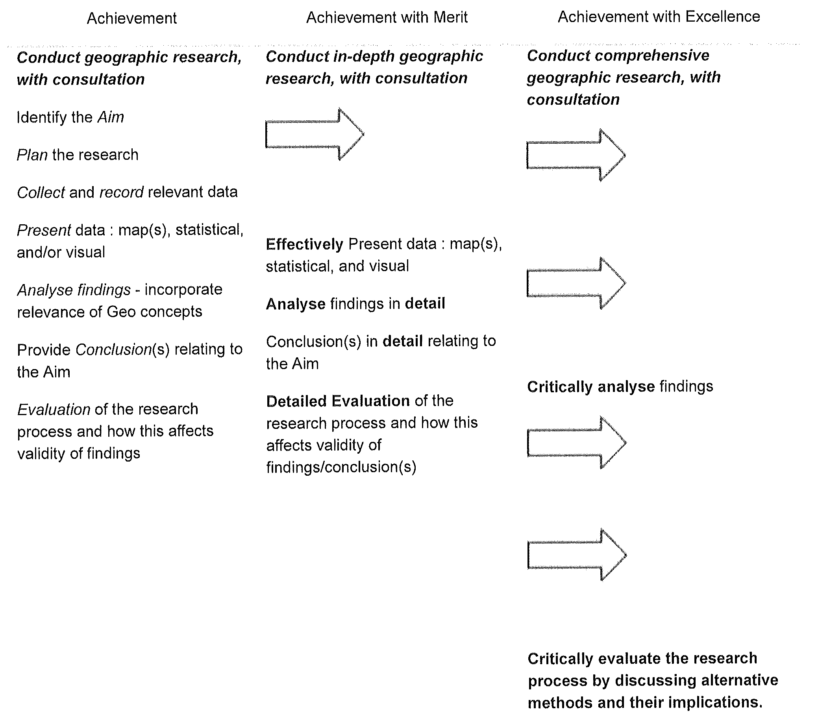
Jane Evans
Northland/Auckland/Central North Geography facilitator

Margaret Leamy
Lower North Island/South Island Geography facilitator

