GEOGRAPHY TIPS

Conduct geographic research, with guidance (AS 91244)

WHAT IS THIS ASSESSMENT ABOUT?

The aim of this standard is to assess students understanding of the geographic research process. Primary data must be the focus in this standard so that links can be made by students between what happens in the real world and geography. As such it involves students getting out ‘into the field’ to collect data.

WHAT IS GEORAPHIC RESEARCH?

The main stages of any geographic research include:

STAGE 1: Identifying a research aim or hypothesis based on observations
STAGE 2: Planning what you intend to do to collect and present primary data and the form of the research.
STAGE 3: Collecting and recording the primary data (and accessing secondary data if required)
STAGE 4: Presenting the collected data
STAGE 5: Explain the findings
STAGE 6: Make a conclusion that relates to the research aim.
STAGE 7: Evaluating the research process, including impacts on validity of the findings and suggestions for improvements.

WHAT IS THE DIFFERENTIATION BETWEEN THE LEVELS?

The Research standard occurs at all 3 levels. The differentiation between levels occurs as a result of:

- The use of the word ‘guidance’ in the title. This relates to the amount of help the teacher is able to give to the student during the research process. At Level 2 it is assumed students are familiar with this process from Level 1 so need to be guided towards what to do rather than being explicitly told as at Level 1. It is vital to read the Conditions of Assessment http://ncea.tki.org.nz/Resources-for-Internally-Assessed-Achievement-Standards/Social-sciences/Geography/Level-2-Geography and clarifications of the standard that clearly set out what the teacher can help with. At Level 2 guidance refers to assistance with the selection of a topic, identification of the aim and methods of collecting, recording and presenting data.
- The instruction words involved – at level 2 the key word is ‘explain’. This will mean that a lot more depth and reasons are required at Level 2 compared to Level 1.
- The amount of data collected. It is expected at Level 2 that more data is collected both in terms of volume and methods used. This is crucial to enable an in-depth explanation of the findings and full coverage of the research aim. Secondary data may also be included.

CHOICE OF TOPIC

At Level 2 the research topic (location or theme) can be selected by the teacher. In general there are 3 requirements that must be fulfilled to make the topic possible for use in this standard. These are:

- It must have a spatial component. In other words it can be mapped.
- It must involve the collection of primary data in the field using a combination of methods (one of which is statistical) and which can adequately answer the research aim.
- It must consider aspects of the natural or cultural environment or interaction between them.

When deciding on a suitable topic you should consider the following:

- Are there opportunities to leave the school site, and for how long?

While this standard offers the ideal excuse to get students outside the classroom it can be difficult to put this into practice. In this case you may need to look for solutions close by that can be conducted within normal class time. Examples here are to conduct a traffic survey comparing 2 sites or compare 2 local shopping centres in terms of the services and facilities provided. Alternatively collect data within or close to the school grounds such as a litter survey, climate variations or cellphone coverage.

- What will stimulate student interest?

Students tend to do a much better job when interested in what they are doing. Investigating shopping habits, graffiti patterns or looking at cellphone coverage are more likely to stimulate their interest. Get students involved in the decision of what topic to choose.

- Can you combine this with another assessment so that students get a more in-depth understanding of it?

For example you may wish to combine this with the AS91241 on Urban patterns and undergo a field trip that collects additional data such as land use or the number of services. In the same way this can provide more background data for the AS91245 on the geographic issue such as the collection of different viewpoints concerned. The problem and GIS skills for AS91247 can also be used with the research standard. Several schools also combine this with AS91240 by carrying out fieldwork in their large natural environment. Background information gained for the externals can aid in the explanation of the research data.

- What equipment do you have to collect the data? How easy is this to use?

The collection of some data will require specialist equipment, especially if it is physically based. Equipment such as Abney levels, survey poles, accurate thermometers and a way of collecting data on altitude and wind speed may be required. Some of this equipment may be available to borrow from subject associations or neighbouring schools. Alternatively you may be able to make some of the equipment yourself. Check what appropriate apps you can download on students phones.

WRITING ASSESSMENT TASKS

Writing your own assessment tasks is not difficult but can be daunting if you are new to geography teaching. Many resources are available via subject associations or cluster groups as teachers are willing to share ideas that have been proved to work well. There are several organisations that you can buy assessment tasks from such as Geostuff http://www.geostuff.co.nz/home.html and Classroom Solutions http://www.classroomsolutions.co.nz/geography.html that are often ideal to use in the first instance until you gain confidence.

If you are writing your own assessment tasks then use the exemplars provided on the TKI site as a guide. 2 exemplars are provided for each standard at http://ncea.tki.org.nz/Resources-for-Internally-Assessed-Achievement-Standards/Social-sciences/Geography/Level-2-Geography . You can download these and use them as a base to add your own context to. When doing this it is important that you use the language of the standard so have this available.

If you have constructed your own assessment task it is important that you get a fresh pair of eyes to moderate this before it is used.

PRE-TEACHING

This standard is likely to take several weeks to be completed. Before assessing this it is important students are familiar with several geographic skills such as:

- What the research process means
- Methods of collecting data in the field eg sketch maps, using specialist equipment
- Geographic conventions expected with all forms of presented data.
- How to interpret statistical data (turning into %, averages and means, statistical maps)
- How to draw graphs using correct conventions.
- Integration of data to effectively present.
- Meaning of command words such as ‘explain’, ‘fully explain
- How to write geographic answers using correct geographic terminology
- What the geographic concepts are and how to apply them to the research
- Background to the topic if not previously covered

STAGE 1: THE RESEARCH AIM

The student must develop the aim using guidance from the teacher. For example, the teacher can suggest a general idea that the student then writes up as a research aim. Good research aims are clear, simple and measurable yet will allow extensive investigation. Since it is vital that relevant concepts are included in the findings it often is an advantage if these are incorporated into the question. e.g. ‘To explain how location affects the pedestrian flow patterns experienced in Queenstown CBD?’ or ‘Fluvial processes create change in the landforms found along the Hutt River.’ Research aims can be written as a question or as a statement or hypothesis that must then be accepted or rejected based on the findings. It is important that the teacher approves the aim and checks the overall planning before continuing to ensure that specific requirements of the standard will be met.

STAGE 2: PLANNING

Planning is part of the assessment. At this level it is best for the research to be done in groups and the planning and collection of data may be a collaborative effort. However, all students need a copy of what is to be done to ensure they know what to do prior to the collection. Planning should make it clear what data the student(s) intend to collect (primary and secondary), how this is to be done and how they intend to present it.

It is important that this is collected as part of the research report.

STAGE 3: COLLECTING AND RECORDING DATA

Primary data must be the focus of this research and collected from the field using a combination of methods. Primary data in geography is taken as data that is unique, collected by a students first hand experience in the field and is not published. Therefore a student taking readings of temperature in different parts of a school by using a thermometer is collecting primary data. A student getting those readings from the internet is collecting secondary data. A student taking photographs or drawing maps that they annotate is collecting primary data, accessing photographs or maps from the internet or photocopied from books is not. A student gaining information from someone by interviewing them is collecting primary data while quoting them from a published article in a magazine or from a video is not. The focus must be on the collected primary data, but secondary data can be used to back up the findings eg weather maps. The intention is for students to ‘interact’ with the environment rather than collecting data by sitting in a classroom.

Ensure enough data is collected to answer research aims. Collection of data from one tourist attraction is not going to answer a research aim relating to tourist patterns in a region. At the same time do not go overboard. Why take 12 slope profiles when 3 would adequately show the common pattern.

The teacher should provide guidance to students as to the possible methods of data collection (at least 2 types) and suggest how to record and present this evidence.. At least one type of primary data collected must be numerical since the standard asks for a statistical form of presentation. Common methods include surveying, measuring or using questionnaires. At the same time it is vital that more than one type of data is collected as the standard asks for a combination of methods so that different geographic skills are used. Other types of data include interviewing, taking photographs, constructing maps, field sketches or making observations. In the case of physical geographic data this tends to be easier since several different methods of measuring can be employed. It is when the basis of research is a questionnaire that issues arise as this alone will not fulfill requirements of the standard. Instead this can be supplemented by including annotated photographs or observations on why particular sites were chosen.

While data can be collected individually it is often easier for students to collect data in groups. This allows students the chance to organize themselves such as allocating different jobs in terms of conducting a slope profile or sending each member to collect data in different locations that can then be shared. However, it is expected that each member of the group include all the necessary data in the assessment. The planning and collecting of data is the only stage in the process that can be completed collaboratively.

It is important that every class member has been seen collecting data at some stage. Getting students to hand in their raw data sheets can provide evidence of this. This can produce problems if a student is absent. If collection of data occurs over several days then as long as they are seen collecting it once they fulfill the criteria. If it is a whole day fieldtrip that they miss an alternative assessment will have to be given.

Handing in raw data sheets is also important to check the validity of the data when it is presented.

STAGE 4: PRESENTING DATA

The teacher can give guidance on how to present the data. For example this means the teacher can suggest that a bar graph or cross section is appropriate but it is then up to the student to determine the size and axes to use. This ensures a step up from the Level 1 research.

The standard clearly expects the spatial nature of the research to be identified, which means that some kind of mapping is expected. This map can be one the students draw themselves or one obtained from secondary sources which is annotated to identify the location of the research. In both cases appropriate mapping conventions are expected namely a title, key or labels and north point and frame, colour and scale.

Statistical presentation is also a requirement at this level. This means that the student has manipulated the raw data in some way. This could be as a table where it has been categorized, averages found or percentages calculated. It could be as a graph in which case appropriate conventions are required such as use of an appropriate scale, labeled axes, a title and key.

Completion of graphs and maps using digital technology such as excel or GIS is acceptable as long as you can verify that they were completed by the student and it is not someone else’s work! They should also ensure that correct conventions are included even if it means adding to these by hand.

Other forms of presentation include sketches, diagrams and photographs. Photographs are only acceptable if they are annotated in a way that makes their relevance to the research clear. In each case conventions are expected such as titles and a key where appropriate.

The step up with presentation of data for the different levels of achievement is based on the accuracy and effectiveness of the presentations not the quantity of them. For Achievement one map, one or more forms of statistical and one or more visual presentations are required. Each piece of presented data must show use of correct conventions used. For Merit the number of presentations are the same but accuracy is expected, so it may be necessary to refer to raw data to check for this. The presentations must show accurate application of appropriate conventions. For Excellence the step up is ‘effective’ presentation. This means that they clearly answer the research question. If 2 or more places are compared in a graphic form then they should be presented side by side at the same scale so the differences can be easily shown. Alternatively the differences are graphed separately. It may also use a combination of data types such as using a statistical map or a cross section showing the summary of the findings spatially. While this will depend on the nature of the research effectively presented data show a deeper understanding of the elements and/or interactions evident in the research or the spatial context.

STAGE 5: EXPLAIN FINDINGS

At this level students must explain the collected and presented evidence. This can be done in two main ways according to the nature of the research.

The findings can sit alongside different forms of presentation so that they both describe what occurs in each map/table/graph or visual and then goes onto give reasons for it. Alternatively the findings can be done as one task referring to several forms of presentation as they develop.

In addition students must incorporate geographic concepts (2 or more) into the findings. This should be incorporated into the findings not as a separate question. This is easier if the research aim includes geographic concepts in it. If it does not then the use of terms such as ‘pattern’, ‘process’ ‘change’ ‘interaction’ and ‘location’ should be straightforward to apply. The teacher can guide the student by suggesting appropriate concepts to use in the research and to provide a definition of them.

The step up for different grades is based on the depth of the response. For Achievement you can expect a student to make several valid ‘findings’ based on the data presented that are explained as well as show an understanding of more than one concept. For Merit you would expect a lot more depth in the findings including use of specific evidence, such as quoting actual amounts or giving details as to the variation in different places or times as well as showing in-depth explanations and a good understanding of the concepts. For Excellence you would expect findings to be explained in depth that also incorporate geographic terminology and a clear understanding of the concepts.

STAGE 6: CONCLUSION

It is important that a conclusion is provided separately from the findings. Students often feel they are repeating information here so reassure them that the point of this is to take out the main points only or do a summary. The vital component here is to directly relate the findings to the original research aim. If this was stated as a question or hypothesis they need to say if they now agree or disagree with it and what was the evidence for this decision. Conclusions do not need to be lengthy and are the reason they are only differentiated between achievement (can provide a conclusion) and Merit (can provide a detailed conclusion).

STAGE 7: EVALUATION

All grades require an evaluation of the research process. This means having to explain the strength(s) and/or weakness(es) of what they did and how this impacted on the validity of their findings and conclusion. This can relate to the planning, collecting, the presenting and/or the findings made. Grades are based on qualitative answers not quantity. For Achievement a strength(s) or a weakness(es) are required. For Merit a more detailed evaluation is required including both strengths and weaknesses of the research process and how they affect the validity of the research findings and/or conclusions. For Excellence students need to extend the evaluation to full explanations and include a discussion of ways the research process could be improved. One way of doing this is to focus on the weaknesses and explain methods that would be more effective, or solutions to improve the validity of the research results.

Evaluation of the research process is often made easier if students keep a log during the whole process. Here they can record any strengths or weaknesses they found as they happened as these are easily forgotten. However, this should not replace the evaluation but be used as the evidence on which to base the evaluation.

Do not panic if ‘outside factors’ upset the collection of data. Unexpected roadworks, rain, faulty equipment, only being able to collect data twice etc will provide the student with more to discuss in the evaluation.

MANAGEMENT OF THE ASSESSMENT

The research standard can be lengthy and take several weeks to complete. It often makes it easier to break this down into parts to make it more manageable. For example, you may want to break the assessment up into
1. The aim and planning
2. The collection and recording
3. The presentation, the findings and conclusion
4. The evaluation.

Evidence is collected as each aspect is completed with teaching between. In this way the assessment becomes part of the learning. If this is done it is important it is not marked between each stage since a holistic judgment must be applied at the end.

If students are given a free rein the research can be so long it becomes a nightmare to mark! It often helps to provide a booklet for this standard especially for the planning and data collection stages. While a booklet can cover other aspects be careful that it does not get too prescriptive and offers direction rather than guidance.

MARKING OF THE ASSESSMENT

It is important to note the aspects of the research that step up through the grades and how the quality is determined. The chart on the next page unpacks the Achievement Criteria, and the geographic research must involve all aspects identified below.
The arrow indicates that there is no step-up in quality required e.g. a more detailed conclusion is not required for Excellence.
The final judgment is based on a holistic examination of the evidence.

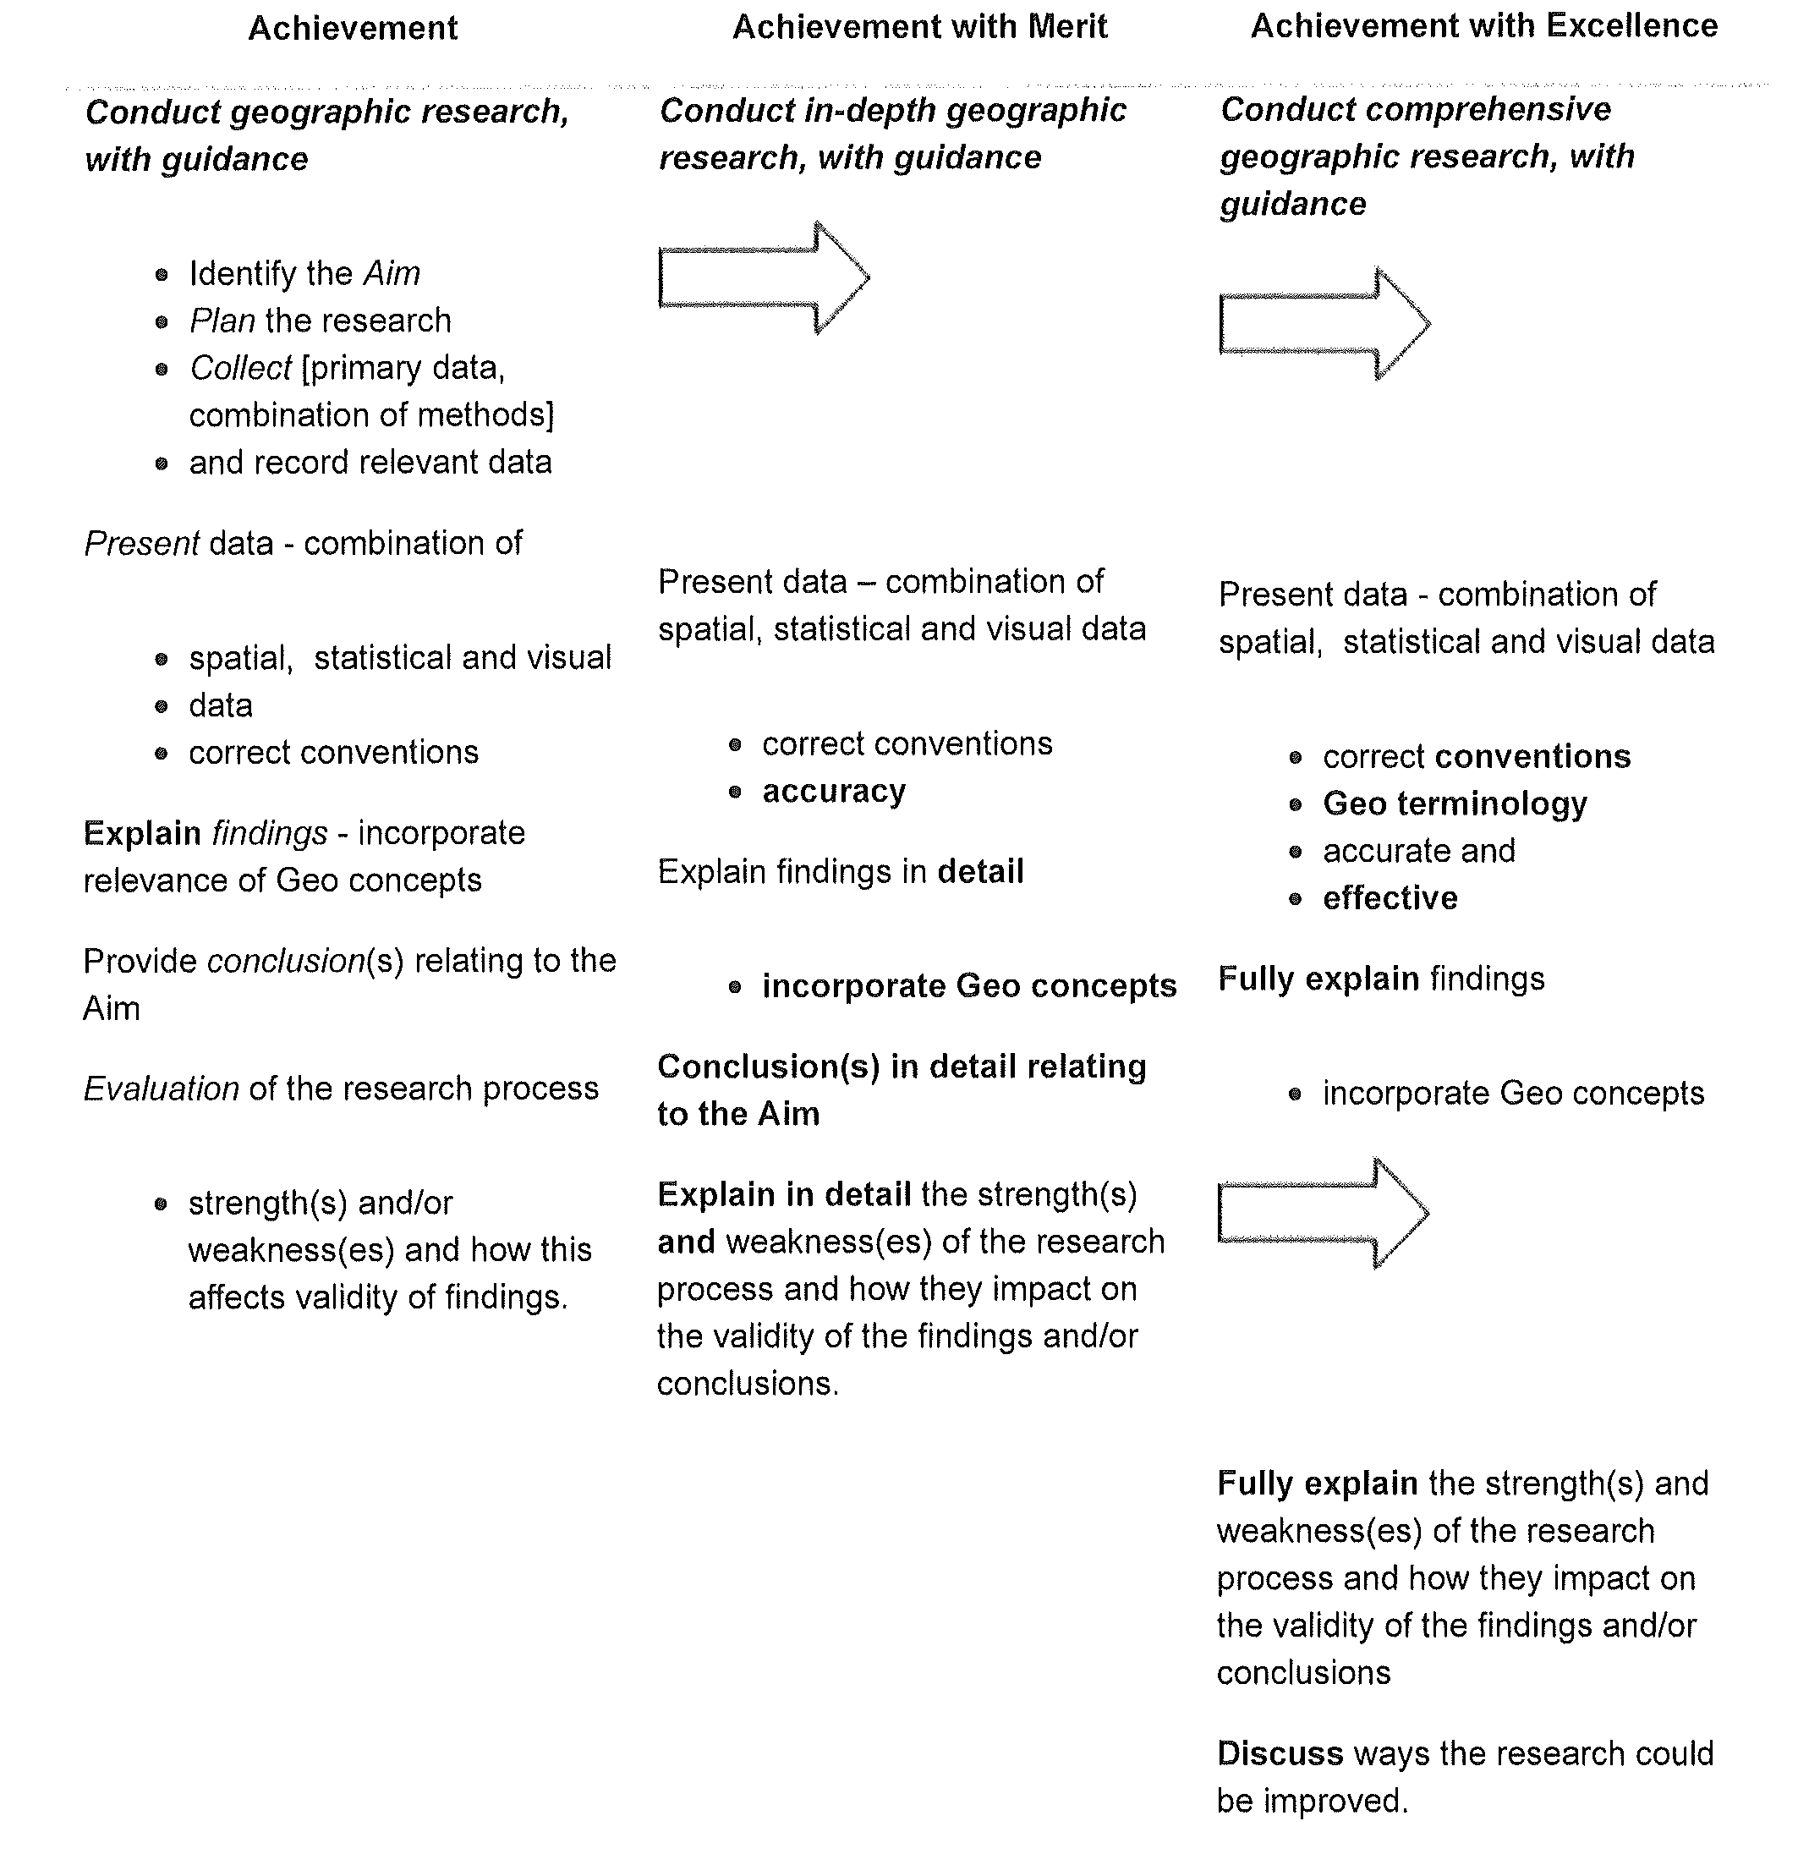

Jane Evans
Northland/Auckland/Central North Geography facilitator

Margaret Leamy
Lower North Island/South Island Geography facilitator

