GEOGRAPHY TIPS

Describe aspects of a contemporary New Zealand geographic issue (AS 91012)

WHAT IS THIS STANDARD ABOUT?

In this standard students have to investigate a geographic issue that is affecting our country now or in the near future. They need to describe the nature of the issue, different viewpoints held in relation to the issue, courses of actin and finally make a justified recommendation.

This standard provides students with the opportunity to apply geographic thinking to a real world situation. It is must be based in New Zealand giving students some understanding of the geography of their own country. It is one of few internals that requires some student judgment rather than just being based on fact. For example it includes higher level thinking skills such as evaluating, justifying and looking at different viewpoints of an issue. It is also useful that this standard scaffolds into a similar one at Level 2 and 3.

UNPACKING THE TERMS

- Geographic Issue: refers to a context that involves a concern, problem, debate or controversy related to a natural or cultural environment. It must have a spatial dimension or be able to be put on a map.
- Contemporary: means an issue of relevance now or will be in the near future (a proposal for a future action).
- New Zealand Issue: this can be of a local, regional or national scale.
- Describe: This means to identify and give an account of; to make reference to the qualities, characteristics or recognisable features. A simple explanation can also be included.
- Assess: means to make judgments about or to weigh up by looking at the advantages/good and disadvantages/bad things involved
- Viewpoints: A way of looking at or thinking about something.
- Geographic Terminology: using subject specific words that show an understanding of geography
- Insight: This means linking causes with effects - reading into and beyond the subject matter/evidence. Consideration of perspectives can help in showing insight

CHOICE OF TOPIC

When deciding on a suitable topic you should consider the following:

- Ensure the issue is ‘geographic’. Many good issues are more social and while these may be of interest to students they will struggle to extract the geography from it. A good geography topic is one that can be mapped.
- Ensure that the issue is ‘current’. That is it has not been built or developed but for which solutions can still be proposed and the possible courses of action are still valid.
- Ensure it is an issue over which there is some debate otherwise students will struggle to get contrasting viewpoints about it.
- Ensure you do not confuse the issue with the solution or outcome. For example, location of a ring road is a solution while the issue is traffic congestion. There should be a possibility of at least 3 different possible courses of action for the issue.
- Ensure it is an issue where data is readily available. This especially applies to the viewpoints that may be hard to find.
- Can you combine this with another geography standard to cut down on background information? It is often useful to combine this with the 1.3 on sustainability looking at a mining, farming or tourism issue or the 1.2 population topic such as exploring NZ attitudes to an ageing population or immigration. It would also work well with the 1.5 research collecting data based on viewpoints.
- Choose a topic in the news or of interest to students. This can be done by basing this on something local for which the student will have some prior knowledge.

EXAMPLES OF TOPICS

- Controversy around the location of a facility such as a marina, hotel complex, museum or sports ground.
- Issues to do with conservation – mining in national parks, tourists visiting a national park, deforestation of a tract of local forest, pollution of a lake or river, possum or pest control, public access to beaches.
- Issues to do with promoting sustainability - traffic control, bicycle lanes, siting of a wind farm or tide turbine, rubbish reduction
- Issues to do with land use – converting farm land to housing development, urban sprawl, siting of a dam, new industrial complex.

WRITING ASSESSMENT TASKS

Writing your own assessment tasks is not difficult but can be daunting if you are new to geography teaching. Many resources are available via subject associations or cluster groups as teachers are willing to share ideas that have been proved to work well. Most cluster groups now use dropboxes for this purpose so check to see what is available in your region. There are several organisations that you can buy assessment tasks from such as Geostuff http://www.geostuff.co.nz/home.html and Classroom Solutions http://www.classroomsolutions.co.nz/geography.html that are often ideal to use in the first instance until you gain confidence.

If you are writing your own assessment tasks then use the exemplars provided on the TKI site as a guide. 2 exemplars are provided for each standard at http://ncea.tki.org.nz/Resources-for-Internally-Assessed-Achievement-Standards/Social-sciences/Geography/Level-1-Geography. You can download these and use them as a base to add your own context to. When doing this it is important that you use the language of the standard so have this available.

If you have constructed your own assessment task it is important that you get a fresh pair of eyes to moderate this before it is used.

The TKI resources are provided as exemplars of what is possible and should not be downloaded and used in their original format as they are readily accessible to students. However, you can adapt them.

DIFFERENTIATION BETWEEN LEVELS

There are several ways that the Level 1 standard is differentiated from Level 2 and 3. These include:

- The key instruction word here is ‘describe’ whereas at Level 2 it is ‘explain’ and Level 3 ‘analyse”. As a result explanations are not required. However, this may be provided by the more able student in which case ‘explain’ will equate to ‘fully describe’ and so should be rewarded.

- The issue chosen. While the same issue can be used at all levels some are easier to understand than others. At Level 1 the issue should not be too complex.

- The assistance that is given by the teacher. It is vital to read the Conditions of Assessment http://ncea.tki.org.nz/Resources-for-Internally-Assessed-Achievement-Standards/Social-sciences/Geography/Level-1-Geography and clarifications of the standard that clearly set out what the teacher can help with. At Level 1 the teacher should select the issue, name the viewpoints and the 3 courses of action to investigate.

- The resources provided. At Level 1 the majority of resources should be provided by the teacher. These should be up to date and allow the student to gain excellence for the aspects covered. These should be of the appropriate reading level for this year group. Alternatively a web quest or similar can be provided as long as these have been vetted to check they are appropriate to the year level. Students can be encouraged to provide additional resources themselves but this is not mandatory at this level.

PRE-TEACHING

This standard is likely to take several weeks to be completed. Before assessing this it is important students are familiar with the following:

- Background to the standard - what is required for each criterion?
- What is meant by a viewpoint and how to categorise viewpoints into those that are based on social, economic, political or environmental grounds.
- How to make judgements based on fact
- What the term specific information’ means and how to incorporate these into answers.
- How to write geographic answers
- Background to the geographic issue – what it is about.
- Understanding the resources provided. What do they mean?
- A chance to add to the resources provided

THE GEOGRAPHIC NATURE OF THE ISSUE

This acts as an introduction to the assessment to ‘set the scene’ or what is the issue and why is it geographic? Since this aspect is only required for achievement a lot of depth is not needed. This can be a question about the characteristics of the natural and cultural features of the issue, who is affected and when it began. The reason it is geographic can be explored by:

- Including a map where the location of the issue can be identified and described in terms of why the location is important. Over what area and scale are the effects of the issue felt?
- Asking for a description of how the issue involves an interaction between people and the environment – how it affects people and the environment.

DESCRIBING THE DIFFERENT VIEWPOINTS RELATING TO THE ISSUE

At Level 1 it is expected that the names of the individuals or groups to be investigated are provided by the teacher. As it states ‘viewpoints’ (plural) in the standard 2 or 3 viewpoints must be covered. Therefore a list from which a student chooses several is ideal. Ensure these are ‘different’ viewpoints so they cover different ends of a spectrum.

This aspect is differentiated from achieved to merit to excellence.

For Achievement 2 or more viewpoints must be described. The description should outline what the individual/group thinks about the issue (for, against or neutral) with some elaboration around it. These should be in the student’s own words and not a direct copy from the resources provided.

For Merit 2 or more viewpoints need to be described as per achievement. The difference here relates to the quality and depth of the answer by incorporating specific information such as names or statistics relating to the issue.

For Excellence the step up relates to the reasoning provided for the viewpoints. Here it is expected to give reasoning behind the viewpoints that explores perspectives (social, economic, political or environmental) values and/or beliefs. The answer should also show insight and use geographic terminology and concepts (ideas).

DESCRIBING THE STRENGTH(S) AND WEAKNESS(ES) OF DIFFERENT COURSES OF ACTION

It is expected that the teacher provide students at Level 1 with the courses of action they are to investigate. 3 courses of action should be supplied of which one can be doing nothing or a compromise of the other 2. .

For each course of action provided students need to provide strength(s) and weakness(es). At least one strength and weakness (both are asked for in the standard) are required for 2 options as a baseline for achievement.
The step up from Achievement to Merit is in the requirement to ‘assess’. When ‘assessing’, students need to make a judgment on the merits of each strength and weakness or how important it is in the context of the issue. ‘Assessing’ is not a more detailed description. It is most successful where a separate task indicates this requirement to students.
For example, “A strength of this proposal is that it will only cost each ratepayer approximately $875. This is a significant advantage of this option because the cost of each proposal is a major consideration as the more expensive options are not likely to be favoured. A weakness of this proposal that a lot of people won’t like is that it will still result in damage to the environment. However, the damage is slight compared to the other options and therefore this weakness should not be taken too seriously”.
This aspect does not go to an Excellence level.

RECOMMENDING A PREFERRED COURSE OF ACTION

This aspect does step up to excellence based on how well students argue why they have selected the option they believe is best to solve this issue.

For Achievement a course of action must be recommended with a reason. This can be one of the options provided or a combination or compromise of them. For Merit a course of action must be recommended with detailed reasons. For Excellence the step up is to not only give comprehensive reasons for the recommendation but also to demonstrate why it is better than the other options. This last point needs to be well explored rather than as a last minute ‘add on’.

MANAGEMENT OF THE ASSESSMENT

The standard can be lengthy and take several weeks to complete. A useful approach to this standard is to collect assessment evidence during the course of the learning. You teach the first aspect, set a task and collect that evidence and then move onto the next. Such an approach means that the assessment does not interfere with the learning. If this is done it is important it is not marked between each stage since a holistic judgment must be applied at the end.

The majority of schools assess this standard using a written booklet. However, it can be assessed in other ways such as producing a poster or power point or movie. It is also possible to do as an oral presentation if feasible with class numbers. You can also assess the different aspects in different ways.

If doing in a written format it often helps to provide a booklet for this standard as it assists the student in seeing how much you are expecting at each stage. However, do ensure if you do this that space is provided for the excellence student to be creative.

MARKING OF THE ASSESSMENT
It is important to note the aspects of the issue that step up through the grades and how the quality is determined. The chart on the next page unpacks the Achievement Criteria. The final judgment is based on a holistic examination of the evidence.
The arrow indicates that there is no step-up in quality required e.g. more detailed assessment of the strengths and weaknesses is not required for Excellence.
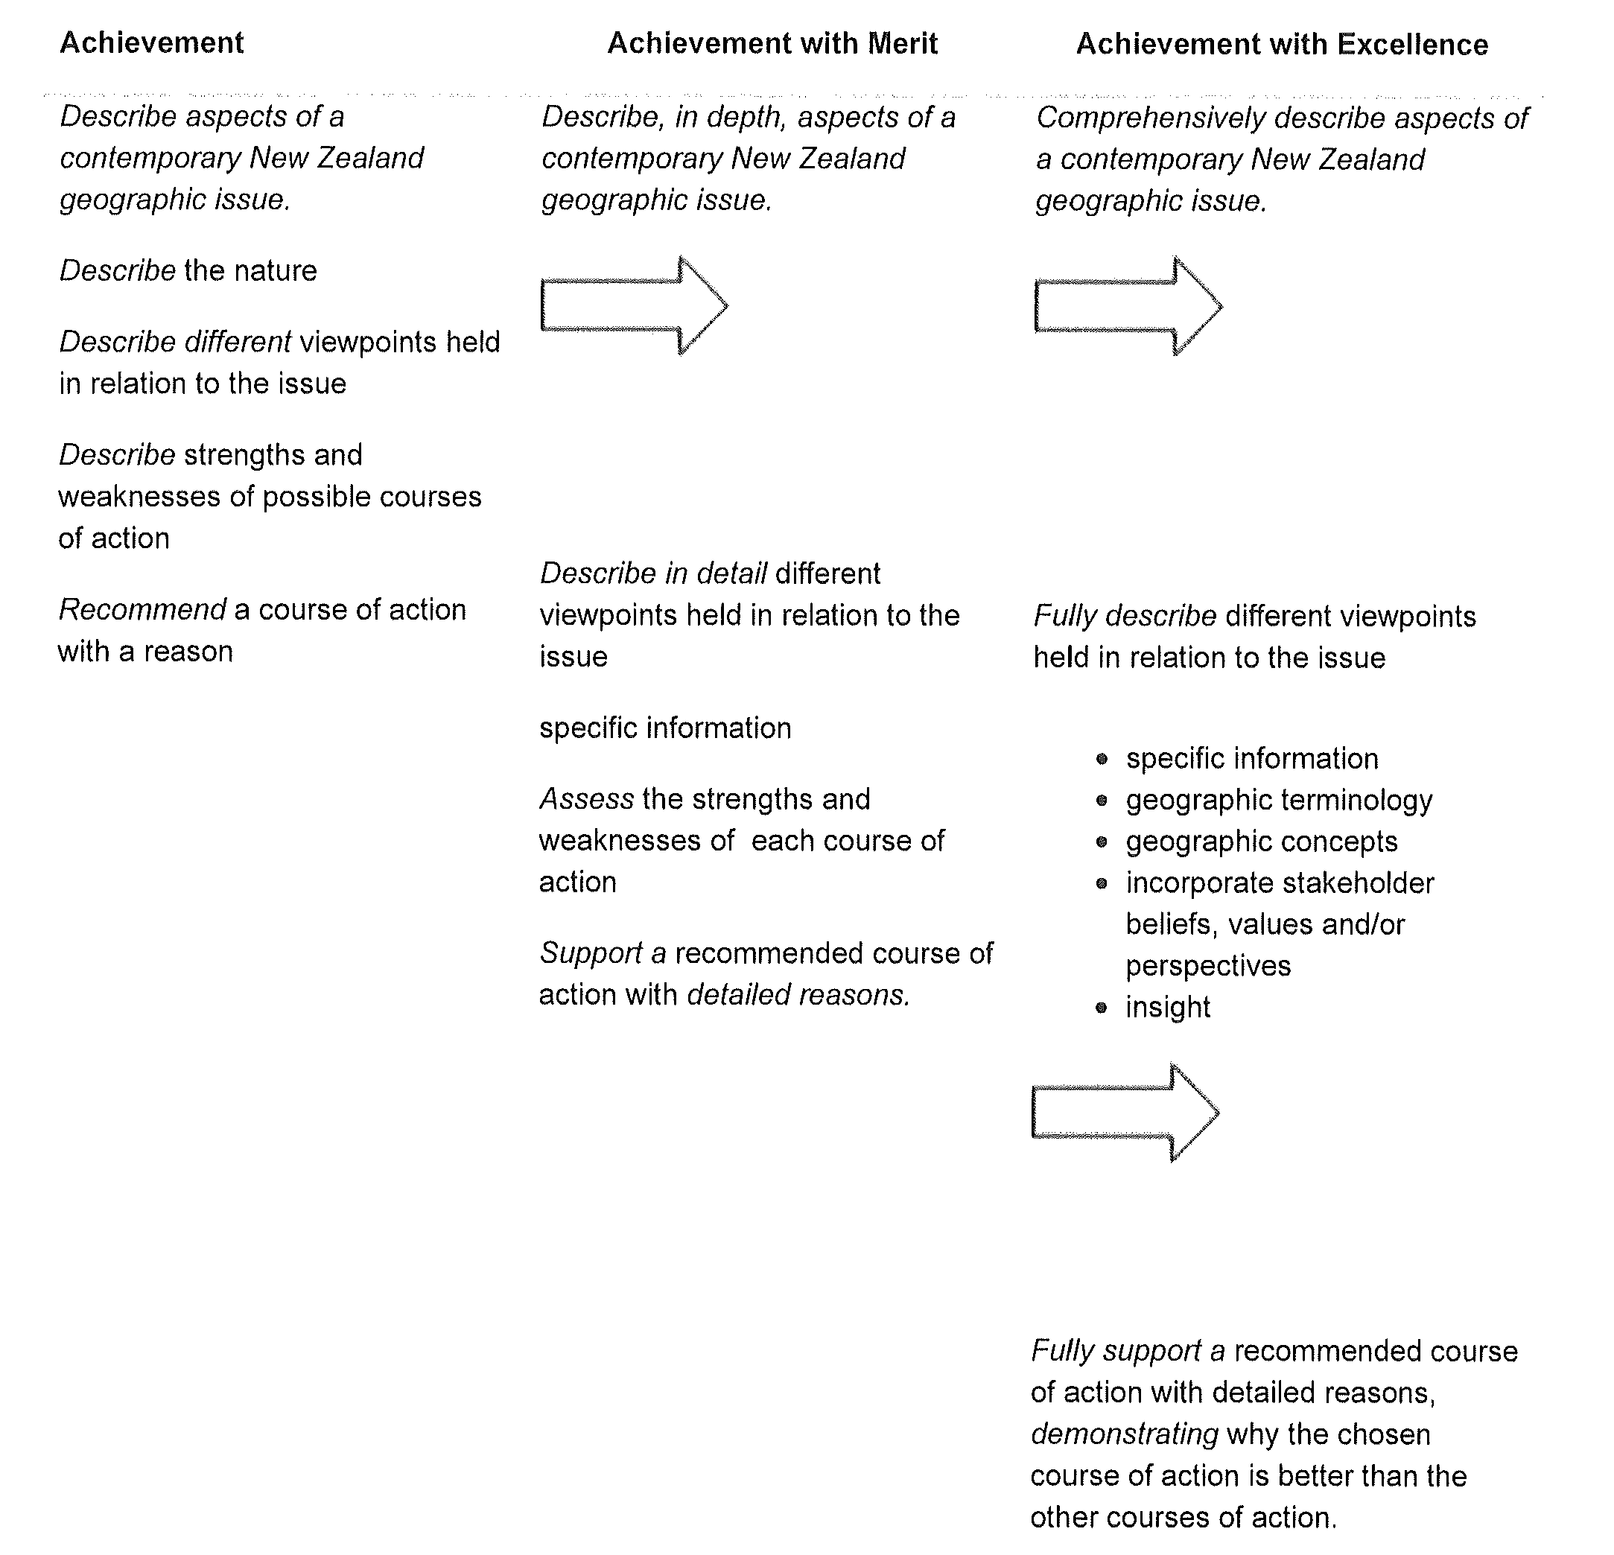

Jane Evans
Previous Northland/Auckland/Central North Geography facilitator

Margaret Leamy
Previous Lower North Island/South Island Geography facilitator

