GEOGRAPHY TIPS

Conduct geographic research, with direction (AS91011)

WHAT IS THIS STANDARD ABOUT?
The aim of this standard is to assess students understanding of the scientific research process. Primary data is a focus in this standard so that links can be made by students between what happens in the real world and geography. As such it involves students getting out ‘into the field’ to collect data.

WHAT IS SCIENTIFIC RESEARCH?
The main stages of any scientific research are the same irrelevant of what subject it is conducted in. These include:

STAGE 1: Setting up an aim, research question or hypothesis
STAGE 2: Planning what you intend to do to collect necessary data and the form of the research.
STAGE 3: Collecting and recording the necessary data
STAGE 4: Presenting the data
STAGE 5: Investigate the findings
STAGE 6: Coming up with a conclusion that relates to the aim.
STAGE 7: Evaluating the research process

A good link to this is https://www.globe.gov/explore-science/student-zone/be-a-scientist/steps-in-the-scientific-process

DIFFERENTIATION BETWEEN LEVELS
The Research standard occurs at all 3 levels. The differentiation between levels occurs as a result of:
- The use of the word ‘direction’ in the title. This means the amount of help the teacher is able to give to the student during the research process. At Level 1 it is assumed students are not so familiar with this process and therefore a lot of help is available. It is vital to read the Conditions of Assessment http://ncea.tki.org.nz/Resources-for-Internally-Assessed-Achievement-Standards/Social-sciences/Geography/Level-1-Geography and clarifications of the standard that clearly set out what the teacher can help with. At Level 1 direction refers to assistance with the selection of a topic and aim, and appropriate fieldwork procedures for collecting, recording and presenting data.

- The instruction words involved – at level 1 the key word is ‘describe’ while at level 2 it is ‘explain’ and at level 3 ‘analyse’. This will mean that a lot more depth is required at Level 2 and 3 compared to Level 1.
- The amount of data collected. It is expected at Level 2 and 3 that more data is collected.

CHOICE OF TOPIC
At Level 1 the topic should be selected by the teacher. In general there are 3 requirements that must be fulfilled to make the topic possible for use in this standard. These are:
- It must have a spatial component. In other words it can be mapped.
- It must involve the collection of primary data in the field using a combination of methods.
- It must consider aspects of the natural or cultural environment or interaction between them.

When deciding on a suitable topic you should also consider the following:

- Are there opportunities to leave the school site, and for how long?

While this standard offers the ideal excuse to get students outside the classroom it can be difficult to put this into practice. In this case you may need to look for solutions close by that can be conducted within normal class time. Examples here are to conduct a traffic investigation or compare 2 local centres as the best site for a service or facility. If this is not feasible collect data within the school grounds such as investigation travel options to school, temperature variation or cellphone coverage.

- What will stimulate student interest?

Students tend to do a much better job when interested in what they are doing. Siting a skateboard park, investigating local weather or looking at cellphone coverage are more likely to stimulate their interest. Get students involved in the decision of what topic to choose.

- Can you combine this with another assessment so that students get a more in-depth understanding of it?

For example if you are also doing the AS91009 on Sustainable use of an environment you may collect data on your selected environment to also use for this standard. Several schools also combine this with AS91007 by seeing how prepared or informed the community is for an extreme natural event.

- What equipment do you have to collect the data? How easy is this to use?

The collection of some data will require specialist equipment. Measuring temperature variations requires thermometers that can be expensive. Distances ideally need measuring tapes although a cheap alternative is to pace them. Traffic and pedestrian counts require a timer although many cellphones now have this app on them.

PRE-TEACHING
This standard is likely to take several weeks to be completed. Before assessing this it is important students are familiar with several geographic skills such as:

- What the research process means
- Methods of collecting data in the field eg sketch maps
- How to draw graphs using correct conventions
- How to write geographic answers
- What the geographic concepts are and how to interpret them.

STAGE 1: IDENTIFYING THE RESEARCH AIM

The success of the research depends on the choice of a good research question. Therefore the aim should be provided by the teacher. Good research aims are clear, simple and measurable. Students should clearly state the aim of the research at the beginning of the report or as a title on their poster.

STAGE 2: PLANNING

Planning is not required for Level 1. However, it is good practice to do this as a class together as this sets the scene for Level 2 research the next year when it is assessed. It also helps for students to understand what they are doing and why. As it is not part of the assessment this does not need to be included in the assessment tasks.

STAGE 3: COLLECTING AND RECORDING DATA

Primary data must be the focus of this research and collected from the field using a combination of methods. Primary data in geography is taken as data that is unique, collected by a students first hand experience in the field, has not been collected before and is not published. Therefore a student taking readings of temperature in different parts of a school by using a thermometer is collecting primary data. A student getting those readings from the internet is collecting secondary data. A student taking photographs or drawing maps that they annotate is collecting primary data, accessing photographs or maps from the internet or photocopied from books is not. A student gaining information from someone by interviewing them is collecting primary data while quoting them from a published article in a magazine or from a video is not.

The focus must be primary but secondary data can be used to back up the findings eg weather maps. However, because this makes the research more complex the majority of schools minimize the amount of secondary data used at this level. More than one type of primary data must be used as the standard asks for a combination of methods so that different geographic skills are used. Common methods include surveying, measuring, interviewing, using questionnaires, taking photographs, constructing maps, field sketches or making observations.

While data can be collected individually it is often easier for students to collect data in groups. This allows students the chance to organize themselves such as allocating different jobs in terms of a traffic count or sending each member to collect data in different locations that can then be shared. However, it is expected that each member of the group includes all the necessary data in the assessment. This allows the accuracy to be checked in terms of the findings made. Collecting data is the only stage in the process that can be completed collaboratively.

It is important that every class member has been seen collecting data at some stage. This can produce problems if a student is absent. If collection of data occurs over several days then as long as they are seen collecting it once they fulfill the criteria. If it is a whole day fieldtrip that they miss an alternative assessment will have to be given.

The teacher should provide direction to students such as what to collect, the methods of how to do this and the format of how to record it. Providing students with a data collection sheet with tables set up will aid here. At the same time it is good practice to encourage students to collect additional data such as the inclusion of observations or taking of photographs to allow more depth.

STAGE 4: PRESENTING DATA
At Level 1 the teacher should direct the student as to the forms of presentation that are expected, such as the type of graph to draw. They can also direct the student by providing some outlines such as the axes for graphs or the tables that the student fills in. However, allow some opportunity for other forms of presentation of student choice especially for the more able student. The presentation must be based on some primary data.

The standard clearly expects the spatial nature of the research to be identified that means that some kind of mapping is expected. This map can be one the students draw themselves or one obtained from secondary sources that is annotated to identify the location of the research. In both cases appropriate mapping conventions are expected namely a title, key or labels and north point (basic) and frame, colour and scale (all).

The research data itself must be presented in different ways (more than one) from a combination of graphs, tables, photographs, sketches and diagrams. Photographs are only acceptable if they are annotated in a way that makes their relevance to the research clear. Again appropriate conventions are required such as labeled axes, a title and key for graphs and titles and annotations for diagrams and photographs.

The step up for different grades in terms of presentation is based on the quality and accuracy of the presentation. For Achievement any 2 types of presentation are required that have basic conventions only. For Merit it must include a map plus any 2 other different types of presentation with basic conventions. For Excellence it must include a map plus any 2 other different types of presentation with ALL conventions. This means that Excellence can be gained by only completing 3 different forms of presentation so it is pointless asking for too many of these. Completing 10 different bar graphs becomes meaningless if one will do.

Completion of graphs and maps using digital technology such as excel is acceptable as long as you can verify the student completed this themselves and is not someone else’s work! They should also ensure that correct conventions are included even if it means adding to these by hand.

STAGE 5: DESCRIBE FINDINGS
It is important to put this into context of research at other levels. At Level 1 students only have to describe their findings rather than going into explaining why they occur. This may be provided by the more able student in which case ‘explain’ will help equate to ‘fully describe’ and so should be rewarded.

What makes this section difficult is the requirement to incorporate a geographic concept into the findings. This can be helped by using a concept in the aim. The concept should be incorporated into the findings not as a separate question. One easy way around this is to get students to comment on the findings of each form of presentation. By asking them to use the concepts such as ‘location’ for a map or ‘pattern’ for a graph it becomes simpler to do. This will depend on the nature of the research as in some cases it may be more appropriate to produce one long answer only that refers to several presentations together.

The step up for different grades is based on the quality of the response. For Achievement a student must ‘describe’ findings based on the data presented as well as show an understanding of one concept. For Merit the students must ‘describe in detail’. This means they need to use direct evidence from the data collected and/or presented such as quoting actual amounts or giving details as to the variation in different places or times. They must also show a good understanding of the concept. For Excellence they must ‘fully describe’ which means they use geographic terminology, refer to all presented data using specific evidence and shows insight by thinking like a geographer! Students also need to show a sound understanding of at least one concept.

STAGE 6: CONCLUSION

It is important that a conclusion is provided separately from the findings. Students often feel they are repeating information here so reassure them that the point of this is to take out the main points only or do a summary. The vital component here is to directly relate the findings to the original research aim. If this was stated as a question or hypothesis they need to say if they now agree or disagree with it and what was the evidence for this decision. Conclusions do not need to be lengthy and are the reason they are only differentiated between achievement (can provide a conclusion) and Merit (can provide a detailed conclusion).

STAGE 7: EVALUATION OF THE RESEARCH PROCESS

The evaluation can be divided into 2 separate parts. All grades require an evaluation of the research process. This means describing a strength(s) and/or weakness(es) of what they did. This can relate to the collecting, the presenting or the findings made. Grades are based on qualitative answers not quantity. For Merit and Excellence you would expect a more in depth answer.

Evaluation of the research process is often made easier if students keep a log during the whole process. Here they can record any strengths or weaknesses they found as they happened as these are easily forgotten. However, they need to be reminded to use this in the evaluation.

Do not panic if ‘outside factors’ upset the collection of data. Unexpected roadworks, rain, faulty equipment, only being able to collect data twice etc will provide the student with more to discuss in the evaluation.

For Excellence there is the added requirement to also comment on the validity of the data collected. This means that the students does not just say what was a strength/weakness but why this impacted on the results gained. Saying that a weakness was that ‘the traffic went so fast we missed some’ is not sufficient without adding ‘this meant we were not accurate with the data to make valid conclusions’. At level 1 there is no expectation that students discuss what improvements can be made. However, this often does occur and can be taken as showing insight.

MANAGEMENT OF THE ASSESSMENT

The research standard can be lengthy and take several weeks to complete. It often makes it easier to break this down into parts to make it more manageable. For example, you may want to break the assessment up into 1. The collection and recording 2. The presentation, the findings and conclusion and finally 3. The evaluation so that each part is done separately with teaching between. If this is done it is important it is not marked between each stage since a holistic judgment must be applied at the end.

If students are given a free rein the research can be so long it becomes a nightmare to mark! It often helps to provide a booklet for this standard as it assists the student in seeing how much you are expecting at each stage. However, do ensure if you do this that space is provided for the excellence student to be creative.

MARKING OF THE ASSESSMENT

It is important to note the aspects of the research that step up through the grades and how the quality is determined. The chart below unpacks the Achievement Criteria, and the geographic research must involve all aspects identified below. The final judgement is based on a holistic examination of the evidence.

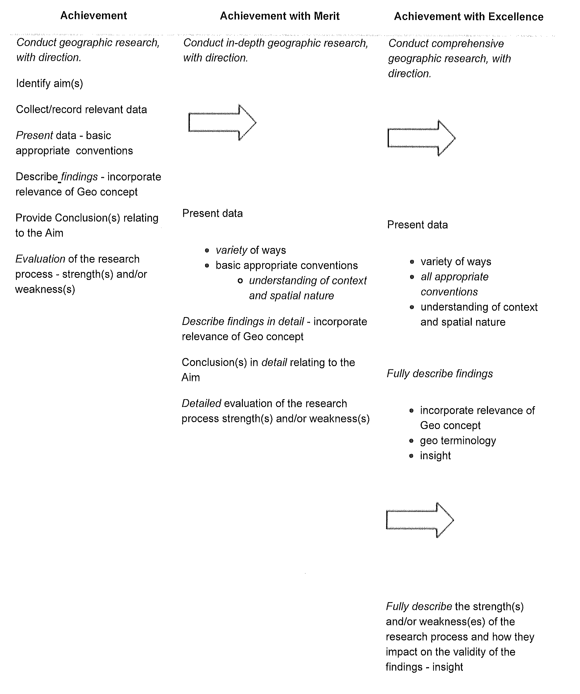
Jane Evans
Previous Northland/Auckland/Central North Geography facilitator

Margaret Leamy
Previous Lower North Island/South Island Geography facilitator

