GEOGRAPHY TIPS

Demonstrate geographic understanding of the sustainable use of an environment (AS 91009)

WHAT IS THIS STANDARD ABOUT?

This standard investigates the geographic concept of sustainability. It looks at the use of a particular environment and explores the extent to which this is sustainable. In this assessment students need to investigate how and why people use this environment, the consequences of this use and how sustainable this is in the future.

Unlike other internal assessments in geography this is a standalone assessment that only occurs at Level 1.

UNPACKING THE TERMS

- Geographic Understanding: refers to an understanding of the spatial dimension of the environment, and an understanding of how people interact with environments and the consequences of that interaction.
- Sustainable Use: refers to the extent to which this use can be maintained in the future to minimise environmental impacts.
- Environment: refers to a part of the earth’s surface characterized by a specific use. This can be either in New Zealand or overseas.
- Describe: This means to identify and give an account of; to make reference to the qualities, characteristics or recognisable features
- Explain: This means to provide reasons for, to account for, to provide a clear answer, to clarify. Logical reasons are provided.
- Fully Explain: This means the response is complete and demonstrates an understanding of all facets. It incorporates relevant geographic concept(s) and uses appropriate geographic terminology.
- Showing Insight: This means in-depth understanding that can involve weighing up and judging evidence - reading into and beyond the subject matter/evidence. Consideration of perspectives can help in showing insight.

CHOICE OF TOPIC

When deciding on a suitable topic you should consider the following:

- It is easier if it is based on land used for specific purposes rather than just general use.
- The sustainability, or otherwise, of the land use should be easy to identify and write about in detail, if it is not easily identified students will struggle to provide comprehensive answers. It requires clear impacts on the environment.
- It must be a topic for which comprehensive resources can be found. These are likely to be written and visual but may include oral through guest speakers with experience in this form of land use eg a farmer.
- Are you able to combine this with a field trip to the environment involved? The ability to see this in action and to meet the personnel involved in the land use will make it more meaningful to students.
- Can you combine this with another geography standard to cut down on background information? For example, it can be combined with the 1.6 looking at a geographic issue surrounding this impact on the environment or by researching the use of a selected environment and its impacts.
- Choose a topic in the news or of interest to students. Utilising the local environment helps students see the geography around them and allows them to use their local knowledge. For example, a rural community may wish to look at the sustainability of dairy farming locally.

EXAMPLES OF TOPICS

Any specific land use where the impacts on both the natural and cultural environment are evident are suitable. Common land uses include: mining, farming, fishing, tourism, energy production, recreation or forestry,

The size of the selected environment needs to be carefully considered and it could be influenced by the use/s that are to be studied e.g. Waihi and mining, marine farming and tourism in Marlborough Sounds or uses of the Clutha River for HEP, tourism and farming. Evidence indicates that when a single orchard or vineyard is selected as the environment, this has hindered students providing a comprehensive understanding.

WRITING ASSESSMENT TASKS

Writing your own assessment tasks is not difficult but can be daunting if you are new to geography teaching. Many resources are available via subject associations or cluster groups as teachers are willing to share ideas that have been proved to work well. Most cluster groups now use dropboxes for this purpose so check to see what is available in your region. There are several organisations that you can buy assessment tasks from such as Geostuff http://www.geostuff.co.nz/home.html and Classroom Solutions http://www.classroomsolutions.co.nz/geography.html that are often ideal to use in the first instance until you gain confidence.

If you are writing your own assessment tasks then use the exemplars provided on the TKI site as a guide. There are 5 exemplars provided for this standard as it also is used as part of the Vocational Pathways for students requiring some applied geography. These are available at http://ncea.tki.org.nz/Resources-for-Internally-Assessed-Achievement-Standards/Social-sciences/Geography/Level-1-Geography. You can download these and use them as a base to add your own context to. When doing this it is important that you use the language of the standard so have this available as you construct it.

If you have constructed your own assessment task it is important that you get a fresh pair of eyes to moderate this before it is used.

The TKI resources are provided as exemplars of what is possible and should not be downloaded and used in their original format as they are readily accessible to students. However, you can adapt them.

WHY IS THIS A LEVEL 1 ASSESSMENT?

There are several characteristics of this assessment that are common to other Level 1 internals.
- Teacher Guidance - It is vital to read the Conditions of Assessment http://ncea.tki.org.nz/Resources-for-Internally-Assessed-Achievement-Standards/Social-sciences/Geography/Level-1-Geography and clarifications of the standard that clearly set out what the teacher can help with. This identifies that for this standard the land use selected is best chosen by the teacher. If choice is provided the teacher should approve the suitability of the environment chosen or it could hinder the whole assessment.
- Resources - As with other Level 1 internals the majority of resources should be provided by the teacher. These should allow the student to gain excellence for the aspects covered. They should be up to date and of the appropriate reading level for this year group. Alternatively a web quest or similar can be provided as long as these have been vetted to check they are appropriate to the year level. Students can be encouraged to provide additional resources themselves but this is not mandatory at this level.

PRE-TEACHING

This standard is likely to take several weeks to be completed. It is important that during the learning process students are familiar with the following:

- An understanding of the term ‘sustainability’.
- Background to the geographic topic – what it is about.
- Understanding the resources provided. What do they mean?
- A chance to add to the resources provided
- What concepts apply to this topic?
- Background to the standard - what is required for each criterion?
- How to write geographic answers

HOW AND WHY PEOPLE USE THE ENVIRONMENT
How, refers to how the environment is used. This is not a detailed account of the processes involved in the selected use, e.g. milking is not directly using the environment, but sowing grass or planting shelter belts is. It often assists by starting with a visual of the environment and describing the different ways it is being used by people.
Why, needs to describe why the selected environment is particularly suited to this use, including both natural and cultural reasons. Why was it chosen as a suitable environment for this type of land use?
This aspect is assessed for achievement only. Hence answers do not need to be complex and can consist of short paragraphs or descriptive annotations on a map or diagram. The inclusion of the latter helps emphasise the spatial nature of the topic.

THE CONSEQUENCES OF THE USE
The consequences of this use refer to the impacts that it has on both the physical and the cultural environments. These impacts must relate to what happens within the selected environment and its outskirts but must not extend beyond it.
These consequences can be broken down further such as considering positive and negative, social and economic, short and long term and those that are direct effects (people directly involved in the ‘use’) as opposed to indirect (such as support services, employment opportunities, locals affected by traffic congestion and noise etc).
This aspect does differentiate from Achievement to Merit and Excellence. For Achievement the instruction word is ‘describe’. For the step to Merit some ‘explanation’ needs to be provided that links this land use to the impact identified. In addition you expect impacts on both people and the environment to be explored with detailed case study information (names, dates and/or statistics). In the step up to Excellence this needs to be done showing depth in which the case study information is integrated into the answer. In addition students must use geographic terminology and at least one clear concept. The concepts of change, process or interaction are especially applicable here.

THE SUSTAINABILITY, OR OTHERWISE, OF CONTINUED USE OF THIS ENVIRONMENT

This aspect focuses on sustainability as a concept and it is important that the student conveys an understanding of this term. The sustainability can relate to the environment itself or the use of it. In many cases these are interdependent eg tourism in Fiordland. If the use is related to a non-renewable resource e.g. mining, the use is not sustainable consequently the focus will be sustainability of the environment. For example, a coal mining environment can be considered to be sustainable through the correct use of trees and rehabilitation even if the resource is non renewable.

It is not appropriate to treat this as a simple list of ‘problems’ and ‘solutions’ unless the concept of sustainability is integrated into this.

This aspect does differentiate from Achievement to Merit and Excellence. For Achievement the instruction word is ‘describe’. For the step to Merit some ‘explanation’ needs to be provided that links this land use to its sustainability. Again use of specific case study information is required to back up these claims. In the step up to Excellence this needs to be done showing depth, use of geographic terminology and a concept.

MANAGEMENT OF THE ASSESSMENT

The assessment can be lengthy and take several weeks to complete. A useful approach to this standard is to collect assessment evidence during the course of the learning. You teach the first aspect, set a task and collect that evidence and then move onto the next. Such an approach means that the assessment does not interfere with the learning. If this is done it is important it is not marked between each stage since a holistic judgment must be applied at the end.

The majority of schools assess this standard using a written booklet. However, it can be assessed in other ways such as producing a poster or power point or movie. It is also possible to do as an oral presentation if feasible with class numbers. You can assess the different aspects in different ways. For example, you can assess the first aspect using a poster, the second as a written report and the third as an oral presentation.

If doing in a written format it often helps to provide a booklet for this standard as it assists the student in seeing how much you are expecting at each stage. However, do ensure if you do this that space is provided for the excellence student to be creative.

MARKING OF THE ASSESSMENT
It is important to note the aspects of the understanding that step up through the grades and how the quality is determined. The chart below unpacks the Achievement Criteria, and the geographic understanding must involve all aspects identified below, but the final judgement is based on a holistic examination of the evidence.

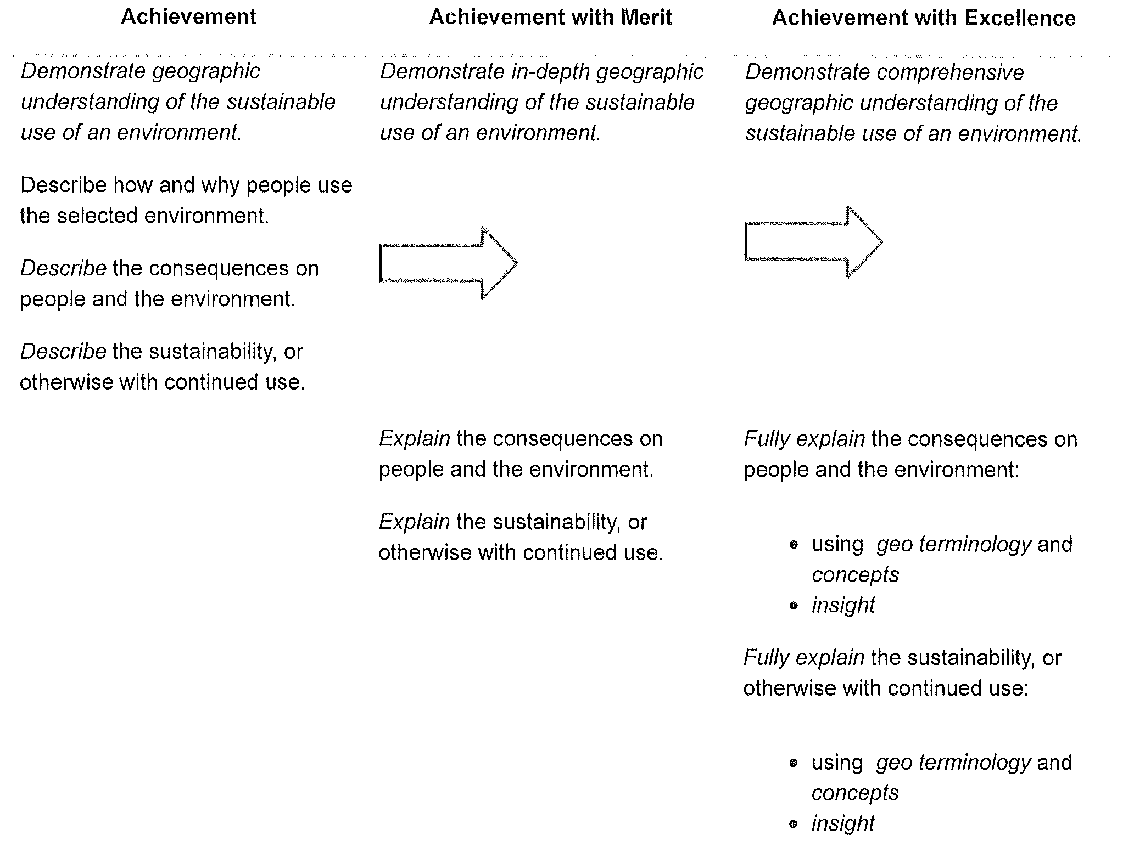

The arrow indicates that there is no step-up in quality required. Evidence from the selected environment must be used throughout the response.

Jane Evans
Previous Northland/Auckland/Central North Geography facilitator

Margaret Leamy
Previous Lower North Island/South Island Geography facilitator

