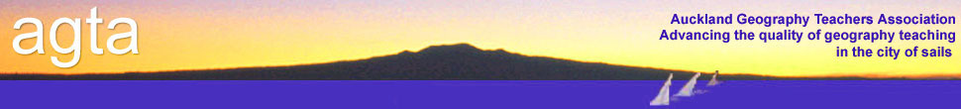

**ATTENTION: HOD GEOGRAPHY and Geography teachers**

**Teaching for Excellence at Level 3**

**Wednesday 27 August 2014**

**COURSE:** This workshop is intended to give teachers help with how to teach Level Three students.

**The course will cover:**

* Excellence criteria – internals and especially externals
* How to teach students to write excellence answers.
* Scaffolding techniques and templates provided
* Looking at model answers and using these for learning
* Question and answers – there’s no such thing as a silly question.

**VENUE:** National Library, 8 Stanley Street, Parnell

**TIME:** 3pm-5.30pm

**FACILITATORS:** A range of teachers from across the Auckland region – representing different types of schools.

**COST:** $18 per person (member schools) Includes afternoon tea.

…………………………………………………………………………..

**AGTA COURSE REGISTRATION FORM**

**Teaching for Excellence at Level 3**

**Wednesday 27 2014**

**School:** _____________________________________________________________

**Name(s):** _____________________________________________________________

**Course Fee:**

AGTA members: No. attending ___ @ $18 per person = _______

**Total enclosed** =

Payment method: Direct Debit : AGTA Bank Account details : 12-3026-0006850-00.

If you pay by direct debit please notify AGTA, agtassociation@gmail.com

Cheques payable to: Auckland Geography Teachers Association

**Return to: Claire McKay (Treasurer)**

**AGTA**

**PO Box 47788**

**Ponsonby**

**Please register as soon as possible as places are limited**

**– email** [**agtassociation@gmail.com**](mailto:agtassociation@gmail.com)AGTA policy on refunds applies.