Auckland Geography Teachers Association

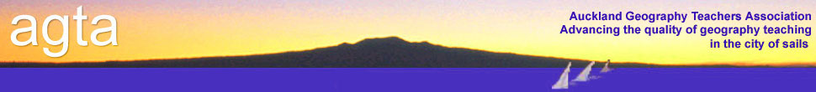

**ATTENTION: HOD GEOGRAPHY and Geography teachers**

**New to Teaching Geography?**

**June 4th 2014**

**COURSE:** This workshop is intended to assist teachers “new to teaching geography” (either beginning teachers or those new to teaching geography). The course will include:

* An overview of the NZ geography curriculum.
* Interpretation of key terminology and the use of concepts.
* Achievement standards – an overview.
* Where to go for information - Cool websites and textbooks.
* Some different ways to teach geography
* Question and answers – there’s no such thing as a silly question.

**VENUE:** National Library, Level 1, 8 Stanley Street, Parnell

**TIME:** 3pm-5.30pm

**FACILITATORS:** Graeme Cope and others

**COST:** $15 per person (member schools) Includes afternoon tea.

…………………………………………………………………………..

**AGTA COURSE REGISTRATION FORM**

**Teachers new to teaching Geography**

**June 4th 2014**

**School:** _____________________________________________________________

**Name(s):** _____________________________________________________________

**Course Fee:**

AGTA members: No. attending ___ @ $15 per person = _______

**Total enclosed** =

Payment method: Direct Debit : AGTA Bank Account details : 12-3026-0006850-00.

If you pay by direct debit please notify Claire McKay.

Cheques payable to: Auckland Geography Teachers Association

**Return to: Claire McKay (Treasurer)**

**AGTA**

**PO Box 47788**

**Ponsonby**

**Please register as soon as possible as places are limited – email** [**agtassociation@gmail.com**](mailto:agtassociation@gmail.com)AGTA policy on refunds applies.