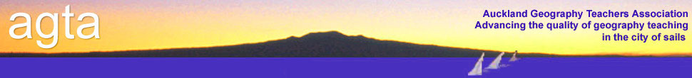

**ATTENTION: HOD GEOGRAPHY**

**Wednesday 27 November 2013**

**COURSE:** **“Doing things differently”**

**Attend this fun filled course whose aim is to share different things that are happening in Geography classrooms and departments across the region.**

* + - * 9am – 10am – Different courses and programmes
      * 10am – 11am – Assessments and ways of assessing
      * 11am – 11.30am – Break
      * 11.30am – 12.30pm – Fieldtrips
      * 12.30pm – 1.30pm – Lunch
      * 1.30pm – 2.30pm – Fun activities on fieldtrips and in classrooms –
      * 2.30pm – 3pm – Wrap-up

9-10am Part One: Different courses and programmes

* Different courses and programmes
* Guerilla Geography

10-11am Part Two: Assessments and ways of assessing

* + - * Using seminars
      * Podcasts
      * Newspapers and magazine articles
      * Creating websites using Weebly and Wix
      * Different assessment methods for various tasks within an assessment

11-11.30am Break

11.30-12.30pm Part Three: Fieldtrips

* + - * Queenstown/Waiheke/North Head
      * QR code/Perception of connection
      * Harbour cruise – looking at spatial/temporal patterns

12.30-1.30pm Lunch

1.30-2.30pm Part Four: Fun activities to involve in fieldtrips/the classroom

* + - * Sandcastles
      * Video activities
      * Using google docs
      * Video/Soc show
      * Current events – bringing Geog into Junior Social Science
      * Geoguessr /Geosetter/Geocaching

**VENUE:** Kohia Teachers Centre, Epsom Ave

**TIME:** 9.00am for a 9.15am start to 3.30pm.

**COST:** $40 per person - Includes morning tea and lunch.

…………………………………………………………………………..

**AGTA COURSE REGISTRATION FORM**

**School:** _____________________________________________________________

**Name(s):** _____________________________________________________________

**Course Fee:**

AGTA members: No. attending ___ @ $40 per person = _______

**Total enclosed** =

Payment method: Direct Debit : AGTA Bank Account details : 12-3026-0006850-00.

If you pay by direct debit please notify Sarah Kemble.

Cheques payable to: Auckland Geography Teachers Association

**Return to: Sarah Kemble (Treasurer)**

**AGTA**

**PO Box 47788**

**Ponsonby**

**Please register as soon as possible as places are limited.** AGTA policy on refunds applies.